Supplementary Materials A: Figures
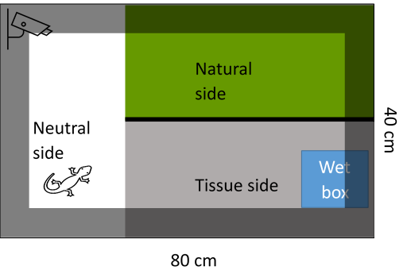
Figure S1: Experimental Setup of one choice arena. The arena is made out of grey, non-transparent plastic.The arena is evenly seperated in the neutral habitat (white), the natural habitat (green) and the tissue habitat (grey). A wall out of plastic seperates the natural side from the tissue side. Inside the tissue side is a wetbox (blue). An open lid (dark grey area) covers the borders of the arena to prevent the fire salamander from escaping. The animals start at the neutral habitat. The whole arena is getting recorded in a 7 day recording, 7 day break manner. After a one night habituation in the neutral zone, the salamander can move in each zone freely.

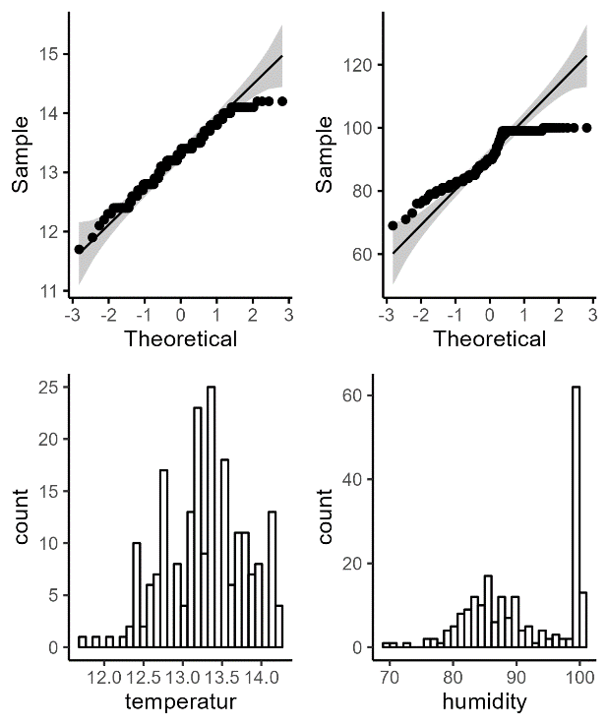
Figure S2: Visualisation of QQ Plots and Histogram for the climate analysis for temperature and humidity. Normality is given, when the black dots are in near proximity to the line for the QQ Plot and follow a Gaussian distribution in the Histogram. Shapiro Wilk test was used as reference and was < 0.05, thus normality was not assumed.
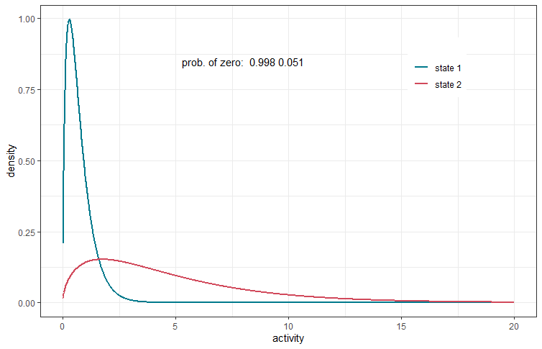
Figure S3: State-dependent gamma distributions of the fire salamanders’ activity time within the 30-min intervals. State 1 corresponds to immobile/non-active behaviour (blue line) and state 2 to active behaviour (red line), when fire salamanders were moving. The probability of zero activity for state 1 is 0.998 and for state 2 0.051.

Actogram: Spring
To reduce repetition, the following paragraph contains a general description of the Actograms on page 42 – 47.
An actogram visualises the rhythmic activity data of individual fire salamanders over the days, but only including the days of recording (10.4. – 5.6.2022, n=4 (ID: I017, I009, I012, I0011); 27.4 – 23.06.2022, n=11) and autumn (15.9– 11.11.2022, n=15). The y-axis shows the time in days. The lower part of the actogram shows the start of the data recording (starting with day 2) and the upper part shows the last days of recording. Each week is separated by a black line. The day and night rhythm is displayed on the x-axis ranging from: 0 am - 6 am black; 6 am – 6 pm white and 6 pm to 0 am black in 30 minute intervals. The orange rectangle covers the daytime. The black bars show the activity of the respective individual within 30 minutes. The greater the bar, the higher the activity in proportion to the other days. Grey rows indicate the days the moss habitat was moistened; the melon-coloured cells indicate time at which no recordings have been made.
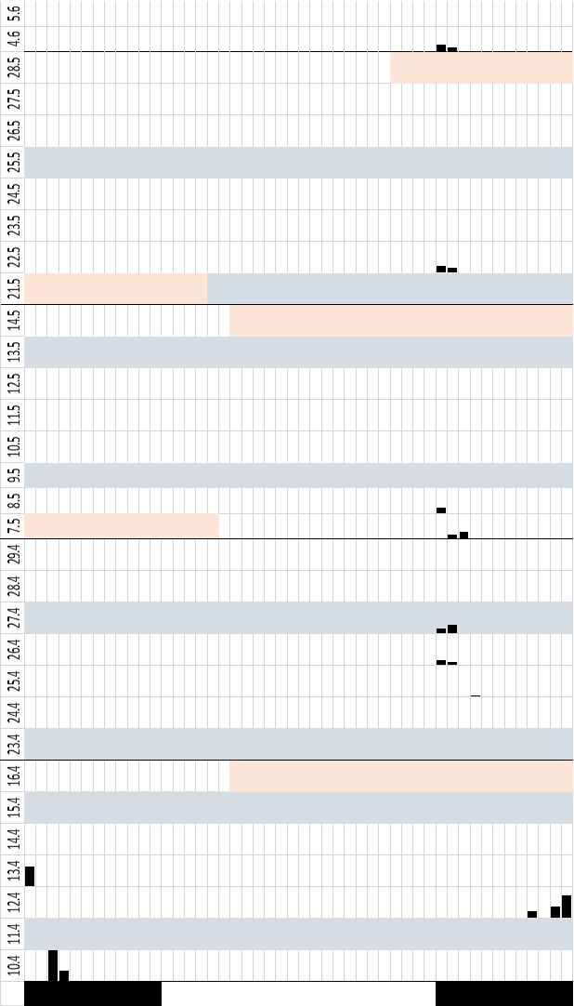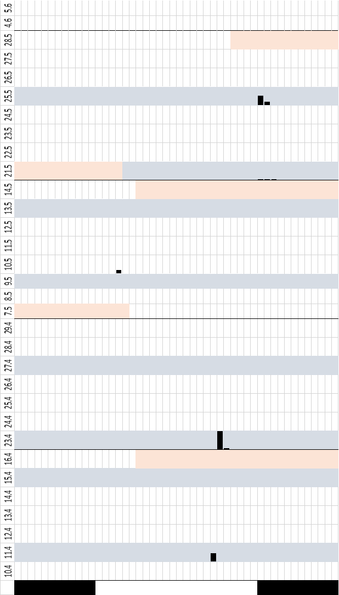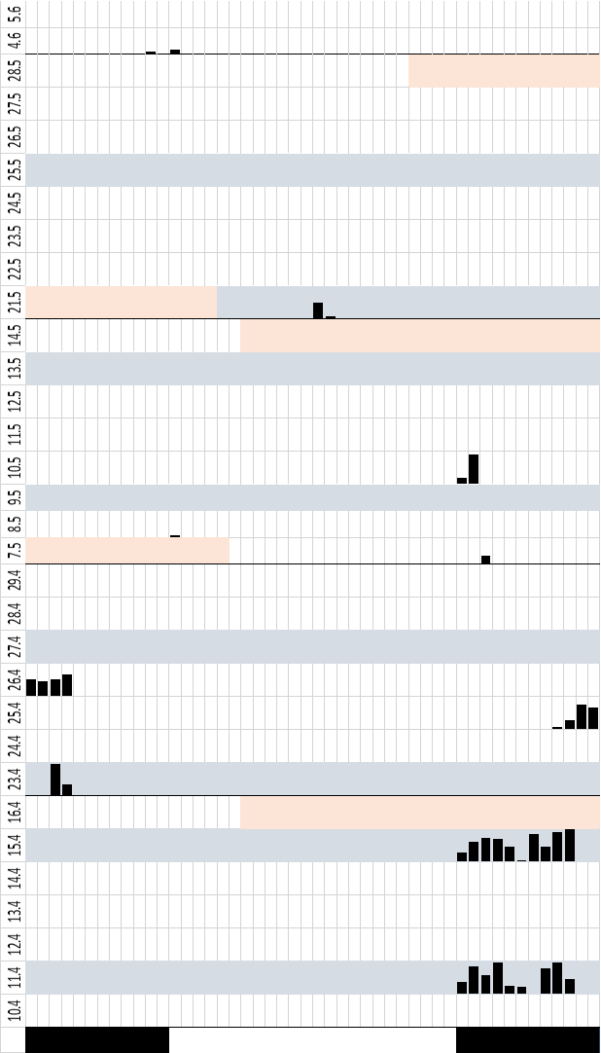
Season: Spring
ID: I009
ID: I012
ID: I011

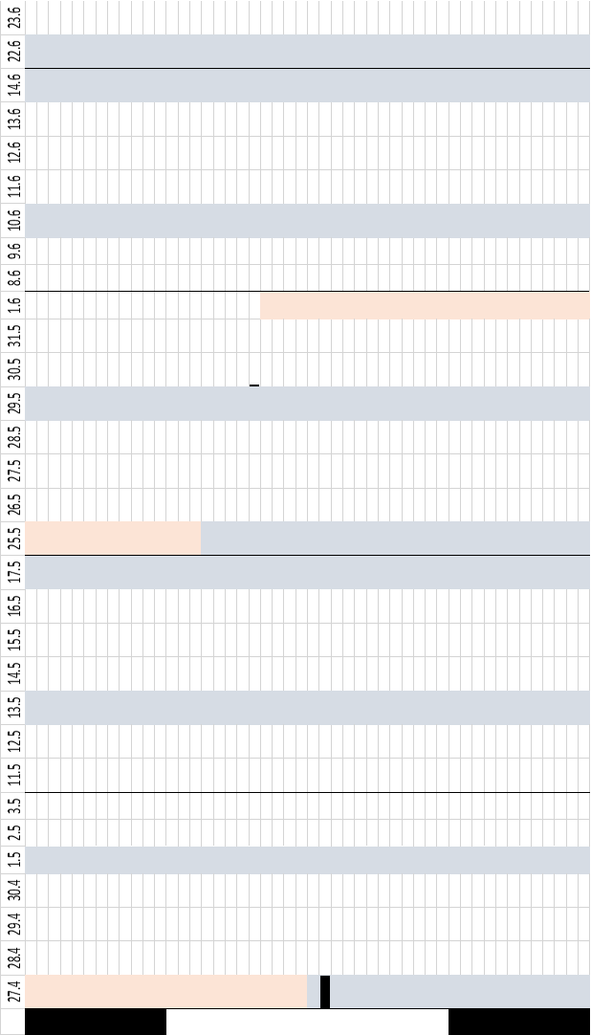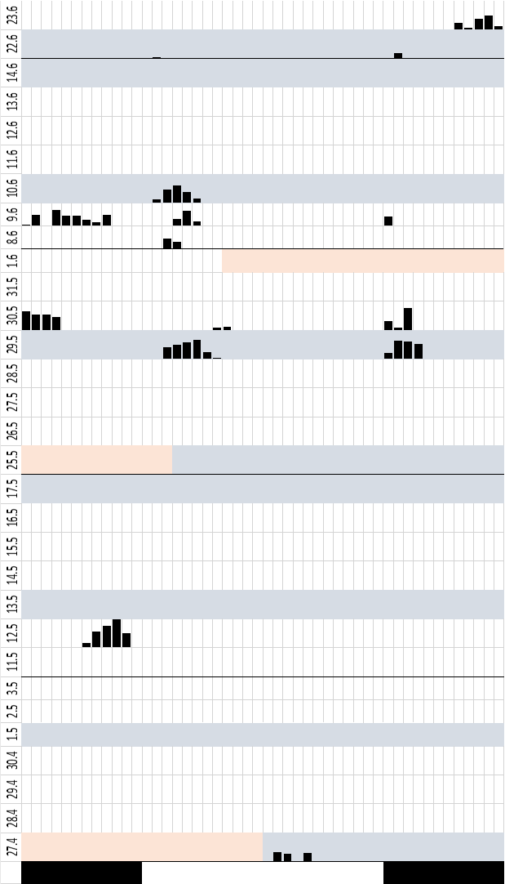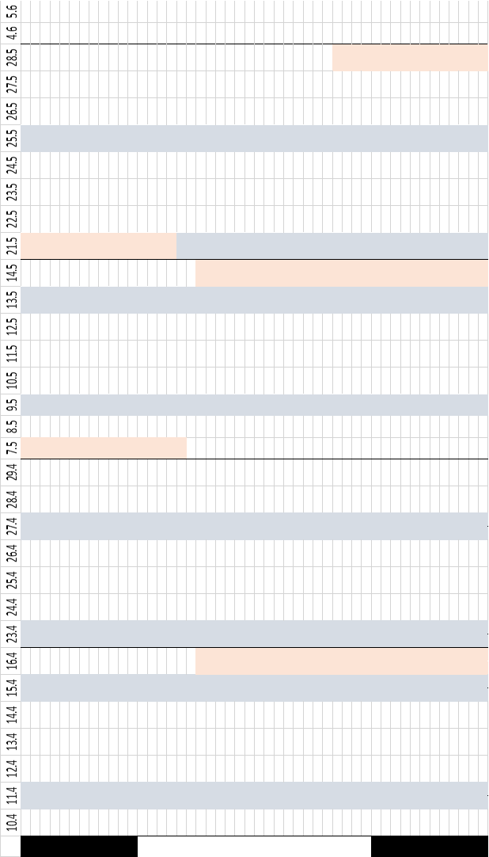
Season: Spring
ID: I017
ID: I001
ID: I002

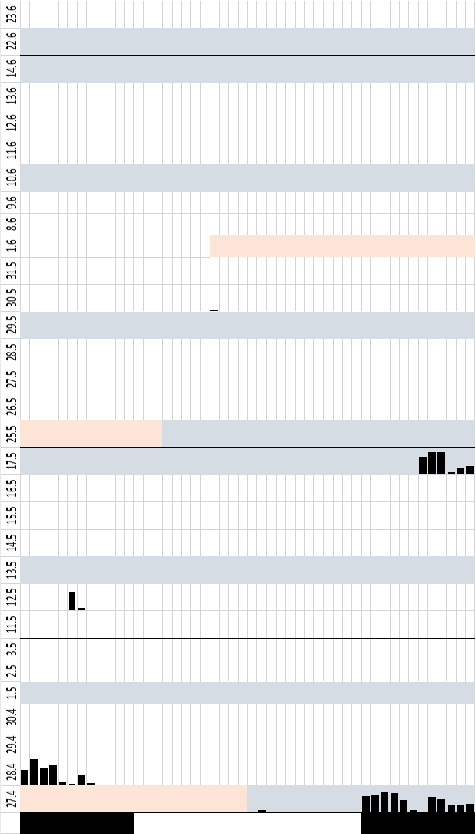
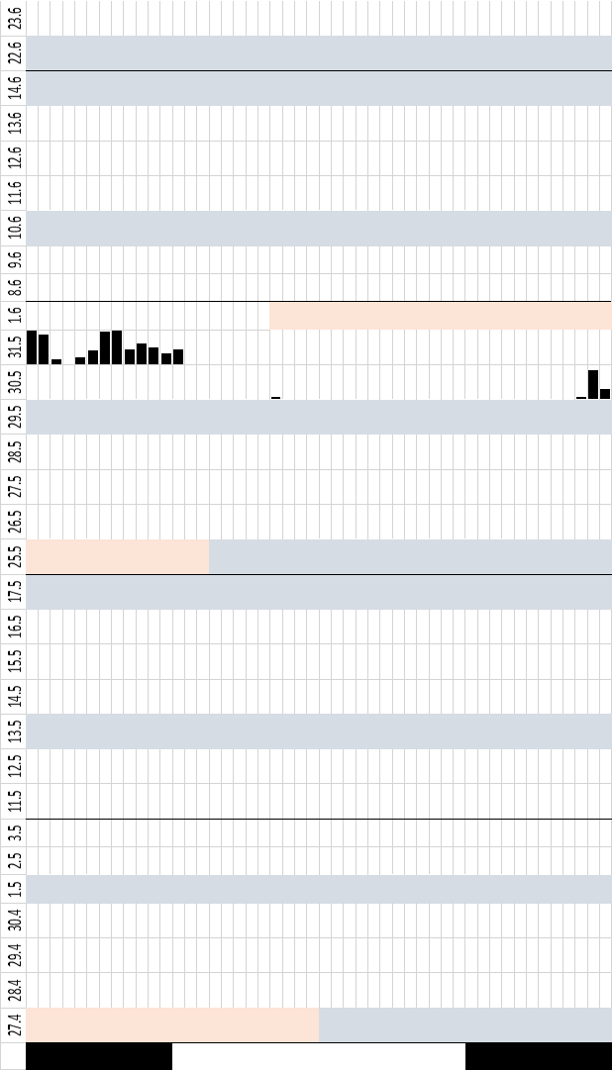
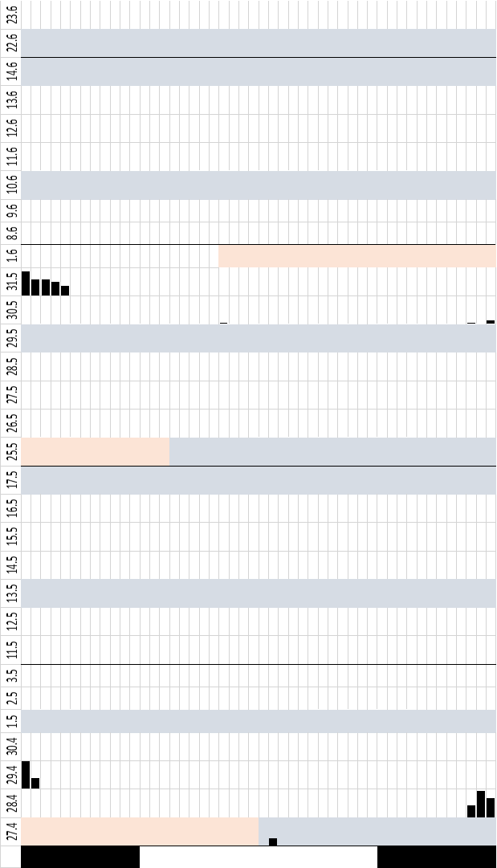
Season: Spring
ID: I004
ID: I005
ID: I003
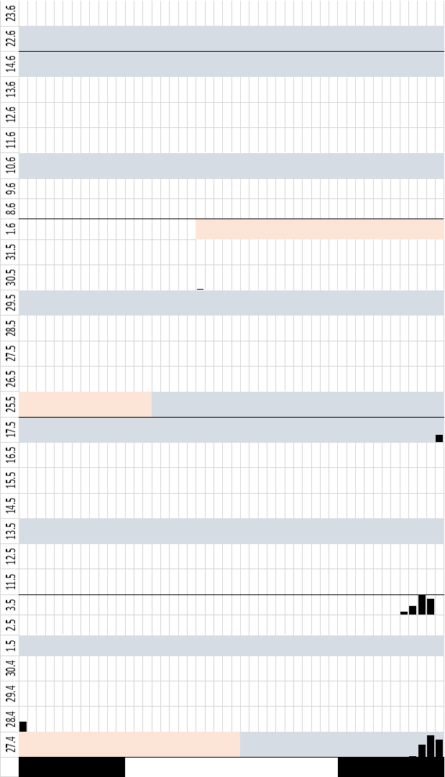
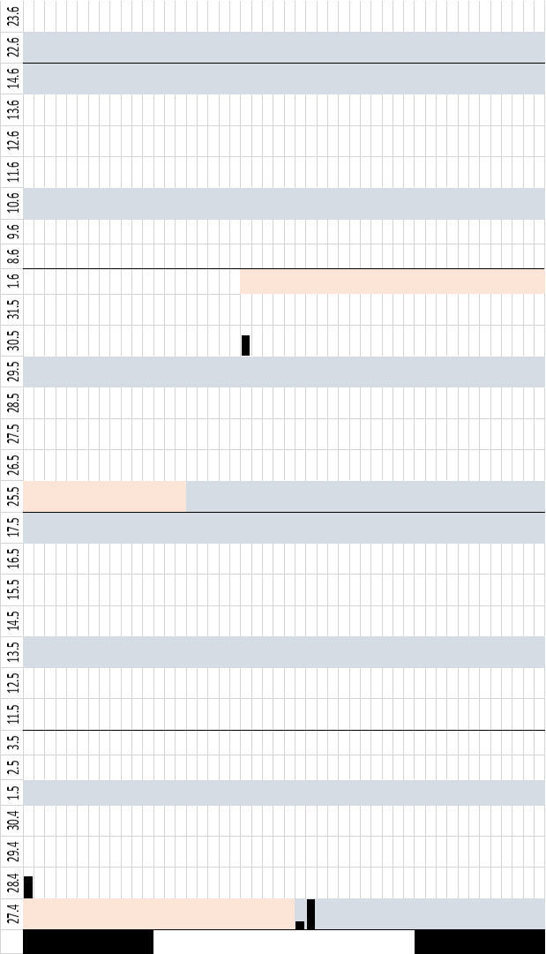
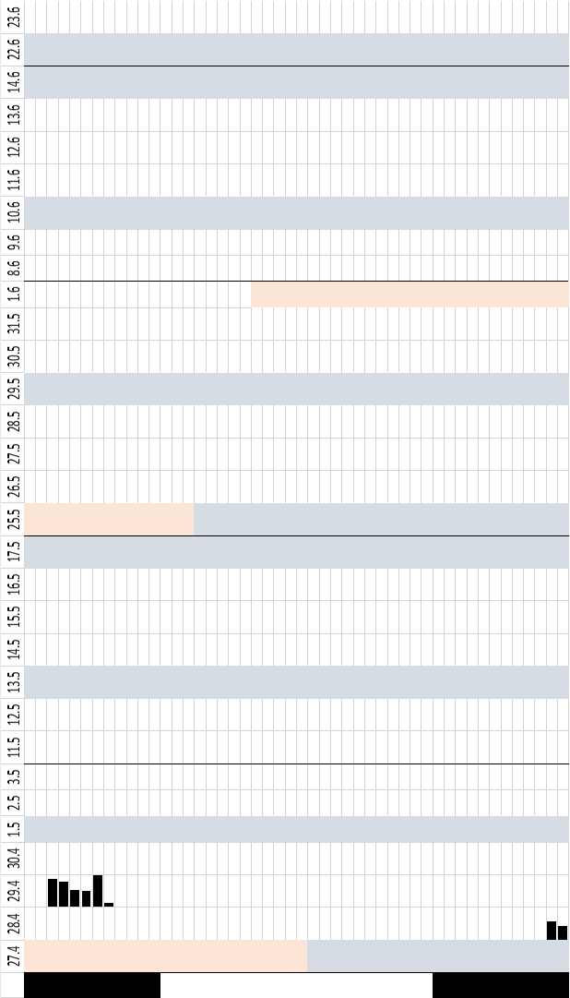
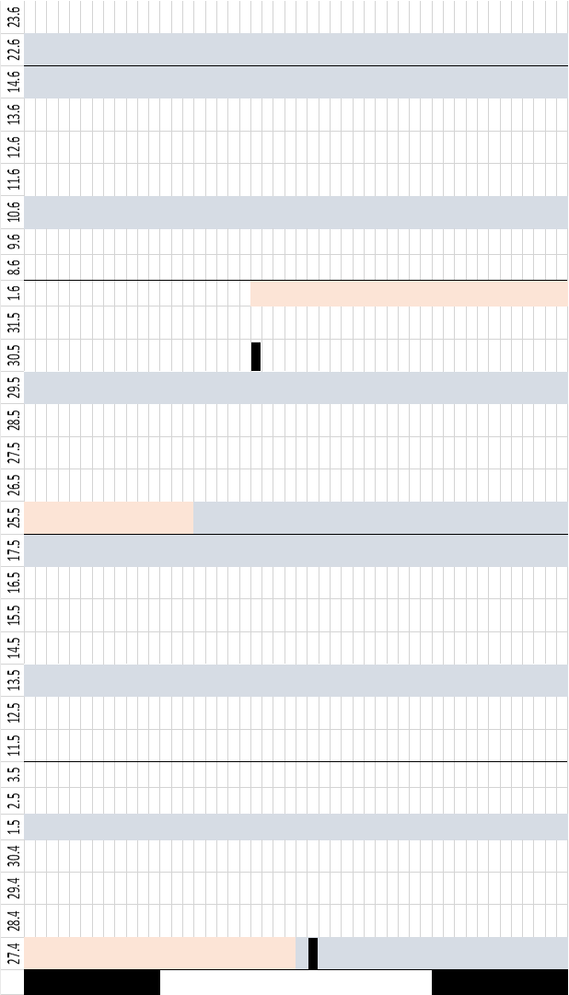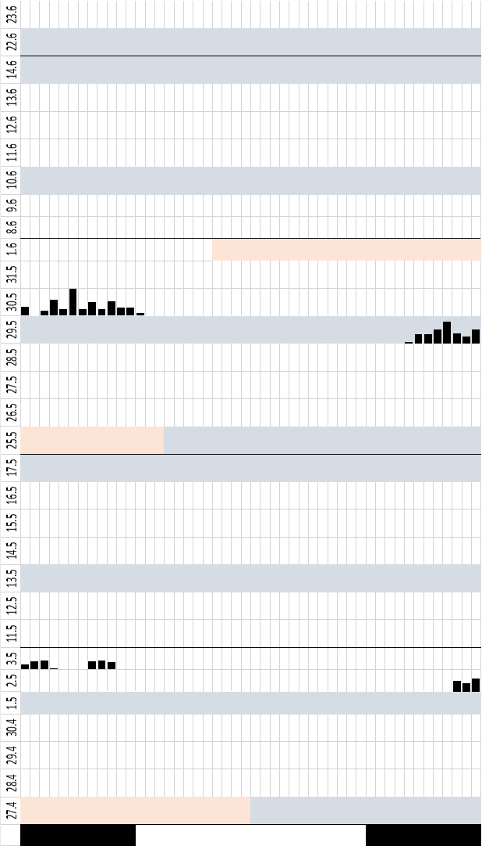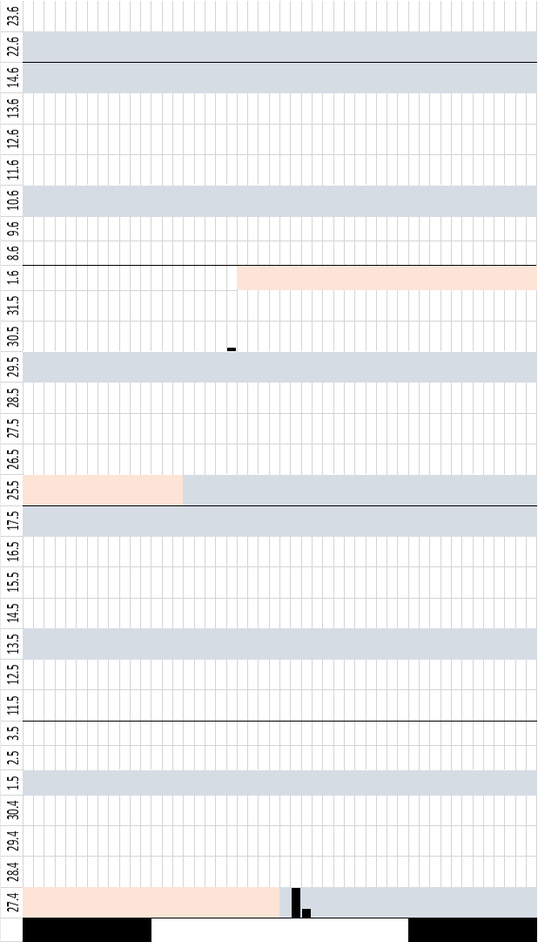
Season: Spring
ID: I004
ID: I005
ID: I003
Season: Spring
ID: I004
ID: I005
ID: I003

Actogram: Autumn
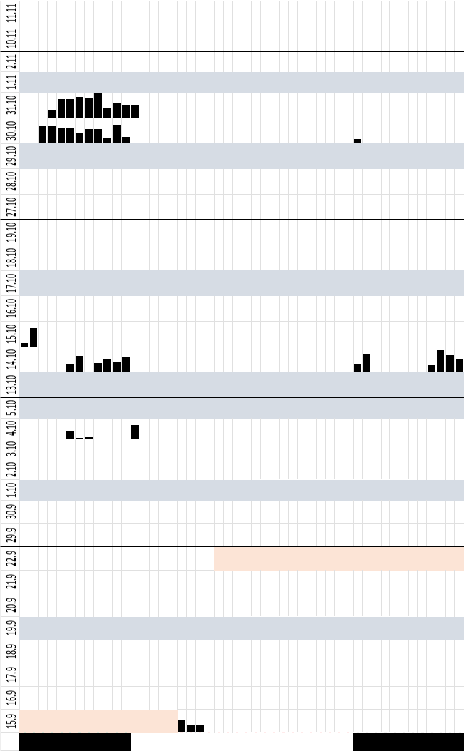
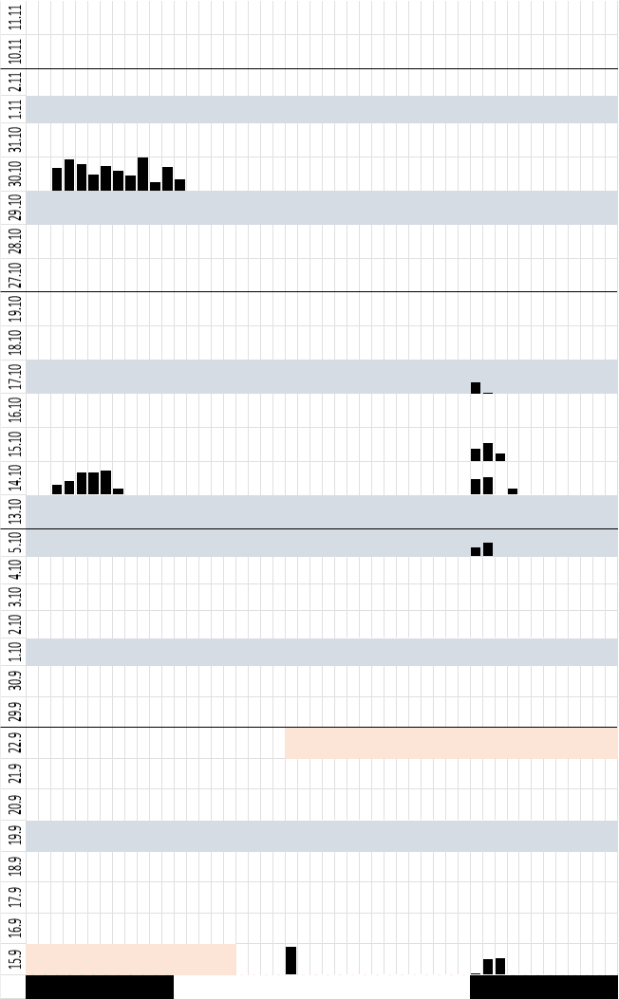
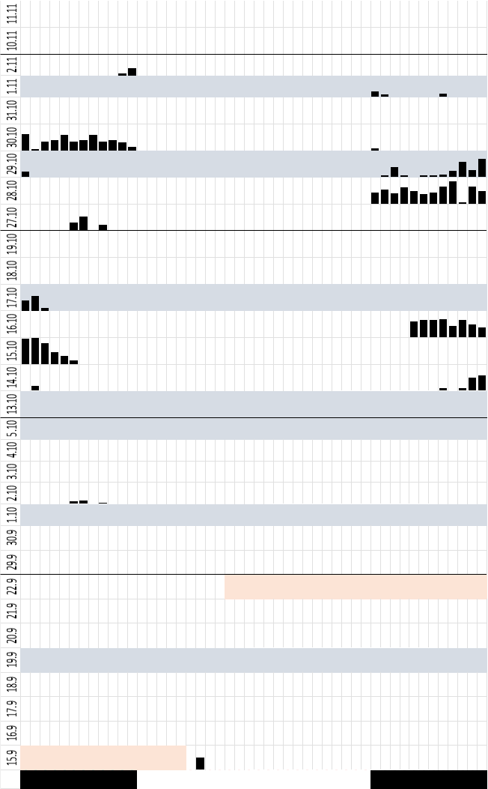
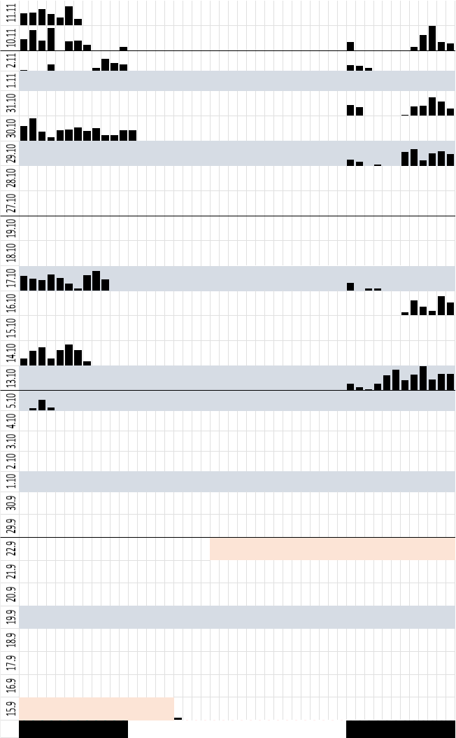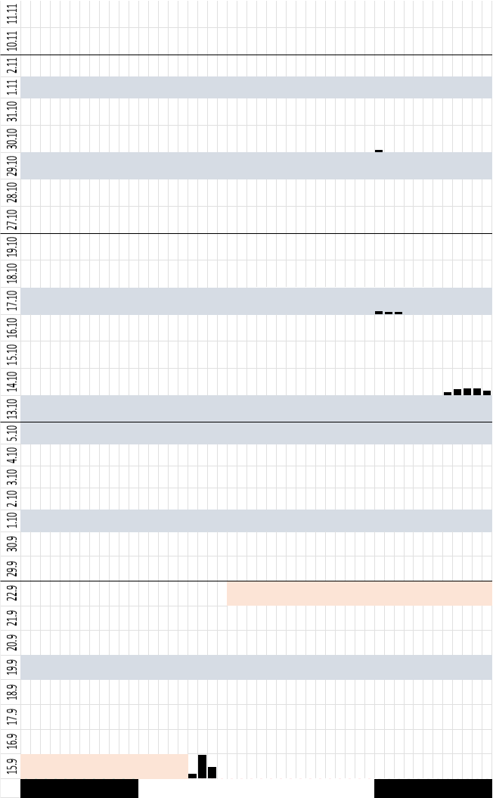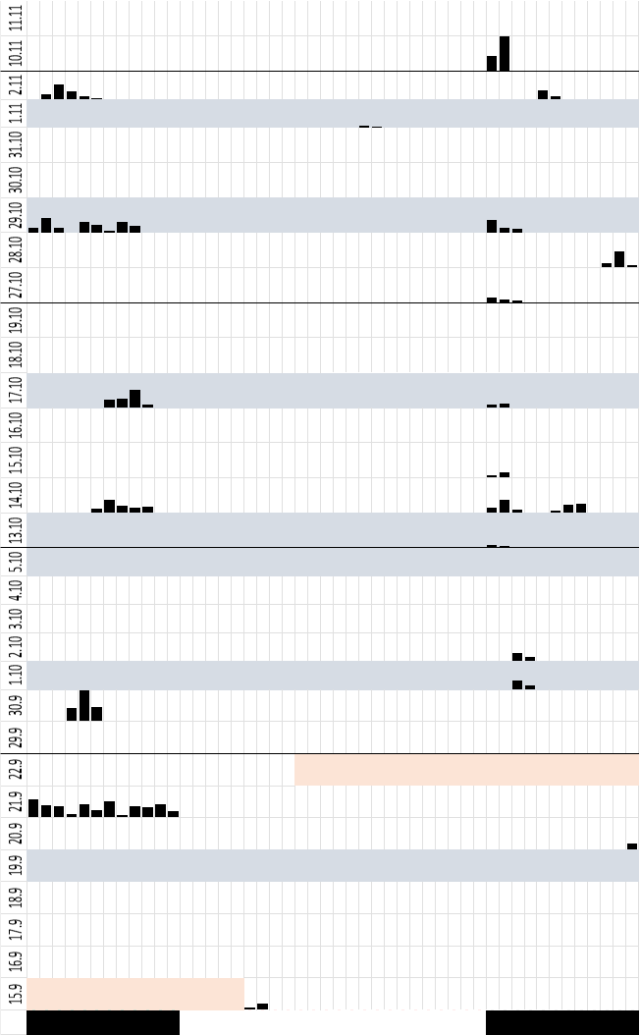
Season: Autumn
ID: II052
ID: II053
ID: II011
Season: Autumn
ID: II010
ID: II013
ID: II036

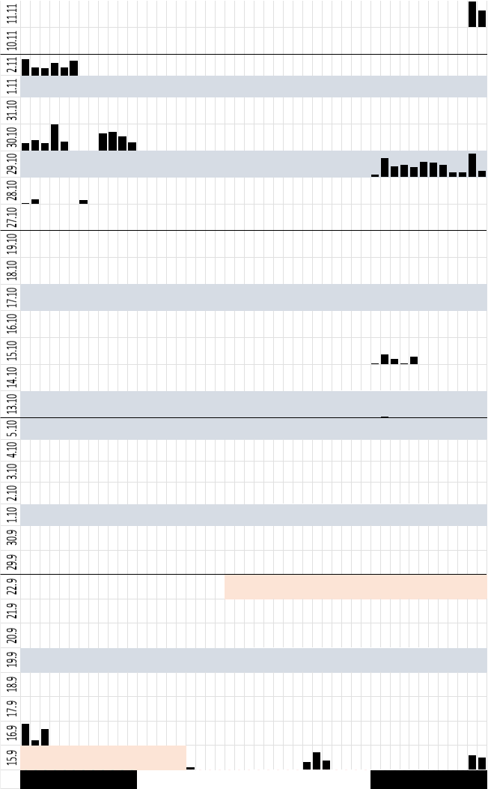
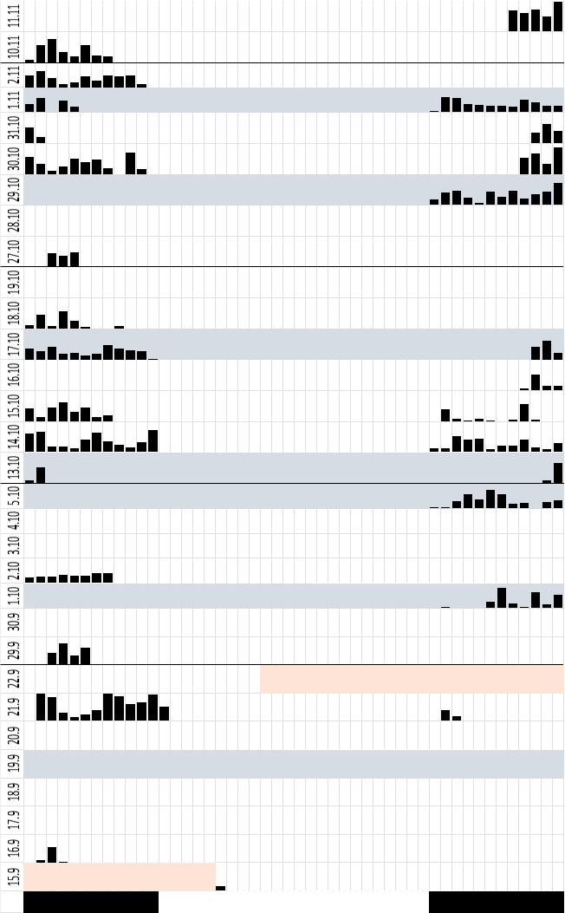
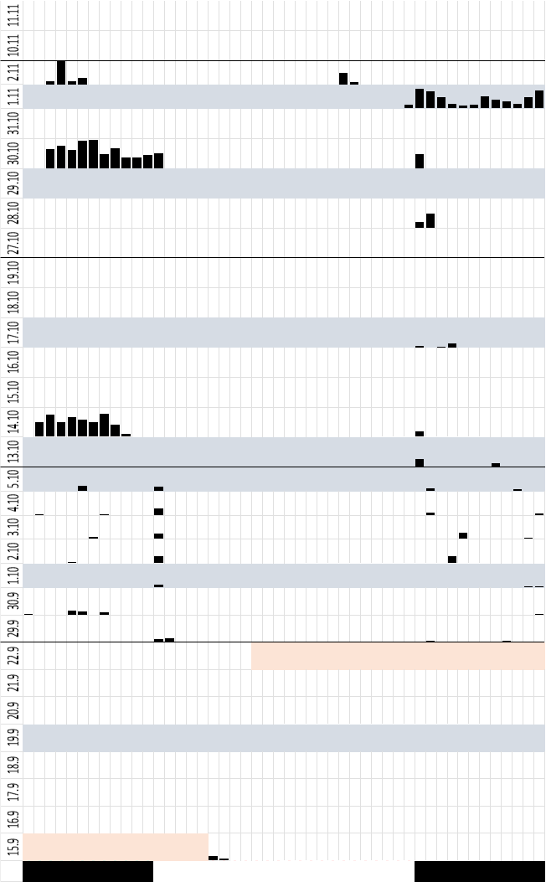
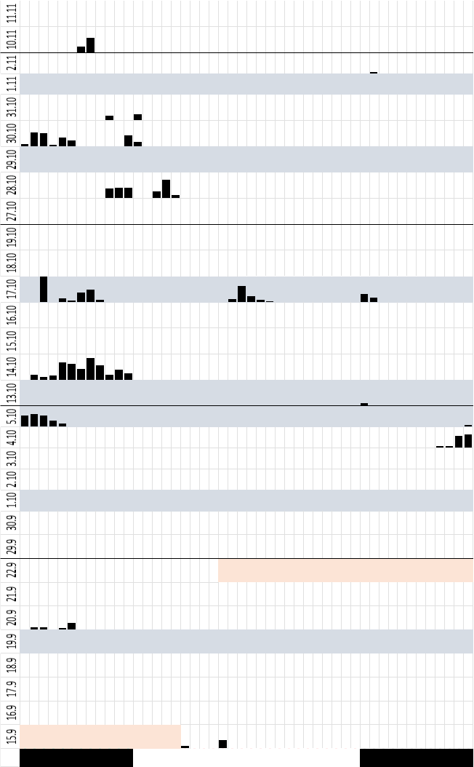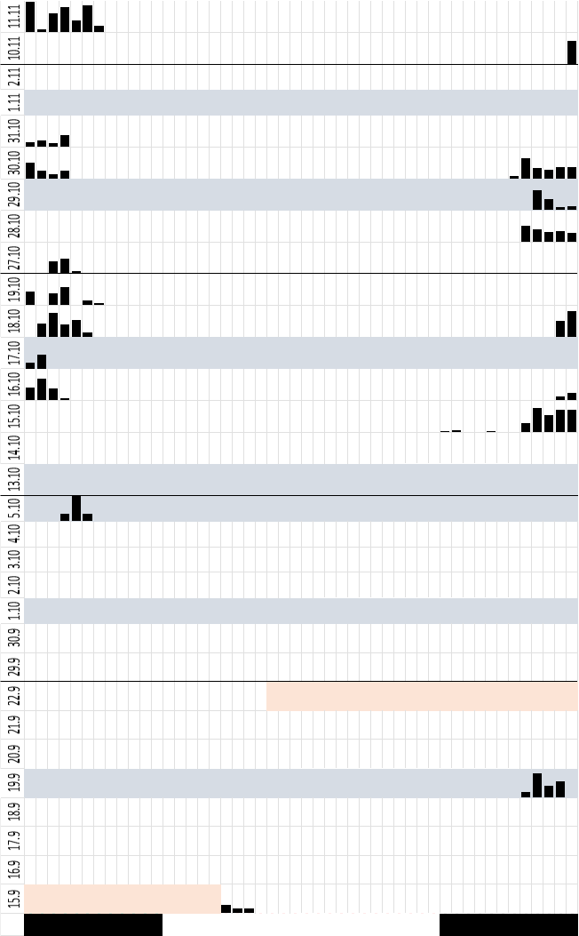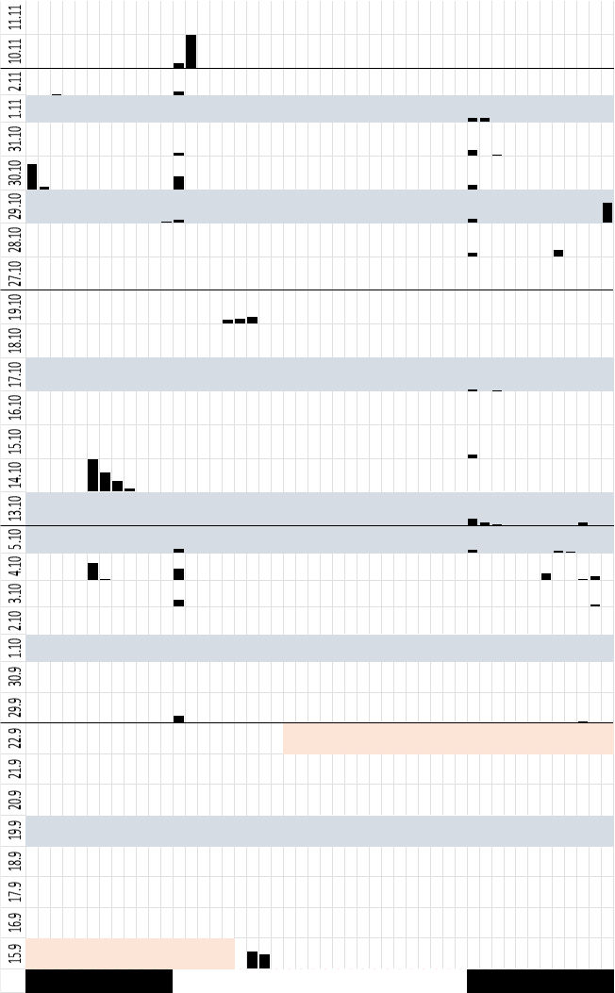
Season: Autumn
ID: II039
ID: II028
ID: II038
Season: Autumn
ID: II009
ID: II019
ID: II056

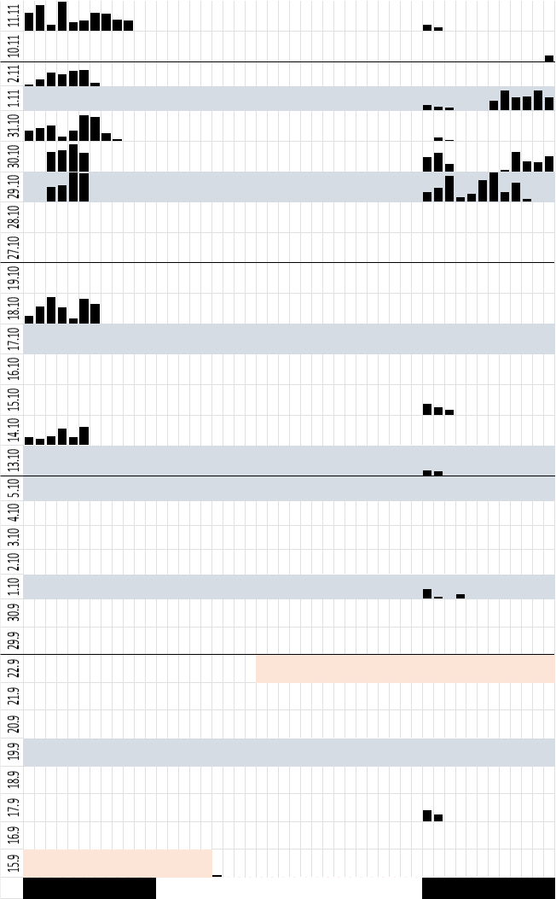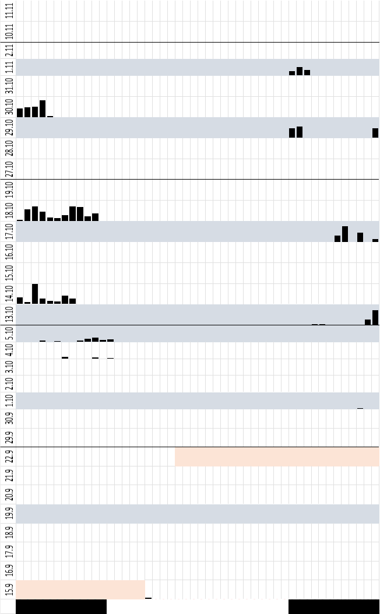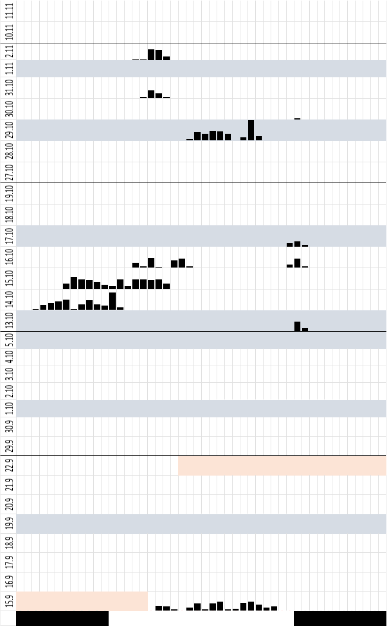
Season: Autumn
ID: II018
ID: II020
ID: II054

Supplementary Materials B: Tables

Table S1: Ethogram of all behaviours with description coded for the video analysis in BORIS.
Behaviour type | Code | Description
State event | Start of the observation
State event | Night activity | Focal individual is active during the night
State event | Night inactivity | Focal individual is inactive during the night
State event | Night out of sight | Focal individual is outside but not visible during the night
State event | Day activity | Focal individual is active during the day
State event | Day inactivity | Focal individual is inactive during the day
State event | Day Out of sight | Focal individual is outside but not visible during the day
State event | Neutral zone activity | Focal individual is active in the neutral side
State event | Neutral zone inactivity | Focal individual is inactive in the neutral side
State event | Neutral zone out of sight | Focal individual is in the neutral side but not visible.
State event | Moss side activity | Focal individual is active at the moss side
State event | Moss inactivity | Focal individual is inactive at the moss side
State event | Moss out of sight | Focal individual is in the moss side but not visible.
State event | Tissue zone activity | Focal individual is active at the tissue side
State event | Tissue inactivity | Focal individual is inactive at the tissue side
State event | Tissue out of sight | Focal individual is in the tissue side but not visible.
State event | Water dish | Focal individual spends time inside the water | Not used in analysis
State event | brick | Focal individual spends time on the brick | Not used in analysis
State event | wetbox | Focal individual spends time on the wetbox | Not used in analysis
State event | First choice | Time needed in video 1 after habituation to choose a hiding spot | Not used in analysis
Table S2: Test statistic of the Shapiro – Wilk – Test for the data sets temperature and humidity. If the p-value is < 0.05, the hypothesis that the data is normally distributed, is rejected.
Data | W | p-value
Temperature | 0.9773 | 0.001922
Humidity | 0.889 | 2.877e-11

Table S3: Estimated state-dependent parameters, i.e. the mean, standard deviation (sd) and the probability of having 0 activity (z), of the zero-adjusted gamma distribution for the activity data. State 1 indicates inactivity and state 2 activity.
 | State 1 | State 2
Activity mean | 0.726 | 4.754
Activity sd | 0.557 | 3.783
Activity z | 0.998 | 0.051

Table S4: Transition probability matrix between state 1, when fire salamanders were inactive, and state 2, when they were actively moving.
 | State 1 | State 2
State 1 | 0.995 | 0.005
State 2 | 0.176 | 0.824

Table S5: Descriptive data of temperature and humidity for both seasons summarised. Including the number of observations (n), the mean (x̄), the standard deviation (sd) and the median.
Temperature | n | x̄ | sd | median
Natural | 71 | 13.17 | 0.56 | 13.1
Artificial | 71 | 13.55 | 0.43 | 13.5
Wetbox | 66 | 13.13 | 0.44 | 13.2
Humidity
Natural | 71 | 90.11 | 5.87 | 90
Artificial | 71 | 83.37 | 4.34 | 83
Wetbox | 66 | 99.18 | 0.39 | 99

Table S6: Descriptive data of the proportion of the daily hiding for both seasons and all individuals summarised. Including the number of observations (n), the mean (x̄), the standard deviation (sd) and the median.
 | n | x̄ | sd | Median
Daily Hiding
natural | 30 | 00.91 | 0.19 | 1
wetbox | 30 | 0.08 | 0.19 | 0
brick | 30 | 0 | 0.01 | 0

Table S7: Descriptive data of the percentage of surface activity for both seasons and sex individually. Including the number of observations (n), the mean (x̄), the standard deviation (sd) and the median.
 | n | x̄ | sd | Median
Natural
Spring | 70 | 3.86 | 7.38 | 2.15
Autumn | 191 | 8.92 | 10.6 | 5.37
Artificial
Spring | 70 | 3.32 | 7.41 | 0.52
Autumn | 191 | 2.78 | 3.53 | 1.35
Neutral
Spring | 70 | 2.47 | 5.94 | 0.9
Autumn | 191 | 3.04 | 5.08 | 1.26
Sex
Natural
female | 143 | 9.9 | 12.35 | 4.64
male | 104 | 4.76 | 5.26 | 3.48
Artificial
female | 143 | 2.84 | 5.75 | 0.49
male | 104 | 3 | 3.55 | 1.72
Neutral
female | 143 | 2.74 | 5.91 | 1.01
male | 104 | 3.03 | 4.57 | 1.21

