Supplementary Figure S3. Complete nightly movement areas (NMA) of all tracked individuals of Phyllodactylus angustidigitus. Polygons represent NMAs derived from sequential GPS locations recorded during nocturnal tracking. Individuals tracked under warmer conditions (mean = 24.7 °C) (A). Individuals tracked under cooler conditions (mean = 19.2 °C) (B). The shaded polygon indicates the salt-encrusted area. Inset shows the study location within Paracas National Reserve.
A.
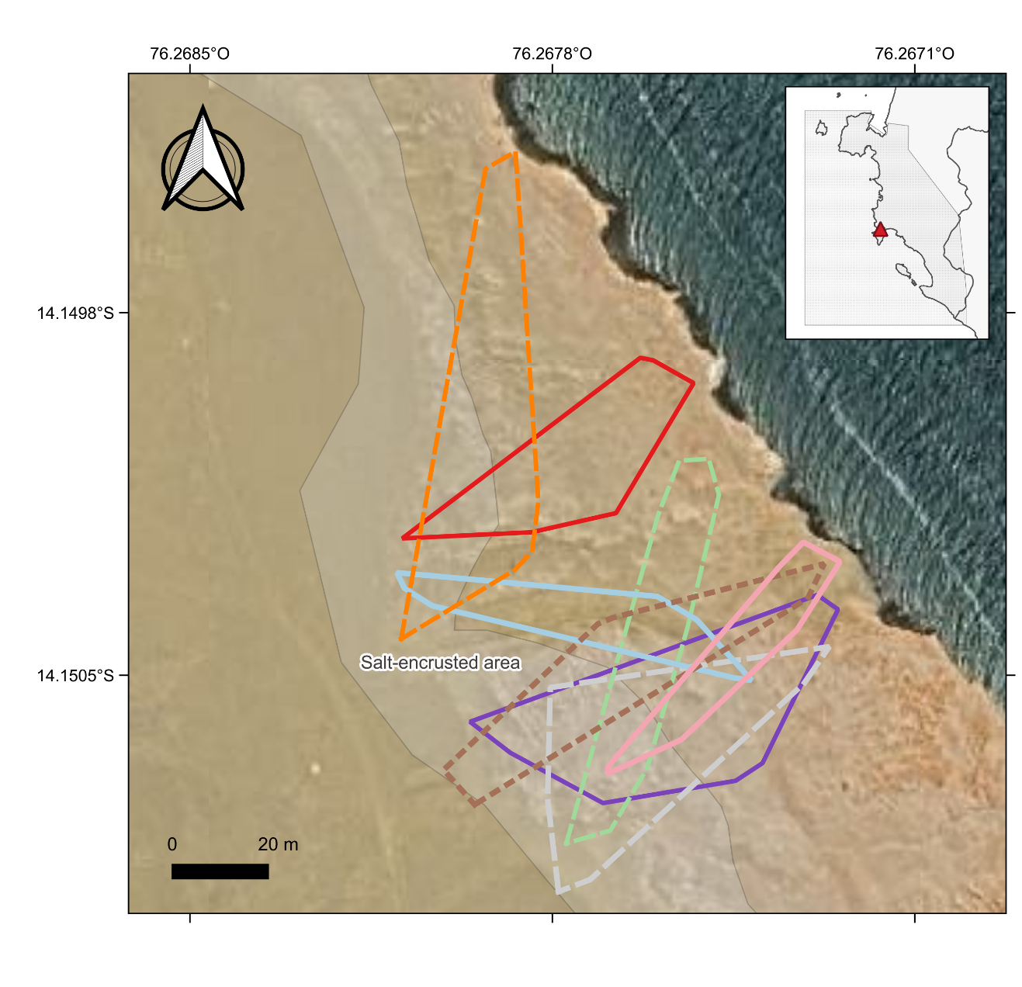

B.
