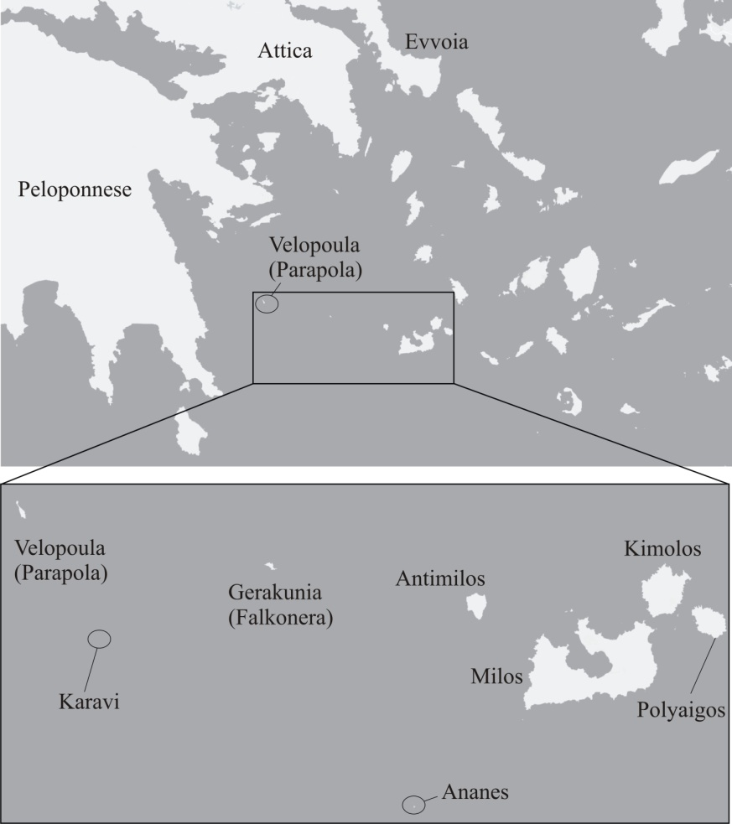

Supplementary Figure S1. Map of the islands constituting the Milos island –group and their position in the Aegean.

Supplementary Figure S2. Chronogram of the combined mitochondrial sequences obtained with BEAST analysis including one representative Podarcis erhardii per “species”, as delimited with mPTP, and closely related Podarcis taxa that were used in order to root and to calibrate the phylogeny (P. muralis, P. milensis, P. cretensis and P. peloponnesiacus). Numbers on each node give the respective time‐estimation as the mean value, bars represent the 95% HPD intervals [min–max] and correspond to the scale in million years at the bottom of the graphic. Numbers in italics show the respective nodal support (posterior probability values).

Supplementary Figure S3. Palaeogeographic reconstruction of the focal region during the Messinian (late Miocene) and the early Pliocene periods (Anastasakis et al., 2006). The approximate position of Velopoula is marked with an arrow.
Supplementary Table S1. List of specimens analyzed in this study. Specimen working codes and the respective collection localities are given in accordance with Figure 1. GenBank Accession Numbers for the sequences are provided. Working codes for specimens collected during this work are also the voucher numbers of the respective tissue-samples that have been deposited in the collections of the Zoological Museum of the University of Patras (ZMUP).

Working Code | Species | Locality | cytb | 16S
Sequences produced here
322 | Podarcis erhardii | Geraneia Mt. east Attica | PQ591863 | PQ567217
372 | Podarcis erhardii | Mikri Vigla, Naxos isl. | PQ591864 | PQ567218
406 | Podarcis erhardii | Dam, Serifos isl. | PQ591865 | PQ567219
415 | Podarcis erhardii | Kolibithra, Tinos isl. | n.a. | PQ567220
500 | Podarcis erhardii | Geraneia Mt. east Attica | PQ591866 | PQ567221
501 | Podarcis erhardii | Geraneia Mt. east Attica | PQ591867 | PQ567222
502 | Podarcis erhardii | Geraneia Mt. east Attica | PQ591868 | PQ567223
546 | Podarcis erhardii | Feneos lake, Peloponnese | PQ591869 | PQ567224
547 | Podarcis erhardii | Feneos lake, Peloponnese | PQ591870 | PQ567225
548 | Podarcis erhardii | Feneos lake, Peloponnese | PQ591871 | PQ567226
553 | Podarcis erhardii | Karystos, Evvoia | PQ591872 | PQ567227
554 | Podarcis erhardii | Karystos, Evvoia | PQ591873 | PQ567228
556 | Podarcis erhardii | Paradisi, Evvoia | PQ591874 | PQ567229
624 | Podarcis erhardii | Velopoula islet | PQ591875 | PQ567230
625 | Podarcis erhardii | Velopoula islet | PQ591876 | PQ567231
626 | Podarcis erhardii | Velopoula islet | PQ591877 | PQ567232
627 | Podarcis erhardii | Velopoula islet | PQ591878 | PQ567233
628 | Podarcis erhardii | Velopoula islet | PQ591879 | PQ567234
629 | Podarcis erhardii | Velopoula islet | PQ591880 | PQ567235
630 | Podarcis erhardii | Velopoula islet | n.a. | PQ567236
631 | Podarcis erhardii | Velopoula islet | PQ591881 | PQ567237
635 | Podarcis erhardii | Stefania islet | PQ591882 | PQ567238
Sequences retrieved from GenBank

From Poulakakis et al. (2003) and Poulakakis et al. (2005) - Working codes and information as presented therein
48 | P. e. riveti | Makedonia (Grevena) | AY896059 | AY896195
49 | P. e. thessalica | Evoia (Kryoneritis) | AY896060 | AY896196
50 | P. e. thessalica | Thessalia (Plastira) | AY896061 | AY896197
51 | P. e. thessalica | Thessalia (Sarantaporos) | AY896062 | AY896198
52 | P. e. riveti | Sterea Ellada (Gkiona) | AY896064 | AY896199
55 | P. e. riveti | Makedonia (Sidironero) | AY896087 | AY896202
57 | P. e. riveti | Serbia (Gostivach) | AY896070 | AY896204
60 | P. e. riveti | Serbia (Makrovi) | AY896073 | AY896207
61 | P. e. riveti | Skopje (Tettovo) | AY896075 | AY896208
67 | P. e. riveti | Skopje (Oxrida) | AY896083 | AY896214
70 | P. e. ruthveni | N Sporades (Alonisos isl.) | AY896091 | AY896217
71 | P. e. ruthveni | N Sporades (Gioura isl.) | AY896092 | AY896218
72 | P. e. ruthveni | N Sporades (Skopelos isl.) | AF486230 | AY896219
75 | P. e. syrinae | Cyclades (Astypalaia isl.) | AF486223 | AY896222
79 | P. e. mykonensis | Cyclades (Syros isl.) | AY896093 | AY896226
80 | P. e. mykonensis | Cyclades (Tinos isl.) | AY896094 | AY896227
81 | P. e. naxensis | Cyclades (Koufonisi isl.) | AY896096 | AY896228
82 | P. e. erhardii | Cyclades (Serifos isl.) | AY896098 | AY896229
83 | P. e. mykonensis | Cyclades (Mykonos isl.) | AY896099 | AY896230
84 | P. e. naxensis | Cyclades (Ios isl.) | AY896100 | AY896231
86 | P. e. megalophthenae | Cyclades (Meg. Fteno isl.) | AY896103 | AY896233
87 | P. e. biinsulicola | Cyclades (Mikro Fteno isl.) | AY896104 | AY896234
88 | P. e. naxensi | Cyclades (Nea Kameni isl.) | AY896105 | AY896235
89 | P. e. naxensi | Cyclades (Thirasia isl.) | AY896106 | AY896236
90 | P. e. naxensis | Cyclades (Sxoinousa isl.) | AY896107 | AY896237
91 | P. e. erhardii | Cyclades (Sifnos isl.) | AY896108 | AY896238
92 | P. e. syrinae | Cyclades (Dio Adelfia isl.) | AY896110 | AY896239
93 | P. e. syrinae | Cyclades (Syrna isl.) | AY896113 | AY896240
94 | P. e. zafranae | Cyclades (Zofrano isl.) | AY896114 | AY896241
95 | P. e. mykonensis | Cyclades (Andros isl.) | AY896115 | AY896242
From Salvi et al. (2021)
3819 | P. erhardii | Thirasia islet, Santorini | MW619424 | MW619285
From Psonis et al. (2017)
658 | P. erhardii | Crnovska River, Serbia | KX657877 | KX658179
636 | P. erhardii | Former Yugoslavian Republic of Macedonia | KX657876 | KX658178
Outgroups
 | P. peloponnesiacus | Psonis et al. (2017) | KX657923 | KX658225
 | P. cretensis | Salvi et al. (2021) | MW619422 | MW619283
 | P. milensis | Psonis et al. (2017) | KX657913 | KX658215
 | P. muralis | Psonis et al. (2017) | KX657921 | KX658223

Supplementary Table S2. Primers from Palumbi, 1996 and PCR conditions for the amplification of the mitochondrial markers, cytochrome b (cytb) and 16S rRNA (16S). Sequencing was performed in Macrogen Europe.
Marker | Primers | Primer sequence | Product length (bps) | PCR- conditions
35 cycles of:
95^{ο}C for 5 min
cytb | GLUDG | 5΄-TGACTTGAARAACCAYCGTTG-3΄ |  | 95^{ο}C for 1 min
cytb | CB2 | 5΄-CCCTCAGAATGATATTGTCCTCA-3΄ | ~500 | 47^{ο}C for 1 min or
16S | 16SAr-L | 5΄-CGGCCGCCTGTTTATCAAAAACAT-3΄ | ~500 | 55^{ο}C for 1 min
16S | 16SBr-H | 5΄-GGAGTCCCGGTTTGAACTCAGATC-3΄ |  | 72^{ο}C for 45 sec  (1.5 mM of MgCl₂)

Supplementary Table S3. Partitions and models used in the respective analyses.

Analysis | Best partitoniong scheme | Best model | Reference
Maximum Likelihood – IQTREE | 1st cytb+2nd cytb+3rd cytb+16S  (single partition) | TIM2+F+G | Kalyaanamoorthy et al., 2017
Bayesian Inference – BEAST | 1st cytb+2nd cytb+3rd cytb+16S  (single partition) | TN+FO+G | Tamura & Nei, 1993
Divergence-times estimation – BEAST (reduced dataset – one sequence per “species”) | 1st cytb+2nd cytb+3rd cytb+16S  (single partition) | TN+FO+G | Tamura & Nei, 1993
F = Empirical state frequency observed from the data
FO = State frequency optimized by maximum-likelihood from the data
G = Gamma distribution

Supplementary Table S4. Genetic diversity between pairs of phylogenetic clades retrieved in our analyses, calculated as net uncorrected pairwise p-distances (mean values given in %). The lower left diagonal shows values estimated for cytb and the upper right one for 16s, respectively. Values estimated between Velopoula and all other clades, are marked with orange (cytb) and green (16s).

Clade | Genetic distances
Balkan Peninsula |  | 1.3 | 1.4 | 3.0 | 2.6 | 2.8 | 3.1 | 3.6 | 2.9 | 3.1 | 4.8
Serbia | 4.1 |  | 0.9 | 2.5 | 1.7 | 1.9 | 2.2 | 2.7 | 2.0 | 2.6 | 4.3
Sporades | 4.8 | 5.9 |  | 3.0 | 2.1 | 2.4 | 2.7 | 3.2 | 2.5 | 3.1 | 4.8
Velopoula | 9.8 | 9.7 | 9.7 |  | 2.2 | 2.6 | 2.9 | 3.5 | 2.7 | 4.0 | 5.6
West Cyclades | 10.3 | 9.8 | 10.4 | 7.4 |  | 0.9 | 1.2 | 1.7 | 1.2 | 3.3 | 4.3
South Cyclades | 8.5 | 9.7 | 9.6 | 7.6 | 7.1 |  | 1.2 | 1.5 | 1.5 | 3.9 | 4.4
Central Cyclades | 11.7 | 11.9 | 10.6 | 7.9 | 7.6 | 7.0 |  | 2.0 | 1.6 | 4.2 | 5.2
Peoloponnes & Attica | 9.7 | 10.3 | 9.9 | 6.7 | 5.8 | 6.1 | 5.9 |  | 0.9 | 4.3 | 4.8
South Evvoia | 9.2 | 10.0 | 9.3 | 7.7 | 6.7 | 6.0 | 6.9 | 2.6 |  | 3.6 | 4.5
Podarcis peloponnesiacus | 11.9 | 13.7 | 13.1 | 11.5 | 13.1 | 11.8 | 12.4 | 12.8 | 12.8 |  | 3.1
Podarcis cretensis | 13.7 | 15.3 | 14.4 | 13.1 | 15.5 | 14.8 | 14.9 | 13.8 | 14.1 | 6.9

References
Anastasakis, G., D. J. W. Piper, M. D. Dermitzakis & V. Karakitsios (2006): Upper Cenozoic stratigraphy and peleogeographic evolution of Myrtoon and adjacent basins, Aegean Sea, Greece. – Marine and Petroleum Geology, 23: 353 – 369.
Kalyaanamoorthy, S., B. Q. Minh, T. K. F. Wong, A. Von Haeseler & L. S. Jermiin (2017): ModelFinder: fast model selection for accurate phylogenetic estimates. – Nature Methods, 14: 587 – 589.
Palumbi, S. R. (1996): Nucleic acids II: the polymerase chain reaction. In D.M. Hillis, C. Moritz, B.K. Mable (Eds.), Molecular Systematics (pp. 205-248). – Sinauer Ltd, Sunderland, Masachousette, U.S.A.
Poulakakis, N., P. Lymberakis, A. Antoniou, D. Chalkia, E. Zouros, M. Mylonas & E. Valakos (2003): Molecular phylogeny and biogeography of the wall-lizard Podarcis erhardii (Squamata: Lacertidae). – Molecular Phylogenetics and Evolution, 28: 38 – 46.
Poulakakis, N., P. Lymberakis, E. Valakos, E. Zouros & M. Mylonas (2005): Phylogenetic relationships and biogeography of Podarcis species from the Balkan Peninsula, by bayesian and maximum likelihood analyses of mitochondrial DNA sequences. – Molecular Phylogenetics and Evolution, 37: 845 – 857.
Salvi, D., C. Pinho, J. Mendes & D.J. Harris (2021): Fossil-calibrated time tree of Podarcis wall lizards provides limited support for biogeographic calibration models. –Molecular Phylogenetics and Evolution, 161: 107 – 169.
Psonis, N., A. Antoniou, O. Kukushkin, D. Jablonski, B. Petrov, J. Crnobrnja-Isailovíc, K. Sotiropoulos, I. Gherghel, P. Lymberakis & N. Poulakakis (2017): Hidden diversity in the Podarcis tauricus (Sauria, Lacertidae) species subgroup in the light of multilocus phylogeny and species delimitation. – Molecular Phylogenetics and Evolution, 106: 6 – 17.
Tamura, K. & M. Nei (1993): Estimation of the number of nucleotide substitutions in the control region of mitochondrial DNA in humans and chimpanzees. – Molecular Biology and Evolution, 10: 512 – 526.

