Supplementary material 1. Accession numbers of the DNA sequences of the American pitviper species included in the analysis.
Species | 12s | 16s | CytB | ND4 | Atapasa | RAG1
Agkistrodon bilineatus | AF057230 | AF156570 | EU483408 | AF156583 | FJ417940 | AF156583
Agkistrodon contortrix | MK313326 | MK313353 | EU483410 | MK313438 | FJ417907 | MK313438
Agkistrodon howardgloydi | AF156594 | AF156571 |  | AF156585 |  | AF156585
Agkistrodon piscivorus | AF259225 | AF259118 | KC431028 | AF156579 | FJ417957 | AF156579
Agkistrodon russeolus | L01766 | AF156573 |  | AF156586 |  | AF156586
Agkistrodon taylori | AF156590 | AF156569 | EU483477 | AF156581 | FJ417942 | AF156581
Atropoides picadoi | AF057208 | AF057255 | AY220323 | AY220346 |  | AY220346
Bothriechis aurifer | MK313319 | MK313339 | DQ305466 | MK313447 |  | MK313447
Bothriechis bicolor | MK313316 | MK313337 | DQ305467 | MK313445 |  | MK313445
Bothriechis guifarroi | MK313315 | MK313336 | KC847275 | MK313441 |  | MK313441
Bothriechis lateralis | MK313313 | MK313334 | AF292572 | AF292610 |  | AF292610
Bothriechis marchi | DQ305428 | DQ305451 | DQ305469 | DQ305486 |  | DQ305486
Bothriechis nigroviridis | MK313325 | MK313346 | MK313554 | MK313444 |  | MK313444
Bothriechis nubestris | MK313324 | MK313345 | MK313553 | MK313442 |  | MK313442
Bothriechis rowleyi | MK313321 | MK313341 | MK313547 | MK313449 |  | MK313449
Bothriechis schlegelii | MK313305 | MK313331 | MK313539 | MK313435 |  | MK313435
Bothriechis supraciliaris | MK313306 | MK313332 | MK313541 | MK313437 |  | MK313437
Bothriechis thalassinus | MK313318 | MK313342 | MK313550 | MK313450 |  | MK313450
Bothrocophias campbelli |  |  | AF191582 | AF292622 |  | AF292622
Bothrocophias colombianus |  |  | AF292602 | AF292640 |  | AF292640
Bothrocophias hyoprora | AF057206 | AF057253 | AY223593 | AF292614 |  | AF292614
Bothrocophias lojanus |  |  | FR691566 | FR691536 |  | FR691536
Bothrocophias microphthalmus | AY223657 | AY223670 | FR691565 | AF292615 |  | AF292615
Bothrocophias myrringae |  |  | OP082447 | OP082452
Bothrocophias tulitoi |  |  | OP082448 | OP082453
Bothrops alternatus | AY223660 | MH697948 | EU867273 | AF292617 |  | AF292617
Bothrops ammodytoides | AY223658 | AY223671 | AY223595 | AY223639 |  | AY223639
Bothrops asper | AF057218 | AF057265 | HE867043 | AF292638 |  | AF292638
Bothrops atrox | MK313303 | MK313329 | MK313537 | MK313433 |  | MK313433
Bothrops barnetti |  |  | OP609935 | OP609946
Bothrops bilineatus | MH697893 | MH697955 | AY223591 | AF292630 |  | AF292630
Bothrops brazili | MN296324 | MN296338 | MN296435 | MN296448 |  | MN296473
Bothrops chloromelas | DQ305430 | DQ305453 | DQ305471 | DQ305488 |  | DQ305488
Bothrops cotiara | AF057217 | AF057264 | AY223597 | AF292619 |  | AF292619
Bothrops diporus | DQ305431 | DQ305454 | DQ305472 | DQ305489 |  | DQ305489
Bothrops erythromelas | MH697937 | MH697997 | AY223600 | AF292626 |  | AF292626
Bothrops fonsecai | KX694552 | KX694621 | AF292580 | AF292618 |  | AF292618
Bothrops itapetiningae | EU867253 | EU867265 | AF292582 | AF292620 |  | AF292620
Bothrops jararaca | MH697938 | MH697999 | AY865818 | AF292627 |  | AF292627
Bothrops jararacussu | KX694553 | AY223674 | AY223602 | AY223643 |  | AY223643
Bothrops jonathani |  |  | OP609937
Bothrops leucurus | MH697943 | MH698003 | MH698090 | AF246279 |  | AF246279
Bothrops lutzi | MH697944 | MH698005 | MH698088 | MH698239 |  | MH698239
Bothrops marajoensis |  |  | AF292605 | AF292643 |  | AF292643
Bothrops marmoratus |  |  |  | KF801265 |  | KF801265
Bothrops mattogrossensis |  |  |  | FN431769 |  | FN431769
Bothrops monsignifer |  |  | OP609938 | OP609948
Bothrops moojeni | EU867258 | EU867269 | AF200222 | AF292644 |  | AF292644
Bothrops muriciensis | MN296333 | MN296346 | MN296444 | MN296456 |  | MN296456
Bothrops neuwiedi |  | MN276221 | KF801162 | KF801287 |  | KF801287
Bothrops oligobalius | MN296327 | MN296341 |  | MH698230 |  | MH698314
Bothrops oligolepis |  | KX660260 |  | KX660646 |  | KX660646
Bothrops osbornei | KU999231 | KU999160 | AF292595 | AF292633 |  | AF292633
Bothrops pauloensis | EU867260 | EU867272 | OP609940 | EU867296 |  | EU867296
Bothrops pictus |  |  | OP609941 | AF292621 |  | AF292621
Bothrops pirajai | MN296334 | MN296348 | OP609942 | MN296457 |  | MN296457
Bothrops pubescens | JN870180 | JN870192 | JN870200 | JN870206 |  | JN870206
Bothrops pulcher | JN870179 |  | AF292593 | AF292631 |  | AF292631
Bothrops punctatus | KU999239 | KU999164 | KU999116 | AF292632 |  | AF292632
Bothrops sazimai |  |  | OP609943 | OP609953
Bothrops sonene | OP616739 | OP616734 | OP609944 | OP609954
Bothrops taeniatus | KX694566 | MH698007 | AY223592 | AF292629 |  | AF292629
Bothrops venezuelensis |  |  | MG265697 | MG265803 |  | MG265803
Cerrophidion godmani | MK313309 | MK313349 | MK313556 | MK313455 |  | MK313455
Cerrophidion petlalcalensis | DQ305420 | DQ305443 | DQ061202 | DQ061227 |  | DQ061227
Cerrophidion sasai | AF057203 | AF057250 | AY223578 | U41879 |  | U41879
Cerrophidion tzotzilorum | JN870182 | JN870193 | DQ061203 | DQ061228 |  | DQ061228
Cerrophidion wilsoni | JQ724145 | JQ627129 | JQ724157 | JQ724170 |  | JQ724170
Crotalus adamanteus | NC041524 | NC041524 | NC041524 | NC041524 |  | NC041524
Crotalus aquilus | AF259232 | AF259125 |  | HQ257772 | HQ257641 | HQ257772
Crotalus armstrongi | HQ257623 |  |  | HQ257868 | HQ257654 | HQ257868
Crotalus atrox | AF057225 | AF259150 | AY223608 | DQ679841 | HQ316631 | DQ679841
Crotalus basiliscus | AF259244 | AF259136 | AY704844 | AY704894 |  | AY704894
Crotalus campbelli | HQ257564 |  |  | HQ257810 |  | HQ257810
Crotalus cerastes | AF259235 | AF259128 | AF259165 | MK313458 | DQ493803 | MK313458
Crotalus cerberus |  |  | AF147859 | JN620963 | KX095994 | JN620963
Crotalus concolor | AY016042 |  | MH122690 | MN058589 | AF462360 | MN058589
Crotalus culminatus |  |  | AY704828 | AY704878 |  | AY704878
Crotalus durissus |  | JQ627284 | AY704811 | AY704861 |  | AY704861
Crotalus ehecatl |  |  | MN067346 | MN067380 |  | MN067380
Crotalus enyo | AF259245 | AF259137 |  |  | KF410271
Crotalus ericsmithi |  |  | KF410284 | KF410289 |  | KF410289
Crotalus helleri | AY016032 |  | JN620814 | AF194152 | AF462375 | AF194152
Crotalus horridus | NC014400 | NC014400 | NC014400 | NC014400 |  | NC014400
Crotalus intermedius gloydi | JN022925 |  |  | JN022855 | JN022801 | JN022855
Crotalus intermedius intermedius | AF259238 | AF259131 |  | JN022856 | JN022805 | JN022856
Crotalus intermedius omiltemanus | JN022912 |  |  | JN022857 | N022802 | JN022857
Crotalus lannomi |  |  | KF410280 | KF410291 |  | KF410291
Crotalus lepidus | HQ257533 |  |  | JN620966 | HQ257658 | JN620966
Crotalus lutosus
Crotalus mictlantecuhtli | AF259250 |  | MN067343 | MN067388 |  | MN067388
Crotalus mitchelli |  | AF259142 | JN620817 | JN620967 | DQ493761 | JN620967
Crotalus molosus molosus | AF259243 | AF057271 | AY704847 | AY704898 |  | AY704898
Crotalus molosus nigrescens |  | AF259135 | AY704841 | AY704891 |  | AY704891
Crotalus molosus oaxacus |  |  | AY704843 | AY704893 |  | AY704893
Crotalus morulus | HQ257618 |  |  | HQ257863 | HQ257648 | HQ257863
Crotalus helleri | AY016032 |  | JN620814 | AF194152 | AF462375 | AF194152
Crotalus lutosus | DQ020025 |  | AF147864 | AF194156 | AF462365 | AF194156
Crotalus oreganus | DQ020024 |  | AF147870 | AF194161 | AF462372 | AF194161
Crotalus ornatus |  |  | MN067339 | MN067378 |  | MN067378
Crotalus polystictus | AF259236 | AF259129 | KF410281 | KF410294 | JF748393 | KF410294
Crotalus pricei miquihuanus | JN022932 | AF259130 |  | JN022843 | JN022792 | JN022843
Crotalus pricei pricei | JN022899 |  |  | JN022850 | JN022793 | JN022850
Crotalus pusillus | AF259229 | AF259122 | AF259159 | HQ257774 | HQ257695 | HQ257774
Crotalus pyrrhus | AF259250 | AF259142 | JN620817 | JN620967 | DQ493772 | JN620967
Crotalus ravus brunneus | HQ257576 |  |  | HQ257833 | HQ257700 | HQ257833
Crotalus ravus ravus | HQ257578 | AF057273 | AF259158 | HQ257823 | HQ257697 | HQ257823
Crotalus ruber exiguus | HQ257575 | AF259152 |  | HQ257820 | HQ257697 | HQ257820
Crotalus ruber exsul | AF259260 |  |  |  | DQ493802
Crotalus ruber ruber | AF259261 | AF259153 | KP765661 | DQ679838 | DQ493799 | DQ679838
Crotalus scutulatus salvini |  |  |  | MH883656
Crotalus scutulatus scutulatus | AF259254 | AF259146 | MH122688 | MH122676 |  | MH122676
Crotalus simus | EU624240 | EU624274 | MN067353 | MN067392 |  | MN067392
Crotalus stejnegeri |  |  | KF410283 | KF410295 |  | KF410295
Crotalus stephensi |  |  |  |  | DQ493763
Crotalus tancitarensis | JN022897 |  |  | JN022842 | JN022800 | JN022842
Crotalus tigris | AF259249 | AF259141 | AY223606 | AF156574 | DQ493815 | AF156574
Crotalus tlaloci | HQ257629 |  |  | HQ257874 |  | HQ257874
Crotalus totonacus |  |  | AY704837 | AY704887 |  | AY704887
Crotalus transversus | AF259239 |  | AF259169 | JN022840 | JN022789 | JN022840
Crotalus triseriatus | HQ257515 | AF259124 |  | HQ257879 | HQ257644 | HQ257879
Crotalus tzabcan |  |  | MN067369 | MN067408 |  | MN067408
Crotalus vegrandis | AF259247 | AF259139 | AY704824 | AY704874 |  | AY704874
Crotalus viridis | AY016025 |  | MH122692 | AF194157 | AF462367 | AF194157
Crotalus willardi | KX694609 | KX694682 | AF259171 | KF410298 | DQ131112 | KF410298
Lachesis acrochorda | JN870187 | JN870197 | JN870204 | JN870212 |  | JN870212
Lachesis melanocephala |  |  | U96018 | U96028
Lachesis muta | MK313327 | MK313347 | AY223604 |  |  | U41885
Lachesis stenophrys | AF057220 | AF057267 | AY223603
Metlapilcoatlus borealis |  |  | MW729752 | MW729737
Metlapilcoatlus indomitus |  |  |  | KX638451 |  | KX638451
Metlapilcoatlus mexicanus | KC847268 | KC847255 | KC847271 | KC847289 |  | KC847289
Metlapilcoatlus nummifer | MK313308 | MK313348 | AY220306 | AY220333 |  | AY220333
Metlapilcoatlus occiduus | DQ305423 | DQ305446 | DQ061194 | DQ061219 |  | DQ061219
Metlapilcoatlus olmec | AY223656 | AY223669 | AY223585 | DQ061221 |  | DQ061221
Mixcoatlus barbouri | HM363639 | HM363640 | HM363641 | HM363642 |  | HM363642
Mixcoatlus browni | HM363643 | HM363648 | HM363649 | HM363646 |  | HM363646
Mixcoatlus melanurus | MK313311 | MK313351 | MK313559 | MK313457 |  | MK313457
Ophryacus undulatus | MK313312 | MK313352 | MK313560 | MK313452 |  | MK313452
Porthidium arcosae | EU624241 | GQ372871 | AF292575 | AF292613 |  | AF292613
Porthidium dunni | MK313310 | MK313350 | MK313558 | MK313456 |  | MK313456
Porthidium hespere |  |  |  | EU017534
Porthidium lansbergii | AY223655 | AY223668 | MN389244 | AY223631 |  | AY223631
Porthidium nasutum | AF057204 | KX694658 | AF292574 | U41887 |  | U41887
Porthidium ophryomegas | AF057205 | AF057252 | AY223580 | DQ061241 |  | DQ061241
Porthidium porrasi | DQ305421 | DQ305444 | DQ061211 | DQ061236 |  | DQ061236
Porthidium yucatanicum | JN870189 | JN870198 | DQ061215 | DQ061244 |  | DQ061244
Sistrurus catenatus | AF259226 | AF057274 | GQ359782 | MH122678 | HQ257638 | MH122678
Sistrurus miliarius | AF259227 | AF057275 | AF259157 | U41889 | HQ257639 | U41889
Sistrurus tergeminus |  |  | GQ359785 | AY223648 | FJ659879

Points of calibration selected to date the mc tree under log-normal molecular clock.
Stem Agkistrodon: LogNormal (mean = 0.01, sd = 0.42, offset =6.0) based on the last common ancestor of the genus dated at 8 Mya (Holman, 2000). Stem Crotalus viridis complex: LogNormal (mean = 0.01, sd = 0.6, offset =5.0) based on the last common ancestor of Crotalus viridis + Crotalus cerberus + Crotalus oreganus in late Pliocene 2.5 Mya (Holman, 2000). Divergence between Crotalus and Sistrurus: LogNormal (mean = 3.0, sd = 0.4, offset =0.0) based on the first appearance of Sistrurus in the fossil record at 13 Mya (Parmley & Holman, 2007). Stem Lachesis: LogNormal (mean = 1.91, sd = 0.75, offset =0.0) based on the uplift of the central cordilleras of Costa Rica at 9 Mya (Zamudio & Greene 1997). Divergence between Macrovipera and Montivipera: LogNormal (mean = 1.0, sd = 1.25, offset =0.0) based on the “Vipera platyspondyla” dated at 17 Mya (Szyndlar, 1987). Stem Bitis: LogNormal (mean = 2.6, sd = 0.7, offset =0.0) based on the first fossil record at 17 Mya (Rage 2003). Stem Vipera: LogNormal (mean = 2.6, sd = 1.0, offset =0.0) based on the stem Vipera at 22.5-21.5 (Szyndlar & Rage, 2002)

Bibliography
Holman, J. A. (2000): Fossil snakes of North America: origin, evolution, distribution, paleoecology. Indiana University Press, USA.
Parmley, D. & J. A. Holman (2007): Earliest fossil record of a pigmy rattlesnake (Viperidae: Sistrurus Garman). – Journal of Herpetology, 41: 141–144.
Rage J-C. (2003): Squamate reptiles from the early Miocene of Arrisdrift (Namibia). – Memoires of Geological Survey of Namibia, 19: 43-50.
Szyndlar, Z. (1987): Snakes from the lower Miocene locality of Dolnice (Czechoslovakia). – Journal of Vertebrate Paleontology, 7: 55–71.
Szyndlar, Z. & J. C. Rage (2002): Fossil record of the true vipers. pp. 419-444. – in: G.W. Schuett, M. Höggren, M.E. Douglas & H.W. Greene (eds). Biology of the vipers. Eagle Mountain Publishing.
Zamudio, K. R. & H. R. Greene (1997): Phylogeography of the bushmaster (Lachesis muta: Viperidae): implications for neotropical biogeography, systematics, and conservation. – Biological Journal of Linnean Society, 62: 421-442.

Taxonomic sampling
Insular endemic vipers lives in small islands constrained by tight elevational ranges (for example Bothrops insularis, Bothrops germanoi, Bothrops otavioi, Crotalus unicolor, Crotalus catalinensis) and were originated by isolation of ancestral colonizers by sea barriers, not by lowlands. Therefore, I discarded these endemic species in my analysis. The Crotalus molossus species complex was recovered as an assemblage of species and subspecies whose relationships among them were well supported and had older divergences rendering Crotalus molossus a non-monophyletic taxa. Thus, in order to account for monophyly among lineages I treated each subspecies as a species the taxa of the Crotalus molossus species complex.

Supplementary material 2. Biogeographic areas used in BioGeoBEARS analysis. Species whose ranges encompasses two different continental regions of America were classified as North and Middle America or Middle and South America. Abbreviations: Eastern North America (ENA), Western North American Highlands (WNAH), Sierra Madre Sur (SMS), Altiplano central (AC), Sierra Madre Occidental (SMO), Sierra Madre Oriental Norte (SMOn), Sierra Madre Oriental Sur (SMOs), Transvolcanic Belt (TB), Pacific Coastal Plains (PCP), Atlantic Plains (AP), Middle American Pacific Lowlands (MAPL), Middle American Caribbean Lowlands (MACL), Maya Block (MB), Chiapan-Guatemalan Highlands (CGH), Chortis Block Highlands (CBH), Talamanca Coordillera (TC), Pacific Andean Plains (PAP), Caribbean Andean Plains (CAP), Tropical Andes (TA), Amazonia (A), Atlantic Forest (AF), Cerrado (CER) Chaco, (CHA), Caatinga (CAT) and Andean Patagonian Pampean (APP).

Species | Primary biogeographic areas | Continental region
Agkistrodon bilineatus | PCP | North America
Agkistrodon contortrix | ENA | North America
Agkistrodon howardgloydi | MAPL | Middle America
Agkistrodon piscivorus | ENA | North America
Agkistrodon russeolus | MB | Middle America
Agkistrodon taylori | ENA | North America
Atropoides picadoi | TC | Middle America
Bothriechis aurifer | CGH | Middle America
Bothriechis bicolor | CGH | Middle America
Bothriechis guifarroi | CBH | Middle America
Bothriechis lateralis | TC | Middle America
Bothriechis marchi | CBH | Middle America
Bothriechis nigroviridis | TC | Middle America
Bothriechis nubestris | TC | Middle America
Bothriechis rowleyi | CGH | Middle America
Bothriechis schlegelii | CBH/CGH/TC/TA | Middle and South America
Bothriechis supraciliaris | TC | Middle America
Bothriechis thalassinus | CBH | Middle America
Bothrocophias campbelli | TA | South America
Bothrops colombianus | TA | South America
Bothrocophias hyoprora | A | South America
Bothrocophias lojanus | TA | South America
Bothrocophias microphthalmus | TA | South America
Bothrocophias myrringae | TA | South America
Bothrocophias tulitoi | TA | South America
Bothrops alternatus | AF / APP | South America
Bothrops ammodytoides | APP | South America
Bothrops asper | SMOs / MB / TC / A / TA / CBH / CGH / MAPL / MACL / PAP | Middle and South America
Bothrops atrox | A | South America
Bothrops barnetti | PAP | South America
Bothrops bilineatus | A | South America
Bothrops brazili | A | South America
Bothrops chloromelas | TA | South America
Bothrops colombianus | TA | South America
Bothrops cotiara | APP | South America
Bothrops diporus | AF / CHA / APP | South America
Bothrops erythromelas | AF / CAA | South America
Bothrops fonsecai | TA | South America
Bothrops itapetiningae | AF / CHA | South America
Bothrops jararaca | AF | South America
Bothrops jararacussu | AF | South America
Bothrops jonathani | TA | South America
Bothrops leucurus | AF | South America
Bothrops lutzi | CER | South America
Bothrops marajoensis | A | South America
Bothrops marmoratus | CER | South America
Bothrops mattogrossensis | AF / CHA | South America
Bothrops monsignifer | TA | South America
Bothrops moojeni | CER | SouthAmerica
Bothrops muriciensis | A | South America
Bothrops neuwiedi | AF | South America
Bothrops oligobalius | A | South America
Bothrops oligolepis | TA | South America
Bothrops osbornei | TA | South America
Bothrops pauloensis | CER / CHA | South America
Bothrops pictus | PAP | South America
Bothrops pirajai | AF | South America
Bothrops pubescens | APP | South America
Bothrops pulcher | A | South America
Bothrops punctatus | PAP | South America
Bothrops sonene | A | South America
Bothrops taeniatus | A | South America
Bothrops venezuelensis | TA | South America
Cerrophidion godmani | CGH | Middle America
Cerrophidion petlalcalensis | SMOs | North America
Cerrophidion sasai | TC | Middle America
Cerrophidion tzotzilorum | CGH | Middle America
Cerrophidion wilsoni | CBH | Middle America
Crotalus adamanteus | ENA | North America
Crotalus aquilus | TB | North America
Crotalus armstrongi | TB | North America
Crotalus atrox | SMOn / AP/ AC/ PCP | North America
Crotalus basiliscus | PCP | North America
Crotalus campbelli | TB | North America
Crotalus cerastes | WNAH | North America
Crotalus cerberus | ENA | North America
Crotalus concolor | ENA | North America
Crotalus culminatus | SMS / TV | North America
Crotalus durissus | AF / CAA / CHA / APP | South America
Crotalus ehecatl | PCP | North America
Crotalus enyo | WNAH | North America
Crotalus ericsmithi | SMS | North America
Crotalus helleri | WNAH | North America
Crotalus horridus | ENA | North America
Crotalus intermedius | SMOs / SMS | North America
Crotalus lannomi | TB | North America
Crotalus lepidus | SMOn / SMO | North America
Crotalus lutosus | WNAH | North America
Crotalus mictlantecuhtli | AP | North America
Crotalus mitchelli | WNAH | North America
Crotalus molossus molosus | SMO /AC | North America
Crotalus molossus nigrescens | SMO / TB | North America
Crotalus molossus oaxacus | SMS | North America
Crotalus morulus | SMOn | North America
Crotalus oreganus | WNAH | North America
Crotalus ornatus | SMOn | North America
Crotalus polystictus | TB | North America
Crotalus pricei | SMO / SMOn | North America
Crotalus pusillus | TB | North America
Crotalus pyrrhus | WNAH | North America
Crotalus ravus | TB /SMS | North America
Crotalus ruber | WNAH | North America
Crotalus scutulatus | SMO / SMOn / SMOs / AC/ TB / SMS | North America
Crotalus simus | MAPL | Middle America
Crotalus stejnegeri | SMO | North America
Crotalus stephensi | WNAH | North America
Crotalus tancitarensis | TB | North America
Crotalus tigris | WNAH | North America
Crotalus tlaloci | TB | North America
Crotalus totonacus | SMOn | North America
Crotalus transversus | TB | North America
Crotalus triseriatus | SMOs/TB | North America
Crotalus tzabcan | MB | Middle America
Crotalus vegrandis | A | South America
Crotalus viridis | ENA | North America
Crotalus willardi | SMO | North America
Lachesis acrochorda | PAP | South America
Lachesis melanocephala | MAPL | Middle America
Lachesis muta | A /AF | South America
Lachesis stenophrys | MACL | Middle America
Metlapilcoatlus borealis | SMOs | North America
Metlapilcoatlus indomitus | CBH | Middle America
Metlapilcoatlus mexicanus | CGH /CBH / TC | MiddleAmerica
Metlapilcoatlus nummifer | SMOs | North America
Metlapilcoatlus occiduus | CGH | Middle America
Metlapilcoatlus olmec | SMOs | North America
Mixcoatlus barbouri | SMS | North America
Mixcoatlus browni | SMS | North America
Mixcoatlus melanurus | SMOs | North America
Ophryacus undulatus | SMS / SMOs | North America
Porthidium arcosae | PAP | South America
Porthidium dunni | PCP | South America
Porthidium hespere | PCP | South America
Porthidium lansbergii | MAPL / CAP | South America
Porthidium nasutum | MACL / TA | Middle and South America
Porthidium ophryomegas | MAPL / CBH | Middle America
Porthidium porrasi | MAPL | Middle America
Porthidium yucatanicum | MB | Middle America
Sistrurus catenatus | ENA | North America
Sistrurus miliarius | ENA | North America
Sistrurus tergeminus | ENA | North America

Sample sizes of the number of localities by species used in the study. The sources were manly GBIF and iNaturalist (using open localities with an maximum error of 500m) and scientific publications (available from the author under request). Agkistrodon bilineatus (76), Agkistrodon contortrix (3348), Agkistrodon howardgloydi (11), Agkistrodon piscivorus (2134), Agkistrodon russeolus (76), Agkistrodon taylori (36), Atropoides picadoi (12), Bothriechis aurifer (14), Bothriechis bicolor (57), Bothriechis guifarroi (14), Bothriechis lateralis (61), Bothriechis marchi (11), Bothriechis nigroviridis (45), Bothriechis nubestris (10), Bothriechis rowleyi (14), Bothriechis schlegelii (356), Bothriechis supraciliaris (6), Bothriechis thalassinus (3), Bothrocophias campbelli (16), Bothrops colombianus (7), Bothrocophias hyoprora (63), Bothrocophias lojanus (16), Bothrocophias microphthalmus (87), Bothrocophias myrringae (9), Bothrocophias tulitoi (9), Bothrops alternatus (303), Bothrops ammodytoides (109), Bothrops asper (1008), Bothrops atrox (563), Bothrops barnetti (8), Bothrops bilineatus (124), Bothrops brazili (74), Bothrops chloromelas (7), Bothrops colombianus (7), Bothrops cotiara (60), Bothrops diporus (152), Bothrops erythromelas (66), Bothrops fonsecai (50), Bothrops itapetiningae (64), Bothrops jararaca (710), Bothrops jararacussu (228), Bothrops jonathani (18), Bothrops leucurus (89), Bothrops lutzi (20), Bothrops marajoensis (3), Bothrops marmoratus (49), Bothrops mattogrossensis (55),
Bothrops monsignifer (10), Bothrops moojeni (259), Bothrops muriciensis (3), Bothrops neuwiedi (146), Bothrops oligobalius (10), Bothrops oligolepis (6), Bothrops osbornei (24), Bothrops pauloensis (82), Bothrops pictus (7), Bothrops pirajai (5), Bothrops pubescens (132), Bothrops pulcher (28), Bothrops punctatus (57), Bothrops sonene (5), Bothrops taeniatus (98), Bothrops venezuelensis (22), Cerrophidion godmani (105), Cerrophidion petlalcalensis (3), Cerrophidion sasai (24), Cerrophidion tzotzilorum (63), Cerrophidion wilsoni
(52), Crotalus adamanteus (709), Crotalus aquilus (163), Crotalus armstrongi (22), Crotalus atrox (4047), Crotalus basiliscus (256), Crotalus campbelli (17), Crotalus cerastes (18), Crotalus cerberus (150), Crotalus concolor (81), Crotalus culminatus (114), Crotalus durissus (959), Crotalus ehecatl (81), Crotalus enyo (277),
Crotalus ericsmithi (1), Crotalus helleri (2336), Crotalus horridus (1242), Crotalus intermedius (95), Crotalus lannomi (1), Crotalus lepidus (666), Crotalus lutosus (1159), Crotalus mictlantecuhtli (30), Crotalus mitchelli
(599), Crotalus molosus molosus (1121), Crotalus molosus nigrescens (663), Crotalus molosus oaxacus (86),
Crotalus morulus (47), Crotalus oreganus (2382), Crotalus ornatus (676), Crotalus polystictus (93), Crotalus pricei (221), Crotalus pusillus (23), Crotalus pyrrhus (162), Crotalus ravus (197), Crotalus ruber (759), Crotalus scutulatus (1887), Crotalus simus (96), Crotalus stejnegeri (13), Crotalus stephensi (236), Crotalus tancitarensis (1), Crotalus tigris (272), Crotalus tlaloci (21), Crotalus totonacus (78), Crotalus transversus (21),
Crotalus triseriatus (285), Crotalus tzabcan (97), Crotalus vegrandis (9), Crotalus viridis (1534), Crotalus willardi (120), Lachesis acrochorda (52), Lachesis melanocephala (53), Lachesis muta (114), Lachesis stenophrys (34), Metlapilcoatlus borealis (49), Metlapilcoatlus indomitus (8), Metlapilcoatlus mexicanus (51), Metlapilcoatlus nummifer (29), Metlapilcoatlus occiduus (9), Metlapilcoatlus olmec (22), Mixcoatlus barbouri (12), Mixcoatlus browni (2), Mixcoatlus melanurus (30), Ophryacus undulatus (46), Porthidium arcosae
(23), Porthidium dunni (100), Porthidium hespere (10), Porthidium lansbergii (34), Porthidium nasutum (160),
Porthidium ophryomegas (71), Porthidium porrasi (14), Porthidium yucatanicum (61), Sistrurus catenatus (305), Sistrurus miliarius (695), Sistrurus tergeminus (593).

Supplementary material 3. Elevational ranges and mid-elevation points of American pitviper species analysed in this study.
Species | Maximum elevation | Minimum elevation | Elevational mid-point | References
Agkistrodon bilineatus | 1672 | 0 | 836.0 | Glody & Conant 1990 Canseco-Márquez & Nolasco-Vélez 2008
Agkistrodon contortrix | 1500 | 0 | 750.0 | Dimarts 1931
Agkistrodon howardgloydi | 285 | 0 | 142.5 | Savage 2002
Agkistrodon piscivorus | 703 | 0 | 351.5 | Dixon & Werker, 2005
Agkistrodon russeolus | 18 | 4 | 7.0 | Ortiz-Medina et al. 2022 Charruau et al. 2014
Agkistrodon taylori | 2050 | 5 | 1022.5 | Dimarts 1931
Atropoides picadoi | 2000 | 300 | 1150.0 | Campbell & Lammar 2004
Bothriechis aurifer | 2300 | 1200 | 1750.0 | Campbell & Lamar 2004
Bothriechis bicolor | 2000 | 500 | 1250.0 | Campbell & Lamar 2004
Bothriechis guifarroi | 1450 | 1015 | 1232.5 | Campbell & Lamar 2004
Bothriechis lateralis | 2134 | 850 | 1492.0 | Campbell & Lamar 2004
Bothriechis marchi | 1500 | 500 | 1000.0 | Campbell & Lamar 2004
Bothriechis nigroviridis | 3000 | 1150 | 2075.0 | Campbell & Lamar 2004
Bothriechis nubestris | 3000 | 2400 | 2700.0 | Doan et al. 2016
Bothriechis rowleyi | 1830 | 1060 | 1445.0 | Campbell & Lamar 2004
Bothriechis schlegelii | 2500 | 0 | 1250.0 | Campbell & Lamar 2004
Bothriechis supraciliaris | 1700 | 800 | 1250.0 | Campbell & Lamar 2004
Bothriechis thalassinus | 1730 | 885 | 1307.5 | Campbell & Lamar 2004
Bothrocophias campbelli | 2225 | 725 | 1475.0 | Valencia et al. 2016
Bothrocophias hyoprora | 1200 | 0 | 600.0 | Campbell & Lamar 2004 Valencia et al. 2016
Bothrocophias lojanus | 2300 | 600 | 1750.0 | Campbell & Lamar 2004 Valencia et al. 2016
Bothrocophias microphthalmus | 2350 | 720 | 1535.0 | Carrillo de Espinoza 1983 Valencia et al. 2016
Bothrocophias myrringae | 2761 | 1754 | 2257.5 | Angarita-Sierra & Cubides-Cubillos 2022
Bothrocophias tulitoi | 2700 | 1650 | 2175.0 | Angarita-Sierra & Cubides-Cubillos 2022
Bothrops alternatus | 700 | 0 | 350.0 | Campbell & Lamar 2004
Bothrops ammodytoides | 2000 | 0 | 1000.0 | Campbell & Lamar 2004
Bothrops asper | 2640 | 0 | 1320.0 | Campbell & Lamar, 2004
Bothrops atrox | 1500 | 0 | 750.0 | Campbell & Lamar, 2004
Bothrops barnetti | 10 | 0 | 5.0 | Campbell & Lamar, 2004
Bothrops bilineatus | 1200 | 0 | 600.0 | Valencia et al. 2016
Bothrops brazili | 1000 | 0 | 500.0 | Campbell & Lamar 2004 Valencia et al. 2016
Bothrops chloromelas | 2000 | 1000 | 1500.0 | Campbell & Lamar 2004
Bothrops colombianus | 2000 | 800 | 1400.0 | Campbell & Lamar 2004
Bothrops cotiara | 1800 | 0 | 900.0 | Campbell & Lama 2004
Bothrops diporus | 700 | 0 | 350.0 | Campbell & Lamar, 2004
Bothrops erythromelas | 2000 | 194 | 847.0 | Campbell & Lamar 2004 de Oliveira & Abrahao Morato 2017
Bothrops fonsecai | 1600 | 1000 | 1300.0 | Campbell & Lamar 2004
Bothrops itapetiningae | 1500 | 500 | 750.0 | Campbell & Lamar 2004 Bressan et al. 2009
Bothrops jararaca | 1000 | 0 | 500.0 | Campbell & Lamar 2004
Bothrops jararacussu | 700 | 0 | 350.0 | Campbell & Lamar 2004
Bothrops jonathani | 3420 | 2100 | 2760.0 | Campbell & Lamar 2004 Carrasco et al. 2009
Bothrops leucurus | 3000 | 400 | 1700.0 | Campbell & Lamar 2004
Bothrops lutzi | 800 | 0 | 400.0 | Campbell & Lamar 2004
Bothrops marajoensis | 10 | 0 | 5.0 | Campbell & Lamar 2004
Bothrops marmoratus | 1400 | 580 | 990.0 | Campbell & Lamar 2004
Bothrops mattogrossensis | 500 | 0 | 250.0 | Campbell & Lamar 2004
Bothrops monsignifer | 1993 | 891 | 1442.0 | Timms et al. 2019
Bothrops moojeni | 1500 | 663 | 1081.5 | Freitas 1999
Bothrops muriciensis | 600 | 400 | 500.0 | Campbell & Lamar 2004
Bothrops neuwiedi | 1000 | 0 | 500.0 | Campbell & Lamar 2004
Bothrops oligobalius | 687 | 36 | 361.5 | Calculated from geolocalities
Bothrops oligolepis | 2500 | 1500 | 200.0 | Campbell & Lamar 2004
Bothrops osbornei | 2000 | 400 | 1200.0 | Campbell & Lamar 2004 Valencia et al. 2016
Bothrops pauloensis | 800 | 0 | 400.0 | Campbell & Lamar 2004
Bothrops pictus | 2300 | 500 | 1400.0 | Campbell & Lamar 2004
Bothrops pirajai | 500 | 0 | 250.0 | Campbell & Lamar 2004
Bothrops pubescens | 500 | 0 | 250.0 | Campbell & Lamar 2004
Bothrops pulcher | 3000 | 300 | 1650.0 | Campbell & Lamar,2004
Bothrops punctatus | 2300 | 200 | 1250.0 | Campbell & Lamar 2004 Valencia et al. 2016
Bothrops sonene | 210 | 208 | 209.0 | Carrasco et al. 2019
Bothrops taeniatus | 2133 | 0 | 1066.5 | Campbell & Lamar 2004
Bothrops venezuelensis | 2800 | 1000 | 1900.0 | Campbell & Lamar 2004
Cerrophidion godmani | 4057 | 1055 | 2556.0 | Calculated from geolocalities
Cerrophidion petlalcalensis | 2300 | 2100 | 2200.0 | Campbell & Lamar 2004
Cerrophidion sasai | 2450 | 1420 | 1935.0 | Campbell & Lamar 2004
Cerrophidion tzotzilorum | 2300 | 2200 | 2100.0 | Campbell & Lamar 2004
Cerrophidion wilsoni | 3491 | 1400 | 2445.5 | Jadin et al. 2012
Crotalus adamanteus | 500 | 0 | 250.0 | Campbell & Lamar 2004
Crotalus aquilus | 3110 | 1600 | 2355.0 | Campbell & Lamar 2004
Crotalus armstrongi | 3270 | 1600 | 2435.0 | Romo Cervantes & Jiménez Velázquez 2018
Crotalus atrox | 2440 | 0 | 1220.0 | Campbell & Lamar 2004
Crotalus basiliscus | 2900 | 0 | 1450.0 | Ponce-Campos & García Aguayo 2007
Crotalus campbelli | 2515 | 2009 | 2262.0 | Bryson et al. 2014
Crotalus cerastes | 1830 | 0 | 915.0 | Campbell & Lamar 2004
Crotalus cerberus | 3293 | 900 | 2096.5 | Klauber 1949 Christman et al. 2020
Crotalus concolor | 2438 | 975 | 1706.5 | Feldner et al. 2016
Crotalus culminatus | 2285 | 0 | 1142.5 | Armstrong & Murphy 1979
Crotalus durissus | 2040 | 0 | 1020.0 | Campbell & Lamar 2004
Crotalus ehecatl | 1585 | 0 | 792.5 | Carbajal-Márquez et al. 2022
Crotalus enyo | 650 | 0 | 325.0 | Carbajal-Márquez 2013
Crotalus ericsmithi | 1037 | 1037 | 1037.0 | Campbell & Flores-Villela 2008
Crotalus helleri | 2743 | 0 | 1371.5 | Klauber 1949
Crotalus horridus | 2000 | 0 | 1000.0 | Campbell & Lamar 2004
Crotalus intermedius | 3020 | 2000 | 2510.0 | Campbell & Lamar 2004
Crotalus lannomi | 1150 | 805 | 977.5 | Campbell & Lamar 2004
Crotalus lepidus | 2900 | 560 | 1730.0 | Romo Cervantes & Jiménez Velázquez 2018
Crotalus lutosus | 3962 | 549 | 1706.5 | Feldner et al. 2016
Crotalus mictlantecuhtli | 1200 | 0 | 600.0 | Carbajal-Márquez et al. 2020
Crotalus mitchelli | 2200 | 0 | 1220.0 | Campbell & Lamar 2004
Crotalus molosus | 2930 | 0 | 1465.0 | Romo Cervantes & Jiménez Velázquez 2018
Crotalus morulus | 2600 | 1190 | 1895.0 | Heimes 2016
Crotalus oreganus | 3355 | 0 | 1677.5 | Campbell & Lamar 2004
Crotalus ornatus | 1981 | 500 | 1240.5 | Heimes 2016
Crotalus polystictus | 2600 | 1450 | 2025.0 | Romo Cervantes & Jiménez Velázquez 2018
Crotalus pricei | 3200 | 1860 | 2302.5 | Romo Cervantes & Jiménez Velázquez, 2018 Armstrong & Murphy 1979 Ernst & Ernst 2003
Crotalus pusillus | 2380 | 1525 | 1952.5 | Campbell & Lamar 2004
Crotalus pyrrhus | 2440 | 0 | 1220.0 | Www.californiaherps.com
Crotalus ravus | 3000 | 1450 | 2225.0 | Romo Cervantes & Jiménez Velázquez, 2018
Crotalus ruber | 1500 | 0 | 750.0 | Campbell & Lamar 2004
Crotalus scutulatus | 2500 | 0 | 1250.0 | Campbell & Lamar 2004
Crotalus simus | 1600 | 914 | 1257.0 | Campbell & Lamar 2004
Crotalus stejnegeri | 1155 | 399 | 777.0 | Campbell & Lamar 2004
Crotalus stephensi | 1200 | 500 | 850.0 | Campbell & Lama, 2004
Crotalus tancitarensis | 3225 | 3220 | 3222.5 | Alvarado-Díaz et al. 2007
Crotalus tigris | 2440 | 0 | 1220.0 | Van Denburgh 1922b
Crotalus tlaloci | 2520 | 1850 | 2185.0 | Bryson et al. 2014
Crotalus totonacus | 1680 | 0 | 840.0 | Armstrong & Murphy 1979
Crotalus transversus | 3600 | 2900 | 3250.0 | Campbell & Lamar 2004
Crotalus triseriatus | 4572 | 2600 | 3586.0 | Heimes 2016 Armstrong & Murphy 1979
Crotalus tzabcan | 197 | 0 | 98.5 | Calculated from geolocalities
Crotalus vegrandis | 300 | 30 | 135.0 | Lancini Villalaz 1966
Crotalus viridis | 2775 | 100 | 1437.5 | Campbell & Lamar 2004
Crotalus willardi | 2750 | 1460 | 2105.0 | Campbell & Lamar 2004
Lachesis acrochorda | 1600 | 0 | 800.0 | Campbell & Lamar 2004
Lachesis melanocephala | 1600 | 0 | 800.0 | Campbell & Lamar 2004
Lachesis muta | 1800 | 0 | 900.0 | Campbell & Lamar 2004
Lachesis stenophrys | 1000 | 0 | 500.0 | Campbell & Lamar 2004
Metlapilcoatlus borealis | 1132 | 1132 | 1132.0 | Tepos-Ramírez et al. 2021
Metlapilcoatlus indomitus | 1910 | 670 | 1290.0 | Solís et al. 2017
Metlapilcoatlus mexicanus | 1600 | 40 | 829.0 | Campbell & Lamar 2004
Metlapilcoatlus nummifer | 1800 | 670 | 1235.0 | Campbell & Lamar 2004
Metlapilcoatlus occiduus | 1600 | 1000 | 1300.0 | Campbell & Lamar 2004
Metlapilcoatlus olmec | 1200 | 530 | 865.0 | Campbell & Lamar 2004
Mixcoatlus barbouri | 3300 | 2390 | 2845.0 | Campbell & Lamar 2004
Mixcoatlus browni | 3296 | 1826 | 2561.0 | Campbell & Lamar 2004
Mixcoatlus melanurus | 2501 | 1600 | 2050.5 | Campbell & Lamar 2004
Ophryacus undulatus | 2800 | 1500 | 2150.0 | Palacios-Aguilar & Flores-Vilella 2018
Porthidium arcosae | 300 | 0 | 150.0 | Valencia et al. 2011
Porthidium dunni | 700 | 0 | 350.0 | Heimes 2016
Porthidium hespere | 300 | 255 | 277.5 | Palacios-Aguilar et al. 2016
Porthidium lansbergii | 1270 | 0 | 635.0 | Campbell & Lamar 2004
Porthidium nasutum | 1500 | 0 | 750.0 | Campbell & Lamar 2004
Porthidium ophryomegas | 1000 | 0 | 500.0 | Campbell & Lamar 2004
Porthidium porrasi | 100 | 0 | 50.0 | Campbell & Lamar 2004
Porthidium yucatanicum | 250 | 0 | 125.0 | Campbell & Lamar 2004
Sistrurus catenatus | 2100 | 0 | 1050.0 | Campbell & Lamar 2004
Sistrurus miliarius | 500 | 0 | 250.0 | Campbell & Lamar 2004
Sistrurus tergeminus | 1200 | 300 | 750.0 | Heimes 2016

References
Alvarado-Diaz, J. & J. A. Campbell (2004): A new montane rattlesnake (Viperidae) from Michoacán, Mexico. – Herpetologica, 60: 281-286.
Angarita-Sierra, T, S. D. Cubides-Cubillos & J. P. Hurtado-Gómez (2022): Hidden in the highs: Two new species of the enigmatic genus of toadheaded pitvipers of the genus Bothrocophias. – Vertebrate Zoology, 72: 971–996.
Armstrong, B. L. & J. B. Murphy (1979): The natural history of Mexican rattlesnakes. University of Kansas. Museum of Natural History. Special Publication.
Bressan, P. M., M. C. Martins Kierulff & A. Midori Sugieda (2009): Fauna ameaçada de extinçao no estado de Sao Paulo: Vertebrados. São Paulo: Fundação Parque Zoológico de São Paulo: Secretaria do Meio Ambiente.
Bryson Jr, R.W., C. W. Likem, M. E. Dorcas, A. Lathrop, J. M. Jones, J. Alvarado-Díaz, C. I. Gründwald & R. W. Murphy (2014): Multilocus species delimitation in the Crotalus triseriatus species group (Serpentes: Viperidae: Crotalinae), with the description of two new species. – Zootaxa, 3826: 475–496.
Campbell J. A. & B. L. Armstrong (1979): Geographic variation in the Mexican Pygmy rattlesnake, Sistrurus ravus, with the description of a new subspecies. – Herpetologica, 35: 304-317.
Campbell J. A. & W. W. Lamar (2004): The Venomous Reptiles of Latin America. Comstock Publishing/Cornell University Press, Ithaca.
Campbell J. A. & O. Flores-Villela (2008): A new long-tailed rattlesnake (Viperidae) from Guerrero, Mexico. – Herpetologica, 64: 246-257.
Canseco-Márquez L. & A. L. Nolasco Vélez (2008): Agkistrodon bilineatus (Cantil). – Herpetological Review, 39: 369.
Carbajal Márquez R. A. (2013): Uso de hábitat de Crotalus enyo (Serpentes: Viperidae) en la región del Cabo, Baja California Sur, Mexico. Centro de investigaciones biologicas del noroeste s.c.
Carbajal-Márquez, R. A. & J. R. Cedeño-Vázquez (2017): The swimming behaviour of Tzabcan Rattlesnake, Crotalus tzabcan Klauber, 1952 (Squamata: Viperidae). – Herpetology Notes, 10: 673-674.
Carbajal-Márquez, R. A., J. R. Cedeño-Vázquez, A. Martínez-Arce, E. Neri-Castro & S. C. Machkour-M'Rabet (2020): Accessing cryptic diversity in Neotropical rattlesnakes (Serpentes: Viperidae: Crotalus) with the description of two new species. – Zootaxa, 4729: 451–481
Carbajal-Márquez, R. A., J. J. Sigala-Rodríguez, J. A. Hidalgo-García, J. J. Ayala-Rodríguez & J. R. Cedeño-Vázquez (2022): Natural History and Morphology of Crotalus ehecatl (Serpentes: Viperidae). – Diversity, 14: 242.
Carrasco, P.A., M. B. Harvey & A. Muñoz Saravia (2009): The rare Andean pitviper Rhinocerophis jonathani (Serpentes: Viperidae: Crotalinae): redescription with comments on its systematics and biogeography. – Zootaxa, 2283: 1–15.
Carrillo de Espinoza, N. (1983): Contribución al conocimiento de las serpientes venenosas del Perú de las familias Viperidae, Elapidae e Hydrophiidae. – Publicaciones del Museo de Historia Natural "Javier Prado" UNMSM. Serie A. – Zoología, 30: 1-55.
Charruau, P., A. H. Escobedo-Galvan, J-M. Koller González & M. A. Morales-Garduza (2014): Geographical distribution: Agkistrodon russeolus (Yucatecan cantil). – Herpetological Review, 45: 662.
Christman, B. L., R. D. Jennings & J. T. Giermakowski (2022): Status assessment of Arizona blcak rattlesnake (Crotalus cerberus) in New Mexico. Report.
de Oliveira Calixto, P. & S. A. Abrahao Morato (2017): Herpetofauna recorded by a fauna rescue program in a C area of João Câmara, Rio Grande do Norte, Brazil. – Check List, 13: 647-657.
Dimarts R. L. (1931): Snakes of the world. Macmillan Company, New York.
Dixon, J. R. & J. E. Werler (2005): Texas snakes. A field guide. University of Texas press.
Doan T. M., A. J. Mason T. A. Castoe, M. Sasa & Parkinson C. L. (2016): A cryptic palm-pitviper species (Squamata: Viperidae: Bothriechis) from the Costa Rican highlands, with notes on the variation within B. nigroviridis. – Zootaxa, 4138: 271–290.
Feldner, M. J., G. W. Schuett & J. M. Slone (2016): Midget faded rattlesnake Crotalus concolor (Woodbury 1020) Rattlesnakes of Arizona. ECO Wear & Publishing.
Freitas De, M. A. (1999): Serpentes da Bahia e do Brasil. Editora Dall.
Gloyd, H. K. & Conant, R. (1990): Snakes of the Agkistrodon complex - a monographic review. 1-614, Society for the Study of Amphibians and Reptiles, Contributions to Herpetology no. 6, Oxford, Ohio.
Heimes, P. (2016): Snakes of Mexico. Chimaira, Frankfurt.
Jadin, R. C., J. H. Townsend, T. A. Castoe & J. A. Campbell (2012): Cryptic diversity in disjunct populations of Middle American Montane Pitvipers: a systematic reassessment of Cerrophidion godmani. – Zoologica Scripta, 41: 455-470.
Klauber, L. M. (1930): New and renamed subspecies of Crotalus confluentus Say, with remarks on related species. – Transactions San Diego Society of Natural History, 6: 95-144.
Klauber, L. M. (1949): Some new and revived subespecies of rattlesnakes. – Transactions of the San Diego Society of Natural History, 11: 61-116.
Lancini Villalaz, A. R. (1966): Crotalus vegarndis Klauber, redescripción y distribución. – Memorias do Instituto Butantan, 33: 725-737.
Markezich, A. L. & Taphorn, D. C. (1993): A variational analysis of populations of Bothrops (Serpentes: Viperidae) from Western Venezuela. – Journal of Herpetology, 27: 248-254.
Marques, O. A. V., M. Martins & I. Sazima (2002): A new insular species of pitviper from Brazil, with comments on evolutionary biology and conservation of the Bothrops jararaca group (Serpentes, Viperidae). – Herpetologica, 58: 303-312.
Nahuat-Cervera, P. E. (2020): Amphibians and reptiles of the Hobonil Educative Center, Tzucacab, Yucatán, Mexico. – Revista Latinoamericana de Herpetología, 3: 53-65.
Ortiz-Medina, J. A., J. I. Vinajera-Sosa, J. Cedeño-Vázquez & V. Mata-Silva (2022): Agkistrodon russeolus (Yucatecan Cantil). Predation. – Herpetological Review, 53: 333–334.
Palacios-Aguilar, R., R. Santos-Bibiano & E. Beltrán-Sánchez (2016): Notable distributional records of amphibians and reptiles from Guerrero, Mexico. – Mesoamerican Herpetology, 3: 527-531.
Palacios-Aguilar, R. & O. Flores-Vilella (2018): An updated checklist of the herpetofauna from Guerrero, Mexico. – Zootaxa, 4422: 1-24.
Peterson, A. T., L. Canseco Márquez, J. L. Contreras Jiménez, G. Escalona-Segura, O. Flores-Villela, J. García-López, B. Hernández-Baños, C. A. Jiménez Ruiz, L. León-Paniagua, S. Mendoza Amaro, A. G. Navarro-Sigüenza, V. Sánchez-Cordero & D. E. Willard (2004): A preliminary biological survey of Cerro Piedra Larga, Oaxaca, Mexico: Birds, mammals, reptiles, amphibians, and plants. – Anales del Instituto de Biología, Universidad Nacional Autónoma de México, Serie Zoología, 75: 439-466.
Ponce-Campos, P. & A. García Aguayo (2007): Crotalus basiliscus. In: IUCN 2012. IUCN Red List of Threatened Species. Version 2012.2.
Savage, J. M. (2002): The Amphibian and Reptiles of Costa Rica:A Herpetofauna between two continents, between two seas. University of Chicago, Chicago, EEUU.
Solís, J. M., M. R. Espinal, E. Wostl, J. M. Mora, L. G. Zuniga & J. Bonilla (2017): New distribution and habitat records for Atropoides indomitus (Serpentes: Viperidae), a Honduran endemic. Honduras, Francisco Morazán, Choluteca. – Mesoamerican Herpetology, 4: 988–992.
Tepos-Ramírez, M., O. Flores-Villela J. A. Velasco, C. Pedraza Lara, O. R. García Rubio & R. C. Jadin (2021): Molecular Phylogenetics and Morphometrics Reveal a New Endemic Jumping Pitviper (Serpentes: Viperidae: Metlapilcoatlus) from the Sierra Madre Oriental of Mexico. – Journal of Herpetology, 55: 181-191.
Timms, J., J. C. Chaparro, P. J. Venegas, D. Salazar-Valenzuela, G. Srocchi, J. Cuevas, G. Laynaud & P. A. Carrasco (2019): A new species of pitviper of the genus Bothrops (Serpentes: Viperidae: Crotalinae) from the Central Andes of South America. – Zootaxa, 4656: 99–120.
Valencia, J. H., G. Vaca-Guerrero & K. Garzon (2011): Natural history, potential distribution and conservation status of the Manabi Hognose Pitviper Porthidium arcosae (Schätti & Kramer, 1993), in Ecuador (Squamata: Viperidae: Crotalinae). – Herpetozoa, 23: 31-43.
Valencia, J. H., K. Garzón-Tello & M. E. Barragán-Paladines (2016): Serpientes venenosas del Ecuador: sistemática, taxonomia, historial natural, conservación, envenenamiento y aspectos antropológicos. Fundación Herpetológica Gustavo Orcés.
Van Denburgh, J. (1922): The Reptiles of Western North America. Volume I. Lizards and "Volume II. Snakes and Turtles. – Occasional Papers of the California Academy of Sciences 10: 1–1028.

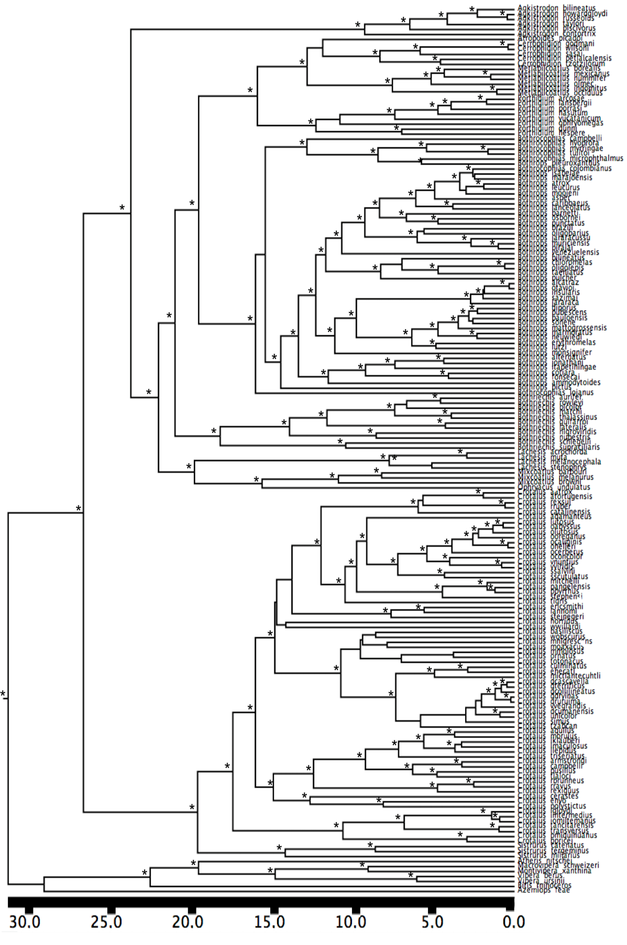
Supplementary material 4. Phylogenetic relationship of the overall species dataset used in this study based on Bayesian analysis of concatenated nuclear and mitochondrial sequences. Asterisks mark nodes supported by posterior probabilities <0.90.
Biogeographic ancestral area reconstruction for North America under the best model (DIVALIKE AICc= 0.999). Ancestral areas with probability less of 0.25 were not depicted for clarity.

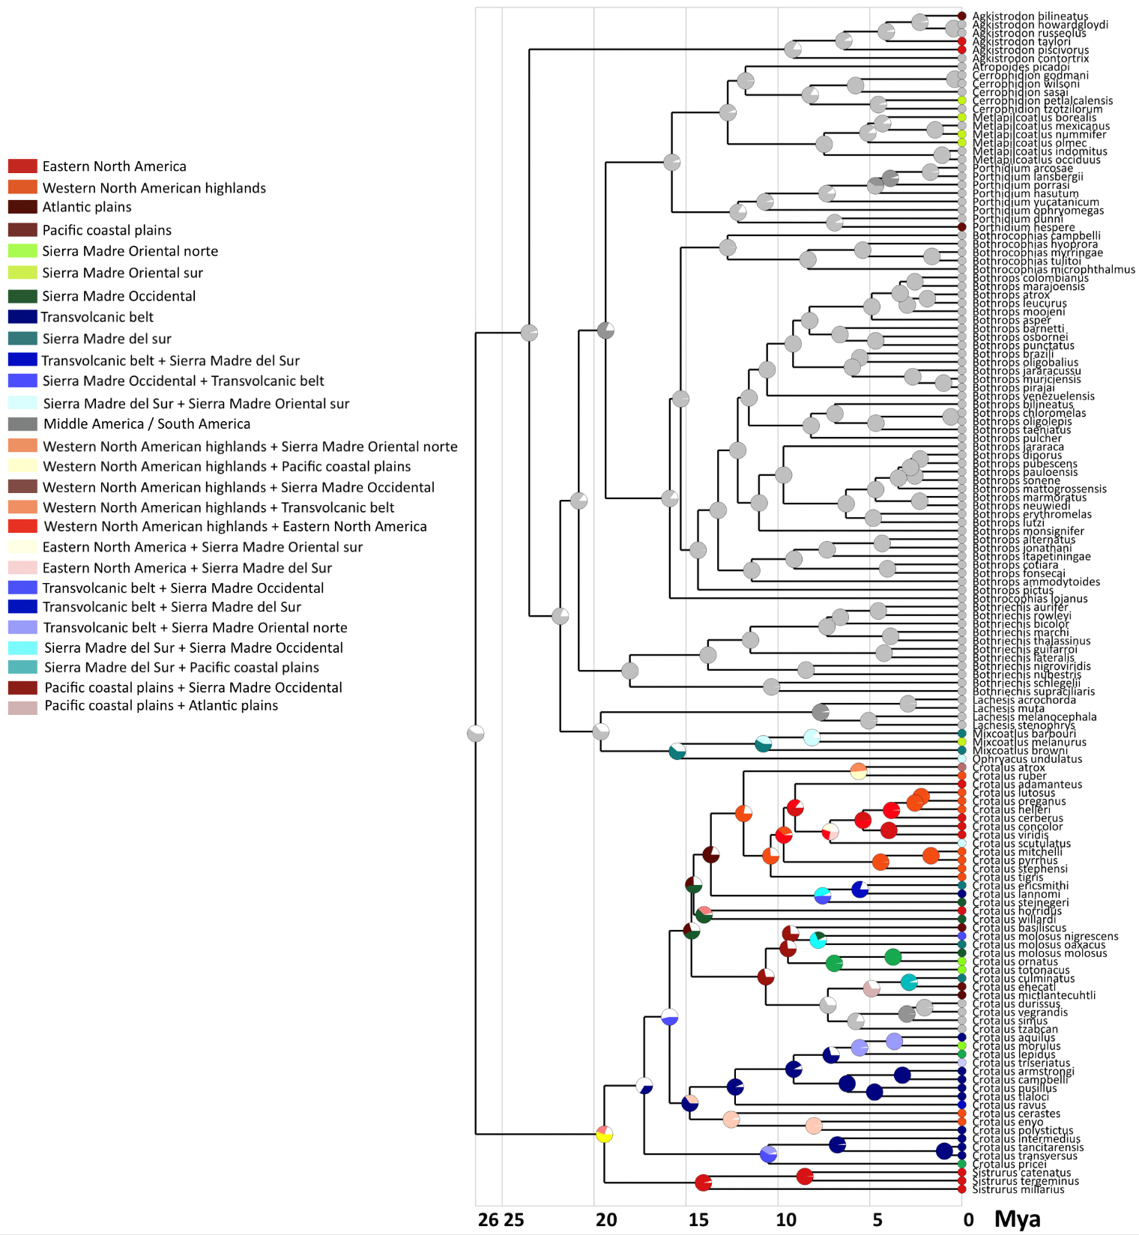

Biogeographic ancestral area reconstruction for Middle America under the best model (DIVALIKE AICc= 0.999). Ancestral areas with probability less of 0.25 were not depicted for clarity.
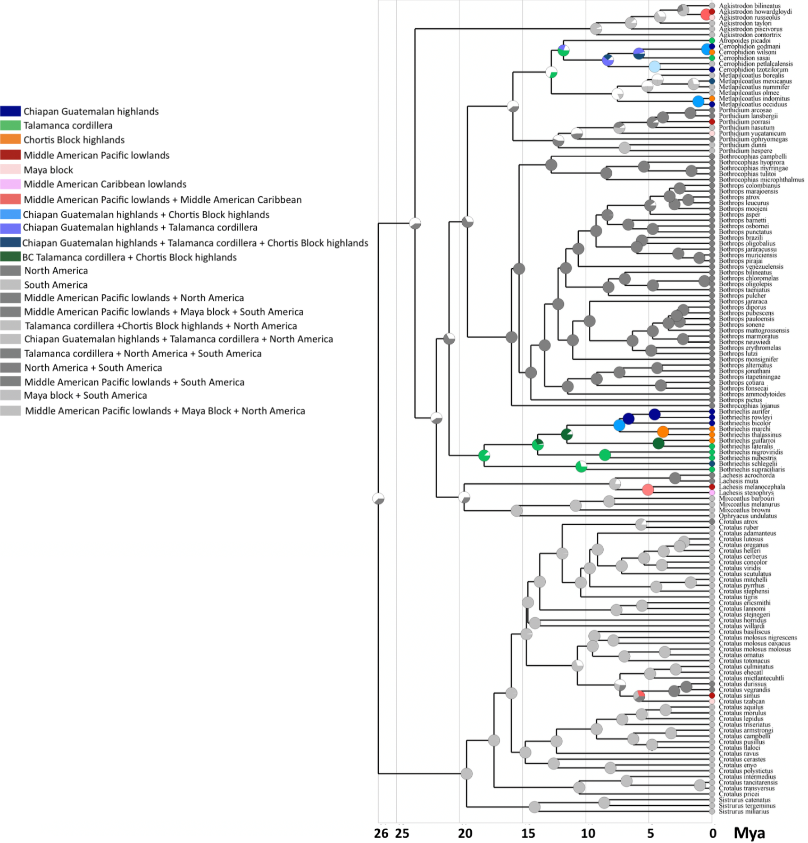

Biogeographic ancestral area reconstruction for South America under the best model (DEC AICc= 0.990). Ancestral areas with probability less of 0.25 were not depicted for clarity.
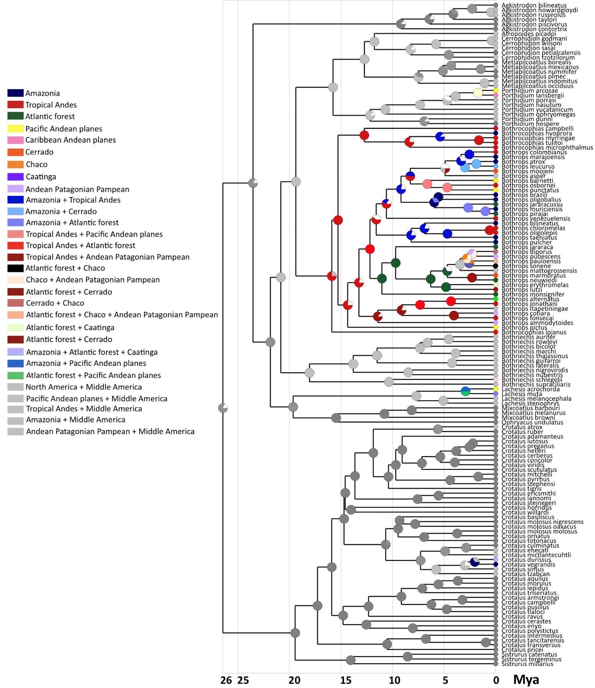

Detailed information about the inferred orographic patterns of speciation in American pitvipers: within mountains, between mountains, within lowlands, between lowlands and between lowlands and mountains. Information provided includes sister lineages groups involved in each event, posterior probabilities of the clade and divergence time in million years ago based on the mc tree. For each speciation event the primary biogeographic areas involved in the orographic pattern are those supported by the highest probability ancestral area reconstructed by the best model in BioGeoBEARS. The probability of orographic pattern is the probability of that supported by the highest probability obtained summing the probabilities of each ancestral speciation event of this mode.
Species | Speciation event | Speciation mode | Age divergence | Node support | Probability of speciation mode
North America
Porthidium dunni / Porthidium hespere | Within Pacific coastal plains | Within lowlands | 6.9 | 1.000 | 0.926
Mixcoatlus barbouri / Mixcoatlus melanurus | Between Sierra Madre Sur and Sierra Madre Oriental Sur | Between mountains | 8.1 | 1.000 | 0.868
Crotalus atrox / Crotalus ruber | Sierra Madre Oriental norte+Altiplano central +Atlantic plains+Pacific Coastal Plains  and Western Central North America | Between mountains and lowlands | 5.6 | 1.000 | 0.491
Crotalus lutosus / Crotalus oreganus | Within Eastern North American highlands | Within mountains | 2.2 | 0.996 | 0.998
Crotalus helleri / Crotalus lutosus + Crotalus oreganus | Within Eastern North American highlands | Within mountains | 2.5 | 1.000 | 0.992
Crotalus concolor / Crotalus viridis | Within Western North America | Within lowlands | 3.9 | 1.000 | 0.999
Crotalus mitchelli / Crotalus pyrrhus | Within Eastern North American highlands | Within mountains | 1.6 | 1.000 | 0.999
Crotalus stephensi / Crotalus mitchelli + Crotalus pyrrhus | Within Eastern North American highlands | Within mountains | 4.4 | 1.000 | 0.995
Crotalus ericsmithi / Crotalus lannomi | Between Sierra Madre Sur and Transvolcanic belt | Between mountains | 5.5 | 0.993 | 0.865
Crotalus horridus / Crotalus willardi | Between Eastern North America and Sierra Madre Occidental | Whitin mountains | 14.0 | 0.300 | 0.627
Crotalus molossus nigriscens / Crotalus molossus oaxacus | Between Sierra Madre Occidental+Transvolcanic belt and Sierra Madre Sur | Between mountains | 7.8 | 0.333 | 0.704
Crotalus molossus molossus / Crotalus ornatus | Between Sierra Madre Occidental + Altiplano central and Sierra Madre Oriental north | Between mountains | 3.7 | 0.680 | 0.998
Crotalus totonacus / Crotalus ornatus + Crotalus molossus molossus | Between Sierra Madre Occidental and Sierra Madre Oriental norte | Between mountains | 6.9 | 0.453 | 0.987
Crotalus basiliscus / Crotalus molossus nigriscens + Crotalus molossus oaxacus | Between Pacific coastal plains and Sierra Madre Occidental | Between lowlands and mountains | 9.3 | 0.140 | 0.743
Crotalus culminatus / Crotalus ehecatl | Between Sierra Madre sur +Transvolcanic belt and Pacific Coastal plains | Between lowlands and mountains | 2.8 | 1.000 | 0.950
Crotalus mictlantecuhtli / Crotalus culminatus + Crotalus ehecatl | Between Pacific coastal plains and Atlantic plains | Between lowlands | 4.9 | 0.684 | 1.000
Crotalus aquilus / Crotalus morulus | Between Transvolcanic belt and Sierra Madre Oriental north | Between mountains | 3.6 | 1.000 | 0.998
Crotalus lepidus / Crotalus aquilus + Crotalus morulus | Between Transvolcanic belt and Sierra Madre Oriental norte | Between mountains | 5.5 | 1.000 | 0.980
Crotalus armstrongi / Crotalus campbelli | Within Transvolcanic belt | Within mountains | 3.2 | 1.000 | 0.994
Crotalus pusillus / Crotalus tlaloci | Within Transvolcanic belt | Within mountains | 4.7 | 1.000 | 0.999
Crotalus enyo / Crotalus polystictus | Between Western North America highlands and Transvolcanic belt | Between mountains | 8.0 | 1.000 | 0.991
Crotalus cerastes / Crotalus enyo + Crotalus polystictus | Between Western North America highlands and Transvolcanic belt | Between mountains | 12.5 | 1.000 | 0.956
Crotalus tancitarensis / Crotalus transversus | Within Transvolcanic belt | Within mountains | 0.9 | 1.000 | 0.992
Crotalus intermedius / Crotalus tancitarensis + Crotalus transversus | Within Transvolcanic belt | Within mountains | 6.7 | 1.000 | 0.981
Sistrurus catenatus / Sistrurus tergeminus | Between Eastern North America and North America | Within lowlands | 8.5 | 1.000 | 0.991
Sistrurus miliarius / Sistrurus catenatus + Sistrurus tergeminus | Between Eastern North America and North America | Within lowlands | 14.0 | 1.000 | 0.961
Middle America
Agkistrodon howardgloydi / Agkistrodon russeolus | Between Maya block and Middle Pacific American lowlands | Between lowlands | 0.4 | 1.000 | 1.000
Cerrophidion godmani / Cerrophidion wilsoni | Between Chiapan-Guatemalan highlands and Chortis Block highlands | Between mountains | 0.3 | 1.000 | 1.000
Cerrophidion sasai / Cerrophidion godmani + Cerrophidion wilsoni | Between Chiapan-Guatemalan highlands and Chiapan-Guatemalan highlands + Chortis Block highlands + Talamanca cordillera | Between mountains | 5.7 | 1.000 | 0.999
Metlapilcoatlus indomitus / Metlapilcoatlus occidus | Between Chortis Block highlands and Chiapan-Guatemalan highlands | Between mountains | 1.0 | 1.000 | 1.000
Bothriechis aurifer / Bothriechis rowleyi | Within Chiapan-Guatemalan highlands | Within mountains | 4.5 | 0.996 | 1.000
Bothriechis bicolor / Bothriechis aurifer + Bothriechis rowleyi | Within Chiapan-Guatemalan highlands | Within mountains | 6.6 | 0.720 | 1.000
Bothriechis marchi / Bothriechis thalassinus | Within Chortis Block highlands | Within mountains | 3.8 | 1.000 | 1.000
Bothriechis guifarroi / Bothriechis lateralis | Between Chortis Block highlands and Talamanca Cordillera | Between mountains | 4.2 | 1.000 | 1.000
Bothriechis nigroviridis / Bothriechis nubestris | Within Talamanca cordillera | Within mountains | 8.4 | 1.000 | 1.000
Lachesis melanocephala / Lachesis stenophrys | Within Middle American lowlands | Within lowlands | 5.0 | 0.823 | 1.000
South America
Porthidium arcosae / Porthidium lansbergii | Between Caribbean Andean plains and Pacific Andean plains | Between lowlands | 1.7 | 1.000 | 1.000
Porthidium porrasi / Porthidium arcosae + Porthidium lansbergii | Between Middle American Pacific lowlands and Pacific Andean plains | Between lowlands | 3.8 | 1.000 | 1.000
Bothrocophias myrringae / Bothrocophias tulitoi | Within Tropical Andes | Within mountains | 1.6 | 1.000 | 1.000
Bothrocophias hyopropa / Bothrocophias myrringae + Bothrocophias tulitoi | Between Tropical Andes and Amazonia | Between lowlands and mountains | 5.3 | 1.000 | 0.879
Bothrops colombianus / Bothrops marajoensis | Between Tropical Andes / Amazonia | Between lowlands and mountains | 2.5 | 1.000 | 1.000
Bothrops atrox / Bothrops leucrurus | Between Amazonia and Atlantic forest | Between lowlands and mountains | 1.8 | 1.000 | 1.000
Bothrops osbornei / Bothrops punctatus | Between Pacific Andean plains and Tropical Andes | Between lowlands and mountains | 4.6 | 1.000 | 1.000
Bothrops barnetti / Bothrops osbornei + Bothrops punctatus | Within Tropical Andes | Within mountains | 6.6 | 1.000 | 1.000
Bothrops brazili / Bothrops oligobalius | Within Amazonia | Within lowlands | 5.5 | 0.533 | 1.000
Bothrops muriciensis / Bothrops pirajai | Between Amazonia and Atlantic forest | Between lowlands and mountains | 0.9 | 1.000 | 1.000
Bothrops jararacussu / Bothrops muriciensis + Bothrops pirajai | Between Amazonia and Atlantic forest | Between lowlands and mountains | 2.6 | 1.000 | 1.000
Bothrops chloromelas / Bothrops oligolepis | Within Tropical Andes | Within mountains | 0.6 | 1.000 | 1.000
Bothrops taeniatus / Bothrops chloromelas + Bothrops oligolepis | Between Tropical Andes / Amazonia | Between lowlands and mountains | 4.6 | 1.000 | 1.000
Bothrops diporus / Bothrops pubescens | Between Atlantic forest+Chaco+Andean Patagonian Pampean and Andean Patagonian Pampean | Ambigous | 2.2 | 0.996 | 0.435
Bothrops sonene / Bothrops pauloensis | Between Amazonia and Cerrado+Chaco | Between lowlands | 2.5 | 0.826 | 0.737
Bothrops marmoratus / Bothrops neuwiedi | Between Cerrado and Atlantic forest | Between lowlands and mountains | 2.3 | 1.000 | 1.000
Bothrops erythromelas / Bothrops lutzi | Between Atlantic forest+Caatinga and Cerrado | Within lowlands | 4.8 | 1.000 | 1.000
Bothrops alternatus / Bothrops jonathani | Between Atlantic forest+Andean Patagonian Pampean and Tropical Andes | Between lowlands and mountains | 4.3 | 1.000 | 1.000
Bothrops itapetiningae / Bothrops alternatus + Bothrops jonathani | Between Tropical Andes and Atlantic Forest | Between mountains | 7.3 | 0.976 | 1.000
Bothrops cotiara / Bothrops fonsecai | Between Andean Patagonian Pampean and Tropical Andes | Between lowlands and mountains | 4.0 | 1.000 | 1.000
Lachesis acrochorda / Lachesis muta | Between Andean Pacific and Amazonia+Atlantic forest | Between lowlands | 2.9 | 1.000 | 1.000
Crotalus durissus / Crotalus vegrandis | Between Atlantic Forest+Caatinga+Chaco Andean Pampean Patagonia and Amazonia | Between lowlands | 2.0 | 0.813 | 1.000
Combined regions
Crotalus simus / Crotalus durissus + Crotalus vegrandis | Between Amazonia and Middle American Pacific lowlands | Between lowlands | 2.0 | 0.783 | 0.776
Cerrophidion petlalcalensis / Cerrophidion tzotzilorum | Between Sierra Madre Oriental sur (North America) and Chiapan Guatemalan highlands (Middle America) | Between mountains | 4.5 | 1.000 | 1.000
Metlapilcoatlus borealis / Metlapilcoatlus mexicanus + Metlapilcoatlus nummifer | Between Sierra Madre Oriental sur / Chiapan Gautemalan highlands + Talamanca cordillera | Between mountains | 4.3 | 0.916 | 0.889
Metlapilcoatlus mexicanus / Metlapilcoatlus nummifer | Between Talamanca cordillera+Chortis Block highlands+Chiapan Guatemalan highlands (Middle America) and Sierra Madre Oriental sur (North America) | Between mountains | 1.4 | 1.000 | 0.974

Model fitting of species log-transformed elevation midpoint using Geiger. The best model Lambda had a lambda parameter =0.854.
Model | AICc | AICc weight
Brownian | 283.722 | <0.00001
OU | 196.006 | 0.00064
EB | 285.812 | <0.00001
Lambda | 185.930 | 0.99148
Kapa | 212.454 | <0.00001
Delta | 248.932 | <0.00001
Mean trend | 285.811 | <0.00001
Rate trend | 264.456 | <0.00001
White noise | 198.260 | 0.00208

