Supplementary Table S1. Different microhabitat types in the study area, with characteristic structures and occurring plant species. For every microhabitat type we describe its function for habitat use of Sand Lizards.
Microhabitat | Characteristic structures | Plant species | Function for Sand Lizards | References
Tack ballast | Crushed stones | none | Hiding/sleeping, sunbathing | Mutz & Donth 1996, Blanke 1999, Märtens 1999, Edgar et al. 2010
Sideway | Bare soil, sand, gravel | Mostly unvegetated, sporadic Oenothera biennis, Bunias orientalis or Verbascum densiflorum | Sunbathing, hunting, egg deposition | House & Spellerberg 1983, Mutz & Donth 1996, Blanke 1999, Edgar et al. 2010
Ruderal herbs and grasses | Vegetation on the embankment, 25 cm to 120 cm tall | Echium vulgare, Melilotus officinalis, Lactua serriola, Anchusa officinalis, Euphorbia characias, Arrhenatherum elatius, Deschampsia flexuosa | Hiding/sleeping, hunting | House & Spellerberg 1983, Blanke 1999, Märtens 1999, Amat et al. 2003
Ruderal herbs and grasses mixed with blackberry | Vegetation on the embankment, 25 cm to 120 cm tall, partly with thornily vegetation | Same as “ruderal herbs and grasses”, but interspersed with Rubus fruticosus | Hiding/sleeping, hunting, overwintering | House & Spellerberg 1983, Mutz & Donth 1996, Clement et al. 2022
Shrubs | Woody vegetation on the embankment, cut down every winter | Robinia pseudoacacia, Syringa vulgaris, Sambucus nigra | Hiding/sleeping, basking | House & Spellerberg 1983, Märtens 1999, Amat et al. 2003, Heltai et al. 2015, Blanke & Frese 2021
Forest | Broad leaf forest mixed with pine, close canopy | Robinia pseudacacia, Pinus sylvestris, Quercus robur and Betula pendula | Hiding/sleeping, hunting, overwintering | House & Spellerberg 1983
Forest edge | Transition between forest and embankment/ field path, ground partly shaded | Same as “forest”, partly Artemisia absinthium or Solidago canadensis | Hiding/sleeping, sunbathing, hunting, overwintering | House & Spellerberg 1983, Dent & Spellerberg 1988
Field path | Sandy, bare soil | Mostly unvegetated, partly Deschampsia flexuosa and Turritis glabra | sunbathing, hunting, egg deposition | House & Spellerberg 1983
Construction | Bridge construction, concrete | Unvegetated | sunbathing, hunting | Edgar et al. 2010, Becker & Buchholz 2016

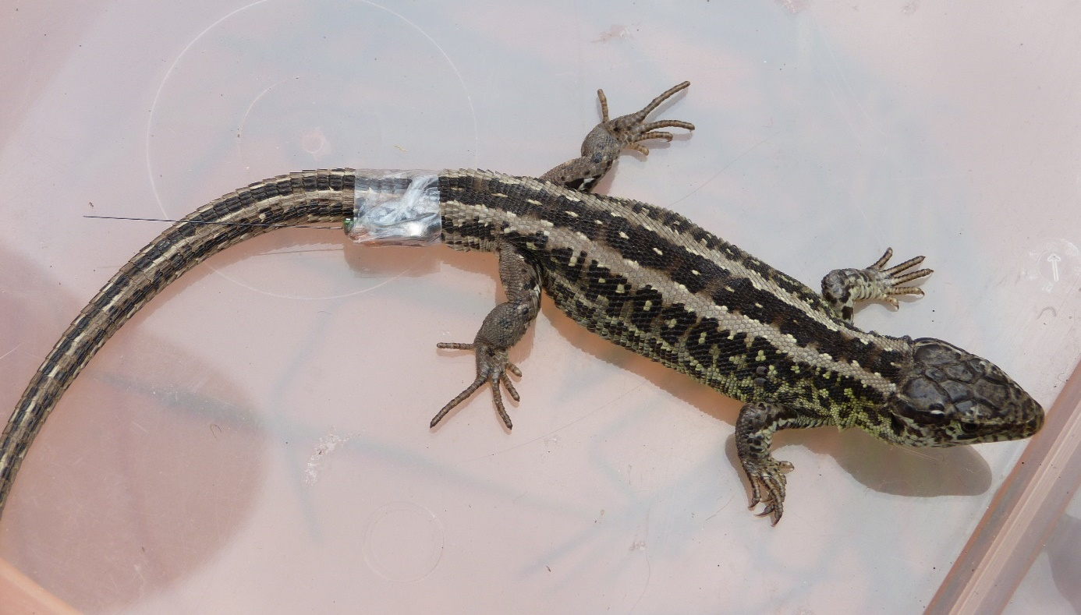
Supplementary Figure S2. A male tagged Sand Lizard, with the transmitter (LB-2X by Holohil) being taped laterally to the tail base. The antenna of the transmitter is shortened to 5 cm length to reduce the risk of entangling in vegetation. The tape that is used for fixation is “Opsite Flexifix polyurethane foil”. Detailed information on the attachment method can be found in Janssen et al. (2024).

Supplementary Table 3. Information on all Sand Lizards with individual ID that were caught during the four seasons spring (SP), summer 1 (S1), summer 2 (S2) and late summer (LS) (more information on seasons are given in Table 1 in main article). Given are the date of capture, the side of the railway an animal was caught, sex (f: female, m: male), Snout-vent-length (SVL), total length and weight of the animal, as well as the number of days the tracking was conducted and the number of fixes that could be gained during this time. Furthermore, we added information if injuries occurred during tracking (no: no injuries, yes¹: autotomy occurred behind the transmitter with reason for autotomy unclear, yes²: autotomy occurred with and because of transmitter) and the transmitter disposal (AT = animal remained tagged in field after tracking, because re-catch was not possible, TF: Transmitter was stripped off and found, TNF: Transmitter was probably stripped of but not found, TMS: transmitter not found because of missing signal, TR: Transmitter removed during re-catch). For all animals with at least 16 fixes and site fidelity, we assigned a habitat section (numbers refer to Figure 1 in main article) and estimated home range size with 95% Minimum Convex Polygon (MCP 95) and 95% autocorrelated kernel density estimation (AKDE 95), as well as the core area with 50 % autocorrelated kernel density estimation (AKDE 50). Animals with less than 16 fixes or without site fidelity were not assigned to a habitat section (-). For these animals, home range sizes could not be calculated.
Animal ID | Season | Date of capture | Railway side | Sex | SVL (cm) | Total length (cm) | Weight (g) | No. of days tracked | No. of fixes | Injuries | Transmitter disposal | Habitat section | MCP 95 | AKDE 95 | AKDE 50
L101 | S1 | 09.06.2020 | south | f | 6.5 | 12 | 9 | 3 | 6 | no | TR | - | - | - | -
L102 | S1 | 09.06.2020 | north | m | 6 | 15 | 10 | 1 | 0 | no | TF | - | - | - | -
L103 | S1 | 09.06.2020 | north | f | 7.5 | 16 | 10.5 | 10 | 36 | no | TF | 5 | 38.57 | 85.31 | 17.8
L104 | S1 | 09.06.2020 | south | f | 7 | 14 | 10 | 1 | 0 | no | TF | - | - | - | -
L105 | S1 | 09.06.2020 | south | m | 7 | 59 | 7.5 | 5 | 10 | no | TNF | - | - | - | -
L106 | S1 | 09.06.2020 | north | m | 7 | 13 | 8 | 15 | 52 | no | AT | 4 | 248.99 | 565.21 | 106.6
L107 | S1 | 10.06.2020 | north | f | 7 | 13 | 9.5 | 14 | 44 | no | TF | 2 | 53.74 | 133.77 | 31.5
L108 | S1 | 10.06.2020 | south | m | 8.5 | 15 | 7.5 | 3 | 6 | yes¹ | TF | - | - | - | -
L109 | S1 | 10.06.2020 | south | m | 9 | 17 | 10.5 | 3 | 7 | no | TNF | - | - | - | -
L110 | S1 | 10.06.2020 | north | f | 8 | 13 | 9 | 3 | 7 | no | TNF | - | - | - | -
L111 | S1 | 10.06.2020 | south | m | 8 | 16 | 8 | 4 | 9 | no | TNF | - | - | - | -
L112 | S1 | 10.06.2020 | north | m | 7 | 16 | 11.5 | 7 | 16 | no | TF | 5 | 149.94 | 409.79 | 130.1
L113 | S1 | 15.06.2020 | south | m | 7 | 15 | 7.5 | 7 | 29 | no | AT | 6 | 73.6 | 194.42 | 40
L114 | S1 | 15.06.2020 | north | f | 7.5 | 18 | 9 | 8 | 35 | no | TR | 2 | 78.61 | 106.23 | 17.6
L115 | S1 | 15.06.2020 | north | m | 6.5 | 17.5 | 8.5 | 7 | 28 | no | TF | 2 | 79.49 | 212.16 | 46.5
L116 | S1 | 15.06.2020 | south | m | 6 | 16 | 8 | 9 | 42 | no | AT | 8 | 246.65 | 314.41 | 51.3
L201 | S2 | 21.07.2020 | south | f | 8 | 16 | 10 | 14 | 36 | no | TR | 6 | 86.15 | 203.34 | 51.4
L202 | S2 | 21.07.2020 | north | f | 7 | 17.5 | 8 | 10 | 24 | no | TF | 5 | 104.93 | 250.6 | 38
L203 | S2 | 21.07.2020 | north | m | 8 | 17 | 9.5 | 10 | 27 | no | TF | 4 | 109.18 | 285.77 | 80
L204 | S2 | 21.07.2020 | north | m | 8 | 16 | 12 | 12 | 31 | no | TNF | 3 | 116.79 | 257.29 | 57.9
L205 | S2 | 21.07.2020 | north | m | 7 | 12 | 9.5 | 10 | 30 | no | TF | 3 | 65.68 | 179.98 | 38.7
L206 | S2 | 21.07.2020 | north | f | 8 | 11 | 8 | 3 | 5 | no | TF | - | - | - | -
L207 | S2 | 22.07.2020 | south | m | 7.5 | 18 | 10 | 10 | 34 | no | TNF | 8 | 178.14 | 378.42 | 69.3
L208 | S2 | 22.07.2020 | south | m | 8 | 20 | 11.5 | 9 | 29 | no | TF | 8 | 137.75 | 368.24 | 73.2
L209 | S2 | 22.07.2020 | south | f | 6.5 | 13 | 10 | 8 | 23 | no | TNF | 8 | 145.61 | 444.69 | 140
L210 | S2 | 22.07.2020 | north | f | 8 | 18 | 10.5 | 9 | 25 | no | TNF | 5 | 53.92 | 262.3 | 58
L211 | S2 | 22.07.2020 | south | f | 8.5 | 19 | 12 | 13 | 35 | no | TR | 6 | 93.64 | 289.16 | 68.6
L212 | S2 | 22.07.2020 | south | m | 8 | 19 | 11 | 3 | 9 | no | TF | - | - | - | -
L213 | S2 | 22.07.2020 | south | f | 8 | 15 | 9.5 | 10 | 31 | no | TF | - | - | - | -
L214 | S2 | 22.07.2020 | south | m | 6.5 | 17 | 10 | 5 | 15 | no | TMS | - | - | - | -
L215 | S2 | 23.07.2020 | south | f | 7 | 18 | 10 | 8 | 26 | no | TF | 7 | 26.14 | 130.08 | 25.1
L216 | S2 | 23.07.2020 | south | m | 8 | 16 | 12.5 | 8 | 27 | no | TF | - | - | - | -
L217 | S2 | 23.07.2020 | north | m | 8 | 16 | 13 | 5 | 15 | no | TF | - | - | - | -
L218 | S2 | 23.07.2020 | north | f | 8.5 | 15 | 11.5 | 7 | 22 | no | TF | 4 | 100.52 | 311.13 | 55.4
L219 | S2 | 23.07.2020 | north | m | 7 | 15 | 8.5 | 7 | 19 | no | TNF | 5 | 52.63 | 140.2 | 18.4
L220 | S2 | 25.07.2020 | north | f | 8 | 16 | 10 | 10 | 33 | no | TR | 4 | 387.42 | 885.43 | 234.2
L301 | LS | 24.08.2020 | north | f | 7 | 8.5 | 7 | 18 | 51 | yes¹ | TR | 4 | 40.24 | 68.24 | 20.5
L302 | LS | 24.08.2020 | north | f | 8 | 9 | 12 | 11 | 33 | no | TF | 2 | 24.32 | 89.4 | 16.5
L303 | LS | 25.08.2020 | north | f | 7 | 13 | 8 | 18 | 47 | no | TR | 4 | 4.91 | 15.3 | 3.9
L304 | LS | 25.08.2020 | north | f | 7.5 | 10 | 9 | 13 | 36 | no | TF | 4 | 18.15 | 66.88 | 9
L305 | LS | 25.08.2020 | south | f | 7 | 16 | 11 | 18 | 49 | no | TR | 7 | 1.16 | 4 | 0.8
L306 | LS | 25.08.2020 | north | m | 6.5 | 15 | 8 | 17 | 52 | no | AT | 4 | 156.91 | 295.44 | 67
L307 | LS | 25.08.2020 | south | m | 6.5 | 16 | 9 | 2 | 5 | no | TMS | - | - | - | -
L308 | LS | 25.08.2020 | north | m | 7 | 14 | 8.5 | 4 | 14 | no | TF | - | - | - | -
L309 | LS | 27.08.2020 | south | f | 7.5 | 16 | 10 | 13 | 35 | no | TR | 7 | 6.06 | 24.92 | 6.8
L310 | LS | 27.08.2020 | south | f | 7.5 | 15 | 10.5 | 0 | 0 | no | TF | - | - | - | -
L311 | LS | 27.08.2020 | north | f | 6 | 13 | 6 | 14 | 45 | no | AT | 3 | 25.15 | 112.17 | 16.5
L312 | LS | 28.08.2020 | north | f | 7.5 | 17.5 | 11 | 12 | 33 | no | TNF | 2 | 45.14 | 131.98 | 25
L313 | LS | 28.08.2020 | north | f | 6 | 15.5 | 7 | 14 | 40 | no | AT | 3 | 33.28 | 93.77 | 23
L314 | LS | 28.08.2020 | north | m | 6 | 13 | 8 | 14 | 41 | no | TR | 4 | 45.17 | 89.35 | 22.7
L315 | LS | 29.08.2020 | south | f | 7 | 19 | 11 | 14 | 40 | no | TR | 7 | 37.11 | 81.15 | 20.1
L316 | LS | 29.08.2020 | south | f | 6.5 | 16 | 9.5 | 3 | 10 | no | TF | - | - | - | -
L401 | SP | 19.04.2021 | north | m | 7 | 19 | 12.5 | 10 | 45 | no | AT | 4 | 24.4 | 72.37 | 14.6
L402 | SP | 19.04.2021 | north | m | 6.5 | 17 | 9 | 10 | 43 | no | TR | 4 | 5.65 | 12.96 | 3.5
L403 | SP | 19.04.2021 | north | m | 7 | 16 | 9.5 | 10 | 46 | no | TR | 4 | 29.82 | 53.32 | 7.9
L404 | SP | 19.04.2021 | north | m | 7.5 | 15 | 10.5 | 3 | 11 | no | TF | - | - | - | -
L405 | SP | 19.04.2021 | north | m | 7 | 18 | 12 | 2 | 6 | no | TF | - | - | - | -
L406 | SP | 19.04.2021 | north | m | 7 | 16 | 9 | 10 | 45 | no | TR | 4 | 12.11 | 36.2 | 9.9
L407 | SP | 19.04.2021 | north | m | 7.5 | 14 | 11.5 | 10 | 44 | no | AT | 4 | 0.75 | 3.44 | 0.8
L408 | SP | 19.04.2021 | north | m | 6 | 14 | 8.5 | 10 | 42 | no | TF | 4 | 15.42 | 30.65 | 6.2
L409 | SP | 19.04.2021 | north | m | 7.5 | 14 | 10.5 | 9 | 36 | no | TNF | 3 | 57.05 | 120.14 | 24.4
L410 | SP | 19.04.2021 | north | m | 7 | 17 | 11 | 2 | 8 | yes² | TF | - | - | - | -
L411 | SP | 19.04.2021 | south | m | 7.5 | 16 | 12.5 | 10 | 45 | no | AT | 8 | 51.31 | 109 | 19.1
L412 | SP | 19.04.2021 | south | m | 6 | 16 | 10 | 10 | 43 | no | AT | 8 | 24.02 | 51.38 | 8.2
L413 | SP | 19.04.2021 | south | m | 7 | 17.5 | 9.5 | 10 | 44 | no | TR | 8 | 15.11 | 106.51 | 18
L414 | SP | 19.04.2021 | south | m | 7 | 17 | 9 | 10 | 45 | no | AT | 8 | 17.17 | 28.94 | 6.1
L415 | SP | 21.04.2021 | south | m | 7.5 | 19 | 9.5 | 3 | 16 | no | TMS | 8 | 0.22 | 0.73 | 0.2
L416 | SP | 21.04.2021 | north | f | 7.5 | 18 | 11 | 7 | 33 | no | AT | 4 | 4.64 | 12.37 | 2.5
L417 | SP | 21.04.2021 | north | m | 6 | 14 | 7 | 8 | 34 | no | AT | 4 | 10.98 | 41.06 | 9.3
L418 | SP | 21.04.2021 | north | m | 7.5 | 13 | 11 | 8 | 37 | no | TR | 4 | 14.43 | 31.08 | 5.2

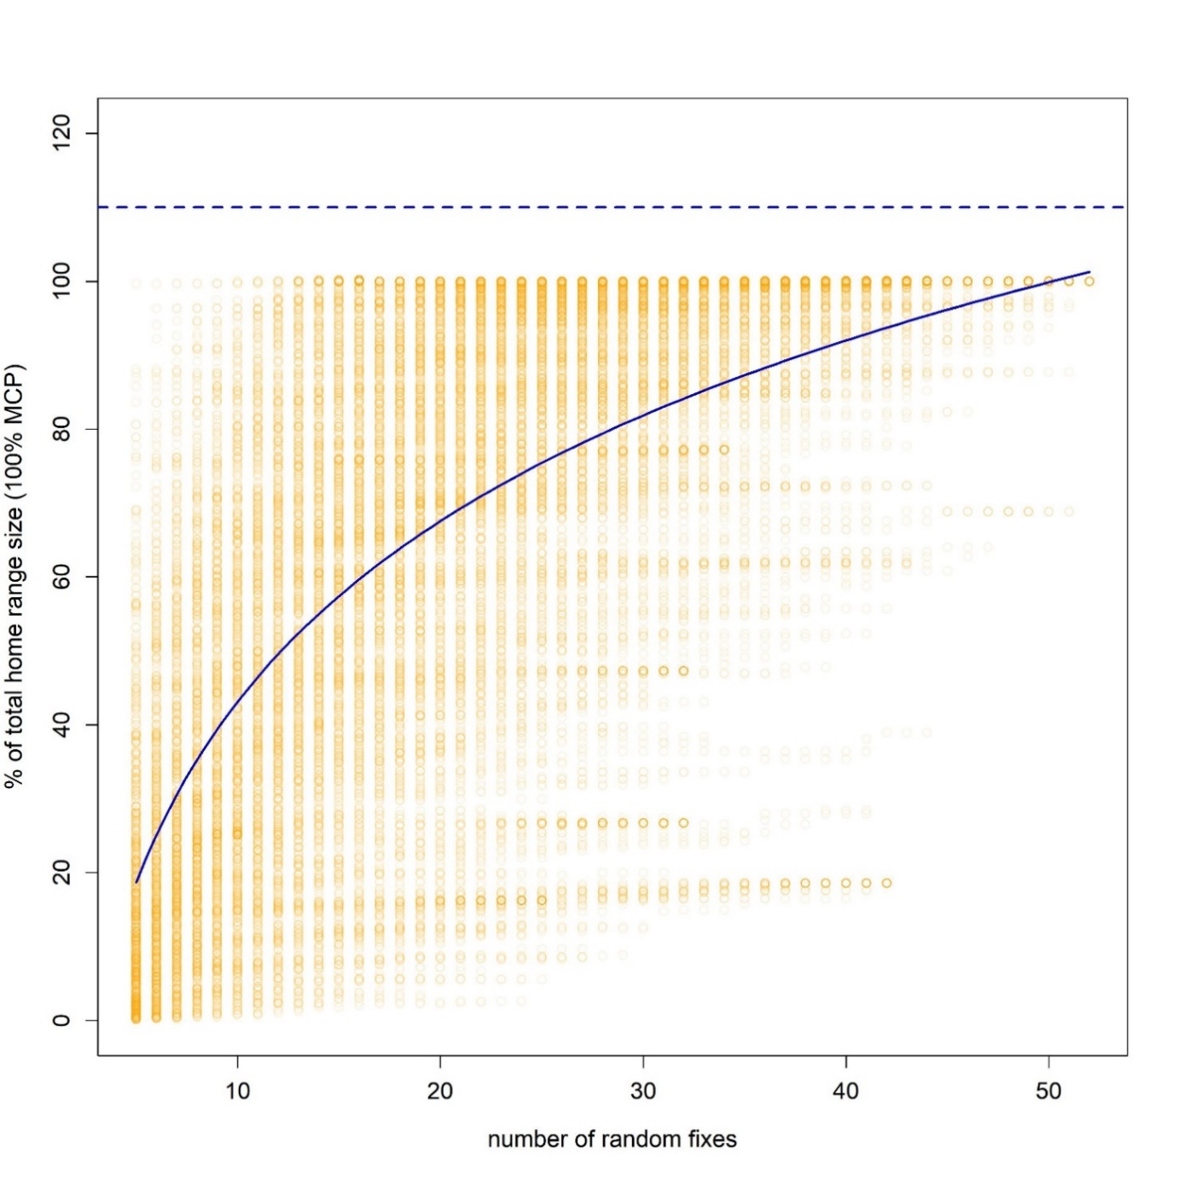
Supplementary Figure S4. Accumulation curve (blue line) for randomized home range sizes calculated with 100 % MCP. For every resident lizard random fixes (ranging from five random fixes to the maximum number of fixes that were collected for that animal) were used to calculate home range size by the MCP method. The calculated home range size was then compared to the 100 % MCP that was calculated with all fixes for every animal, to reflect the percentage of total home range size, that was achieved for the respective number of random fixes. The calculation of home range size was repeated 20 times for every number of random fixes per animal. The percentage of total home range size for a given set of random fixes per animal is displayed as an orange circle. The accumulation curve depicts an asymptote that converges to a hypothetical maximum of 109 % (dashed blue line), indicating that even with more than 50 fixes, home range sizes estimated by the MCP method still increase with an increasing number of fixes. This is a known characteristic for home range estimations based on MCP method (Börger et al. 2006).
Supplementary Figure 5. Boundaries of Sand Lizard home ranges, calculated with 50% and 95% AKDE_{C}, during (A) spring, (B) summer 1, (C) summer 2 and (D) late summer. Red polygons are the core areas (50% AKDE_{C}), while the yellow lines display the estimated home range (95% AKDE_{C}). All home range boundaries are labelled in white with the ID of the respective Sand Lizard (see Supplementary Table S3 for more information on study animals). Blue boxes (labelled from 1 to 8) display habitat sections within a 15 m strip from the middle of the railway track into to the surrounding area, that show a similar array of abiotic and biotic structures (microhabitat type, aspect and slope). Every study animal was assigned to one habitat section (see Supplementary Table S3) to test the effect of these explanatory variables on home range size in the regression model.
