**Supplementary material 1.** Accession numbers of the DNA sequences of the American pitviper species included in the analysis.

|  |  |  |  |  |  |  |
| --- | --- | --- | --- | --- | --- | --- |
| Species | 12s | 16s | CytB | ND4 | Atapasa | RAG1 |
| *Agkistrodon bilineatus* | AF057230 | AF156570 | EU483408 | AF156583 | FJ417940 | AF156583 |
| *Agkistrodon contortrix* | MK313326 | MK313353 | EU483410 | MK313438 | FJ417907 | MK313438 |
| *Agkistrodon howardgloydi* | AF156594 | AF156571 |  | AF156585 |  | AF156585 |
| *Agkistrodon piscivorus* | AF259225 | AF259118 | KC431028 | AF156579 | FJ417957 | AF156579 |
| *Agkistrodon russeolus* | L01766 | AF156573 |  | AF156586 |  | AF156586 |
| *Agkistrodon taylori* | AF156590 | AF156569 | EU483477 | AF156581 | FJ417942 | AF156581 |
| *Atropoides picadoi* | AF057208 | AF057255 | AY220323 | AY220346 |  | AY220346 |
| *Bothriechis aurifer* | MK313319 | MK313339 | DQ305466 | MK313447 |  | MK313447 |
| *Bothriechis bicolor* | MK313316 | MK313337 | DQ305467 | MK313445 |  | MK313445 |
| *Bothriechis guifarroi* | MK313315 | MK313336 | KC847275 | MK313441 |  | MK313441 |
| *Bothriechis lateralis* | MK313313 | MK313334 | AF292572 | AF292610 |  | AF292610 |
| *Bothriechis marchi* | DQ305428 | DQ305451 | DQ305469 | DQ305486 |  | DQ305486 |
| *Bothriechis nigroviridis* | MK313325 | MK313346 | MK313554 | MK313444 |  | MK313444 |
| *Bothriechis nubestris* | MK313324 | MK313345 | MK313553 | MK313442 |  | MK313442 |
| *Bothriechis rowleyi* | MK313321 | MK313341 | MK313547 | MK313449 |  | MK313449 |
| *Bothriechis schlegelii* | MK313305 | MK313331 | MK313539 | MK313435 |  | MK313435 |
| *Bothriechis supraciliaris* | MK313306 | MK313332 | MK313541 | MK313437 |  | MK313437 |
| *Bothriechis thalassinus* | MK313318 | MK313342 | MK313550 | MK313450 |  | MK313450 |
| *Bothrocophias campbelli* |  |  | AF191582 | AF292622 |  | AF292622 |
| *Bothrocophias colombianus* |  |  | AF292602 | AF292640 |  | AF292640 |
| *Bothrocophias hyoprora* | AF057206 | AF057253 | AY223593 | AF292614 |  | AF292614 |
| *Bothrocophias lojanus* |  |  | FR691566 | FR691536 |  | FR691536 |
| *Bothrocophias microphthalmus* | AY223657 | AY223670 | FR691565 | AF292615 |  | AF292615 |
| *Bothrocophias myrringae* |  |  | OP082447 | OP082452 |  |  |
| *Bothrocophias tulitoi* |  |  | OP082448 | OP082453 |  |  |
| *Bothrops alternatus* | AY223660 | MH697948 | EU867273 | AF292617 |  | AF292617 |
| *Bothrops ammodytoides* | AY223658 | AY223671 | AY223595 | AY223639 |  | AY223639 |
| *Bothrops asper* | AF057218 | AF057265 | HE867043 | AF292638 |  | AF292638 |
| *Bothrops atrox* | MK313303 | MK313329 | MK313537 | MK313433 |  | MK313433 |
| *Bothrops barnetti* |  |  | OP609935 | OP609946 |  |  |
| *Bothrops bilineatus* | MH697893 | MH697955 | AY223591 | AF292630 |  | AF292630 |
| *Bothrops brazili* | MN296324 | MN296338 | MN296435 | MN296448 |  | MN296473 |
| *Bothrops chloromelas* | DQ305430 | DQ305453 | DQ305471 | DQ305488 |  | DQ305488 |
| *Bothrops cotiara* | AF057217 | AF057264 | AY223597 | AF292619 |  | AF292619 |
| *Bothrops diporus* | DQ305431 | DQ305454 | DQ305472 | DQ305489 |  | DQ305489 |
| *Bothrops erythromelas* | MH697937 | MH697997 | AY223600 | AF292626 |  | AF292626 |
| *Bothrops fonsecai* | KX694552 | KX694621 | AF292580 | AF292618 |  | AF292618 |
| *Bothrops itapetiningae* | EU867253 | EU867265 | AF292582 | AF292620 |  | AF292620 |
| *Bothrops jararaca* | MH697938 | MH697999 | AY865818 | AF292627 |  | AF292627 |
| *Bothrops jararacussu* | KX694553 | AY223674 | AY223602 | AY223643 |  | AY223643 |
| *Bothrops jonathani* |  |  | OP609937 |  |  |  |
| *Bothrops leucurus* | MH697943 | MH698003 | MH698090 | AF246279 |  | AF246279 |
| *Bothrops lutzi* | MH697944 | MH698005 | MH698088 | MH698239 |  | MH698239 |
| *Bothrops marajoensis* |  |  | AF292605 | AF292643 |  | AF292643 |
| *Bothrops marmoratus* |  |  |  | KF801265 |  | KF801265 |
| *Bothrops mattogrossensis* |  |  |  | FN431769 |  | FN431769 |
| *Bothrops monsignifer* |  |  | OP609938 | OP609948 |  |  |
| *Bothrops moojeni* | EU867258 | EU867269 | AF200222 | AF292644 |  | AF292644 |
| *Bothrops muriciensis* | MN296333 | MN296346 | MN296444 | MN296456 |  | MN296456 |
| *Bothrops neuwiedi* |  | MN276221 | KF801162 | KF801287 |  | KF801287 |
| *Bothrops oligobalius* | MN296327 | MN296341 |  | MH698230 |  | MH698314 |
| *Bothrops oligolepis* |  | KX660260 |  | KX660646 |  | KX660646 |
| *Bothrops osbornei* | KU999231 | KU999160 | AF292595 | AF292633 |  | AF292633 |
| *Bothrops pauloensis* | EU867260 | EU867272 | OP609940 | EU867296 |  | EU867296 |
| *Bothrops pictus* |  |  | OP609941 | AF292621 |  | AF292621 |
| *Bothrops pirajai* | MN296334 | MN296348 | OP609942 | MN296457 |  | MN296457 |
| *Bothrops pubescens* | JN870180 | JN870192 | JN870200 | JN870206 |  | JN870206 |
| *Bothrops pulcher* | JN870179 |  | AF292593 | AF292631 |  | AF292631 |
| *Bothrops punctatus* | KU999239 | KU999164 | KU999116 | AF292632 |  | AF292632 |
| *Bothrops sazimai* |  |  | OP609943 | OP609953 |  |  |
| *Bothrops sonene* | OP616739 | OP616734 | OP609944 | OP609954 |  |  |
| *Bothrops taeniatus* | KX694566 | MH698007 | AY223592 | AF292629 |  | AF292629 |
| *Bothrops venezuelensis* |  |  | MG265697 | MG265803 |  | MG265803 |
| *Cerrophidion godmani* | MK313309 | MK313349 | MK313556 | MK313455 |  | MK313455 |
| *Cerrophidion petlalcalensis* | DQ305420 | DQ305443 | DQ061202 | DQ061227 |  | DQ061227 |
| *Cerrophidion sasai* | AF057203 | AF057250 | AY223578 | U41879 |  | U41879 |
| *Cerrophidion tzotzilorum* | JN870182 | JN870193 | DQ061203 | DQ061228 |  | DQ061228 |
| *Cerrophidion wilsoni* | JQ724145 | JQ627129 | JQ724157 | JQ724170 |  | JQ724170 |
| *Crotalus adamanteus* | NC041524 | NC041524 | NC041524 | NC041524 |  | NC041524 |
| *Crotalus aquilus* | AF259232 | AF259125 |  | HQ257772 | HQ257641 | HQ257772 |
| *Crotalus armstrongi* | HQ257623 |  |  | HQ257868 | HQ257654 | HQ257868 |
| *Crotalus atrox* | AF057225 | AF259150 | AY223608 | DQ679841 | HQ316631 | DQ679841 |
| *Crotalus basiliscus* | AF259244 | AF259136 | AY704844 | AY704894 |  | AY704894 |
| *Crotalus campbelli* | HQ257564 |  |  | HQ257810 |  | HQ257810 |
| *Crotalus cerastes* | AF259235 | AF259128 | AF259165 | MK313458 | DQ493803 | MK313458 |
| *Crotalus cerberus* |  |  | AF147859 | JN620963 | KX095994 | JN620963 |
| *Crotalus concolor* | AY016042 |  | MH122690 | MN058589 | AF462360 | MN058589 |
| *Crotalus culminatus* |  |  | AY704828 | AY704878 |  | AY704878 |
| *Crotalus durissus* |  | JQ627284 | AY704811 | AY704861 |  | AY704861 |
| *Crotalus ehecatl* |  |  | MN067346 | MN067380 |  | MN067380 |
| *Crotalus enyo* | AF259245 | AF259137 |  |  | KF410271 |  |
| *Crotalus ericsmithi* |  |  | KF410284 | KF410289 |  | KF410289 |
| *Crotalus helleri* | AY016032 |  | JN620814 | AF194152 | AF462375 | AF194152 |
| *Crotalus horridus* | NC014400 | NC014400 | NC014400 | NC014400 |  | NC014400 |
| *Crotalus intermedius gloydi* | JN022925 |  |  | JN022855 | JN022801 | JN022855 |
| *Crotalus intermedius intermedius* | AF259238 | AF259131 |  | JN022856 | JN022805 | JN022856 |
| *Crotalus intermedius omiltemanus* | JN022912 |  |  | JN022857 | N022802 | JN022857 |
| *Crotalus lannomi* |  |  | KF410280 | KF410291 |  | KF410291 |
| *Crotalus lepidus* | HQ257533 |  |  | JN620966 | HQ257658 | JN620966 |
| *Crotalus lutosus* |  |  |  |  |  |  |
| *Crotalus mictlantecuhtli* | AF259250 |  | MN067343 | MN067388 |  | MN067388 |
| *Crotalus mitchelli* |  | AF259142 | JN620817 | JN620967 | DQ493761 | JN620967 |
| *Crotalus molosus molosus* | AF259243 | AF057271 | AY704847 | AY704898 |  | AY704898 |
| *Crotalus molosus nigrescens* |  | AF259135 | AY704841 | AY704891 |  | AY704891 |
| *Crotalus molosus oaxacus* |  |  | AY704843 | AY704893 |  | AY704893 |
| *Crotalus morulus* | HQ257618 |  |  | HQ257863 | HQ257648 | HQ257863 |
| *Crotalus helleri* | AY016032 |  | JN620814 | AF194152 | AF462375 | AF194152 |
| *Crotalus lutosus* | DQ020025 |  | AF147864 | AF194156 | AF462365 | AF194156 |
| *Crotalus oreganus* | DQ020024 |  | AF147870 | AF194161 | AF462372 | AF194161 |
| *Crotalus ornatus* |  |  | MN067339 | MN067378 |  | MN067378 |
| *Crotalus polystictus* | AF259236 | AF259129 | KF410281 | KF410294 | JF748393 | KF410294 |
| *Crotalus pricei miquihuanus* | JN022932 | AF259130 |  | JN022843 | JN022792 | JN022843 |
| *Crotalus pricei pricei* | JN022899 |  |  | JN022850 | JN022793 | JN022850 |
| *Crotalus pusillus* | AF259229 | AF259122 | AF259159 | HQ257774 | HQ257695 | HQ257774 |
| *Crotalus pyrrhus* | AF259250 | AF259142 | JN620817 | JN620967 | DQ493772 | JN620967 |
| *Crotalus ravus brunneus* | HQ257576 |  |  | HQ257833 | HQ257700 | HQ257833 |
| *Crotalus ravus ravus* | HQ257578 | AF057273 | AF259158 | HQ257823 | HQ257697 | HQ257823 |
| *Crotalus ruber exiguus* | HQ257575 | AF259152 |  | HQ257820 | HQ257697 | HQ257820 |
| *Crotalus ruber exsul* | AF259260 |  |  |  | DQ493802 |  |
| *Crotalus ruber ruber* | AF259261 | AF259153 | KP765661 | DQ679838 | DQ493799 | DQ679838 |
| *Crotalus scutulatus salvini* |  |  |  | MH883656 |  |  |
| *Crotalus scutulatus scutulatus* | AF259254 | AF259146 | MH122688 | MH122676 |  | MH122676 |
| *Crotalus simus* | EU624240 | EU624274 | MN067353 | MN067392 |  | MN067392 |
| *Crotalus stejnegeri* |  |  | KF410283 | KF410295 |  | KF410295 |
| *Crotalus stephensi* |  |  |  |  | DQ493763 |  |
| *Crotalus tancitarensis* | JN022897 |  |  | JN022842 | JN022800 | JN022842 |
| *Crotalus tigris* | AF259249 | AF259141 | AY223606 | AF156574 | DQ493815 | AF156574 |
| *Crotalus tlaloci* | HQ257629 |  |  | HQ257874 |  | HQ257874 |
| *Crotalus totonacus* |  |  | AY704837 | AY704887 |  | AY704887 |
| *Crotalus transversus* | AF259239 |  | AF259169 | JN022840 | JN022789 | JN022840 |
| *Crotalus triseriatus* | HQ257515 | AF259124 |  | HQ257879 | HQ257644 | HQ257879 |
| *Crotalus tzabcan* |  |  | MN067369 | MN067408 |  | MN067408 |
| *Crotalus vegrandis* | AF259247 | AF259139 | AY704824 | AY704874 |  | AY704874 |
| *Crotalus viridis* | AY016025 |  | MH122692 | AF194157 | AF462367 | AF194157 |
| *Crotalus willardi* | KX694609 | KX694682 | AF259171 | KF410298 | DQ131112 | KF410298 |
| *Lachesis acrochorda* | JN870187 | JN870197 | JN870204 | JN870212 |  | JN870212 |
| *Lachesis melanocephala* |  |  | U96018 | U96028 |  |  |
| *Lachesis muta* | MK313327 | MK313347 | AY223604 |  |  | U41885 |
| *Lachesis stenophrys* | AF057220 | AF057267 | AY223603 |  |  |  |
| *Metlapilcoatlus borealis* |  |  | MW729752 | MW729737 |  |  |
| *Metlapilcoatlus indomitus* |  |  |  | KX638451 |  | KX638451 |
| *Metlapilcoatlus mexicanus* | KC847268 | KC847255 | KC847271 | KC847289 |  | KC847289 |
| *Metlapilcoatlus nummifer* | MK313308 | MK313348 | AY220306 | AY220333 |  | AY220333 |
| *Metlapilcoatlus occiduus* | DQ305423 | DQ305446 | DQ061194 | DQ061219 |  | DQ061219 |
| *Metlapilcoatlus olmec* | AY223656 | AY223669 | AY223585 | DQ061221 |  | DQ061221 |
| *Mixcoatlus barbouri* | HM363639 | HM363640 | HM363641 | HM363642 |  | HM363642 |
| *Mixcoatlus browni* | HM363643 | HM363648 | HM363649 | HM363646 |  | HM363646 |
| *Mixcoatlus melanurus* | MK313311 | MK313351 | MK313559 | MK313457 |  | MK313457 |
| *Ophryacus undulatus* | MK313312 | MK313352 | MK313560 | MK313452 |  | MK313452 |
| *Porthidium arcosae* | EU624241 | GQ372871 | AF292575 | AF292613 |  | AF292613 |
| *Porthidium dunni* | MK313310 | MK313350 | MK313558 | MK313456 |  | MK313456 |
| *Porthidium hespere* |  |  |  | EU017534 |  |  |
| *Porthidium lansbergii* | AY223655 | AY223668 | MN389244 | AY223631 |  | AY223631 |
| *Porthidium nasutum* | AF057204 | KX694658 | AF292574 | U41887 |  | U41887 |
| *Porthidium ophryomegas* | AF057205 | AF057252 | AY223580 | DQ061241 |  | DQ061241 |
| *Porthidium porrasi* | DQ305421 | DQ305444 | DQ061211 | DQ061236 |  | DQ061236 |
| *Porthidium yucatanicum* | JN870189 | JN870198 | DQ061215 | DQ061244 |  | DQ061244 |
| *Sistrurus catenatus* | AF259226 | AF057274 | GQ359782 | MH122678 | HQ257638 | MH122678 |
| *Sistrurus miliarius* | AF259227 | AF057275 | AF259157 | U41889 | HQ257639 | U41889 |
| *Sistrurus tergeminus* |  |  | GQ359785 | AY223648 | FJ659879 |  |

Points of calibration selected to date the mc tree under log-normal molecular clock.

Stem *Agkistrodon*: LogNormal (mean = 0.01, sd = 0.42, offset =6.0) based on the last common ancestor of the genus dated at 8 Mya (Holman, 2000). Stem *Crotalus viridis* complex: LogNormal (mean = 0.01, sd = 0.6, offset =5.0) based on the last common ancestor of *Crotalus viridis* + *Crotalus cerberus* + *Crotalus oreganus* in late Pliocene 2.5 Mya (Holman, 2000). Divergence between *Crotalus* and *Sistrurus*: LogNormal (mean = 3.0, sd = 0.4, offset =0.0) based on the first appearance of *Sistrurus* in the fossil record at 13 Mya (Parmley & Holman, 2007). Stem *Lachesis*: LogNormal (mean = 1.91, sd = 0.75, offset =0.0) based on the uplift of the central cordilleras of Costa Rica at 9 Mya (Zamudio & Greene 1997). Divergence between *Macrovipera* and *Montivipera*: LogNormal (mean = 1.0, sd = 1.25, offset =0.0) based on the “*Vipera platyspondyla*” dated at 17 Mya (Szyndlar, 1987). Stem *Bitis*: LogNormal (mean = 2.6, sd = 0.7, offset =0.0) based on the first fossil record at 17 Mya (Rage 2003). Stem Vipera: LogNormal (mean = 2.6, sd = 1.0, offset =0.0) based on the stem Vipera at 22.5-21.5 (Szyndlar & Rage, 2002)

**Bibliography**

Holman, J. A. (2000): Fossil snakes of North America: origin, evolution, distribution, paleoecology. Indiana University Press, USA.

Parmley, D. & J. A. Holman (2007): Earliest fossil record of a pigmy rattlesnake (Viperidae: *Sistrurus* Garman). – Journal of Herpetology, **41:** 141–144.

Rage J-C. (2003): Squamate reptiles from the early Miocene of Arrisdrift (Namibia). – Memoires of Geological Survey of Namibia, **19:** 43-50.

Szyndlar, Z. (1987): Snakes from the lower Miocene locality of Dolnice (Czechoslovakia). – Journal of Vertebrate Paleontology, **7:** 55–71.

Szyndlar, Z. & J. C. Rage (2002): Fossil record of the true vipers. pp. 419-444. – in: G.W. Schuett, M. Höggren, M.E. Douglas & H.W. Greene (eds). Biology of the vipers. Eagle Mountain Publishing.

Zamudio, K. R. & H. R. Greene (1997): Phylogeography of the bushmaster (*Lachesis muta*: Viperidae): implications for neotropical biogeography, systematics, and conservation. – Biological Journal of Linnean Society, **62:** 421-442.

**Taxonomic sampling**

Insular endemic vipers lives in small islands constrained by tight elevational ranges (for example *Bothrops insularis*, *Bothrops germanoi*, *Bothrops otavioi*, *Crotalus unicolor*, *Crotalus catalinensis*) and were originated by isolation of ancestral colonizers by sea barriers, not by lowlands. Therefore, I discarded these endemic species in my analysis. The *Crotalus molossus* species complex was recovered as an assemblage of species and subspecies whose relationships among them were well supported and had older divergences rendering *Crotalus molossus* a non-monophyletic taxa. Thus, in order to account for monophyly among lineages I treated each subspecies as a species the taxa of the *Crotalus molossus* species complex.

**Supplementary material 2.** Biogeographic areas used in BioGeoBEARS analysis. Species whose ranges encompasses two different continental regions of America were classified as North and Middle America or Middle and South America. Abbreviations: Eastern North America (ENA), Western North American Highlands (WNAH), Sierra Madre Sur (SMS), Altiplano central (AC), Sierra Madre Occidental (SMO), Sierra Madre Oriental Norte (SMOn), Sierra Madre Oriental Sur (SMOs), Transvolcanic Belt (TB), Pacific Coastal Plains (PCP), Atlantic Plains (AP), Middle American Pacific Lowlands (MAPL), Middle American Caribbean Lowlands (MACL), Maya Block (MB), Chiapan-Guatemalan Highlands (CGH), Chortis Block Highlands (CBH), Talamanca Coordillera (TC), Pacific Andean Plains (PAP), Caribbean Andean Plains (CAP), Tropical Andes (TA), Amazonia (A), Atlantic Forest (AF), Cerrado (CER) Chaco, (CHA), Caatinga (CAT) and Andean Patagonian Pampean (APP).

|  |  |  |
| --- | --- | --- |
| Species | Primary biogeographic areas | Continental region |
| *Agkistrodon bilineatus* | PCP | North America |
| *Agkistrodon contortrix* | ENA | North America |
| *Agkistrodon howardgloydi* | MAPL | Middle America |
| *Agkistrodon piscivorus* | ENA | North America |
| *Agkistrodon russeolus* | MB | Middle America |
| *Agkistrodon taylori* | ENA | North America |
| *Atropoides picadoi* | TC | Middle America |
| *Bothriechis aurifer* | CGH | Middle America |
| *Bothriechis bicolor* | CGH | Middle America |
| *Bothriechis guifarroi* | CBH | Middle America |
| *Bothriechis lateralis* | TC | Middle America |
| *Bothriechis marchi* | CBH | Middle America |
| *Bothriechis nigroviridis* | TC | Middle America |
| *Bothriechis nubestris* | TC | Middle America |
| *Bothriechis rowleyi* | CGH | Middle America |
| *Bothriechis schlegelii* | CBH/CGH/TC/TA | Middle and South America |
| *Bothriechis supraciliaris* | TC | Middle America |
| *Bothriechis thalassinus* | CBH | Middle America |
| *Bothrocophias campbelli* | TA | South America |
| *Bothrops colombianus* | TA | South America |
| *Bothrocophias hyoprora* | A | South America |
| *Bothrocophias lojanus* | TA | South America |
| *Bothrocophias microphthalmus* | TA | South America |
| *Bothrocophias myrringae* | TA | South America |
| *Bothrocophias tulitoi* | TA | South America |
| *Bothrops alternatus* | AF / APP | South America |
| *Bothrops ammodytoides* | APP | South America |
| *Bothrops asper* | SMOs / MB / TC / A / TA / CBH / CGH / MAPL / MACL / PAP | Middle and South America |
| *Bothrops atrox* | A | South America |
| *Bothrops barnetti* | PAP | South America |
| *Bothrops bilineatus* | A | South America |
| *Bothrops brazili* | A | South America |
| *Bothrops chloromelas* | TA | South America |
| *Bothrops colombianus* | TA | South America |
| *Bothrops cotiara* | APP | South America |
| *Bothrops diporus* | AF / CHA / APP | South America |
| *Bothrops erythromelas* | AF / CAA | South America |
| *Bothrops fonsecai* | TA | South America |
| *Bothrops itapetiningae* | AF / CHA | South America |
| *Bothrops jararaca* | AF | South America |
| *Bothrops jararacussu* | AF | South America |
| *Bothrops jonathani* | TA | South America |
| *Bothrops leucurus* | AF | South America |
| *Bothrops lutzi* | CER | South America |
| *Bothrops marajoensis* | A | South America |
| *Bothrops marmoratus* | CER | South America |
| *Bothrops mattogrossensis* | AF / CHA | South America |
| *Bothrops monsignifer* | TA | South America |
| *Bothrops moojeni* | CER | SouthAmerica |
| *Bothrops muriciensis* | A | South America |
| *Bothrops neuwiedi* | AF | South America |
| *Bothrops oligobalius* | A | South America |
| *Bothrops oligolepis* | TA | South America |
| *Bothrops osbornei* | TA | South America |
| *Bothrops pauloensis* | CER / CHA | South America |
| *Bothrops pictus* | PAP | South America |
| *Bothrops pirajai* | AF | South America |
| *Bothrops pubescens* | APP | South America |
| *Bothrops pulcher* | A | South America |
| *Bothrops punctatus* | PAP | South America |
| *Bothrops sonene* | A | South America |
| *Bothrops taeniatus* | A | South America |
| *Bothrops venezuelensis* | TA | South America |
| *Cerrophidion godmani* | CGH | Middle America |
| *Cerrophidion petlalcalensis* | SMOs | North America |
| *Cerrophidion sasai* | TC | Middle America |
| *Cerrophidion tzotzilorum* | CGH | Middle America |
| *Cerrophidion wilsoni* | CBH | Middle America |
| *Crotalus adamanteus* | ENA | North America |
| *Crotalus aquilus* | TB | North America |
| *Crotalus armstrongi* | TB | North America |
| *Crotalus atrox* | SMOn / AP/ AC/ PCP | North America |
| *Crotalus basiliscus* | PCP | North America |
| *Crotalus campbelli* | TB | North America |
| *Crotalus cerastes* | WNAH | North America |
| *Crotalus cerberus* | ENA | North America |
| *Crotalus concolor* | ENA | North America |
| *Crotalus culminatus* | SMS / TV | North America |
| *Crotalus durissus* | AF / CAA / CHA / APP | South America |
| *Crotalus ehecatl* | PCP | North America |
| *Crotalus enyo* | WNAH | North America |
| *Crotalus ericsmithi* | SMS | North America |
| *Crotalus helleri* | WNAH | North America |
| *Crotalus horridus* | ENA | North America |
| *Crotalus intermedius* | SMOs / SMS | North America |
| *Crotalus lannomi* | TB | North America |
| *Crotalus lepidus* | SMOn / SMO | North America |
| *Crotalus lutosus* | WNAH | North America |
| *Crotalus mictlantecuhtli* | AP | North America |
| *Crotalus mitchelli* | WNAH | North America |
| *Crotalus molossus molosus* | SMO /AC | North America |
| *Crotalus molossus nigrescens* | SMO / TB | North America |
| *Crotalus molossus oaxacus* | SMS | North America |
| *Crotalus morulus* | SMOn | North America |
| *Crotalus oreganus* | WNAH | North America |
| *Crotalus ornatus* | SMOn | North America |
| *Crotalus polystictus* | TB | North America |
| *Crotalus pricei* | SMO / SMOn | North America |
| *Crotalus pusillus* | TB | North America |
| *Crotalus pyrrhus* | WNAH | North America |
| *Crotalus ravus* | TB /SMS | North America |
| *Crotalus ruber* | WNAH | North America |
| *Crotalus scutulatus* | SMO / SMOn / SMOs / AC/ TB / SMS | North America |
| *Crotalus simus* | MAPL | Middle America |
| *Crotalus stejnegeri* | SMO | North America |
| *Crotalus stephensi* | WNAH | North America |
| *Crotalus tancitarensis* | TB | North America |
| *Crotalus tigris* | WNAH | North America |
| *Crotalus tlaloci* | TB | North America |
| *Crotalus totonacus* | SMOn | North America |
| *Crotalus transversus* | TB | North America |
| *Crotalus triseriatus* | SMOs/TB | North America |
| *Crotalus tzabcan* | MB | Middle America |
| *Crotalus vegrandis* | A | South America |
| *Crotalus viridis* | ENA | North America |
| *Crotalus willardi* | SMO | North America |
| *Lachesis acrochorda* | PAP | South America |
| *Lachesis melanocephala* | MAPL | Middle America |
| *Lachesis muta* | A /AF | South America |
| *Lachesis stenophrys* | MACL | Middle America |
| *Metlapilcoatlus borealis* | SMOs | North America |
| *Metlapilcoatlus indomitus* | CBH | Middle America |
| *Metlapilcoatlus mexicanus* | CGH /CBH / TC | MiddleAmerica |
| *Metlapilcoatlus nummifer* | SMOs | North America |
| *Metlapilcoatlus occiduus* | CGH | Middle America |
| *Metlapilcoatlus olmec* | SMOs | North America |
| *Mixcoatlus barbouri* | SMS | North America |
| *Mixcoatlus browni* | SMS | North America |
| *Mixcoatlus melanurus* | SMOs | North America |
| *Ophryacus undulatus* | SMS / SMOs | North America |
| *Porthidium arcosae* | PAP | South America |
| *Porthidium dunni* | PCP | South America |
| *Porthidium hespere* | PCP | South America |
| *Porthidium lansbergii* | MAPL / CAP | South America |
| *Porthidium nasutum* | MACL / TA | Middle and South America |
| *Porthidium ophryomegas* | MAPL / CBH | Middle America |
| *Porthidium porrasi* | MAPL | Middle America |
| *Porthidium yucatanicum* | MB | Middle America |
| *Sistrurus catenatus* | ENA | North America |
| *Sistrurus miliarius* | ENA | North America |
| *Sistrurus tergeminus* | ENA | North America |

Sample sizes of the number of localities by species used in the study. The sources were manly GBIF and iNaturalist (using open localities with an maximum error of 500m) and scientific publications (available from the author under request). *Agkistrodon bilineatus* (76), *Agkistrodon contortrix* (3348), *Agkistrodon howardgloydi* (11), *Agkistrodon piscivorus* (2134), *Agkistrodon russeolus* (76), *Agkistrodon taylori* (36), *Atropoides picadoi* (12), *Bothriechis aurifer* (14), *Bothriechis bicolor* (57), *Bothriechis guifarroi* (14), *Bothriechis lateralis* (61), *Bothriechis marchi* (11), *Bothriechis nigroviridis* (45), *Bothriechis nubestris* (10), *Bothriechis rowleyi* (14), *Bothriechis schlegelii* (356), *Bothriechis supraciliaris* (6), *Bothriechis thalassinus* (3), *Bothrocophias campbelli* (16), *Bothrops colombianus* (7), *Bothrocophias hyoprora* (63), *Bothrocophias lojanus* (16), *Bothrocophias microphthalmus* (87), *Bothrocophias myrringae* (9), *Bothrocophias tulitoi* (9), *Bothrops alternatus* (303), *Bothrops ammodytoides* (109), *Bothrops asper* (1008), *Bothrops atrox* (563), *Bothrops barnetti* (8), *Bothrops bilineatus* (124), *Bothrops brazili* (74), *Bothrops chloromelas* (7), *Bothrops colombianus (7), Bothrops cotiara (60), Bothrops diporus* (152), *Bothrops erythromelas* (66), *Bothrops fonsecai* (50), *Bothrops itapetiningae* (64), *Bothrops jararaca* (710), *Bothrops jararacussu* (228), *Bothrops jonathani* (18), *Bothrops leucurus* (89), *Bothrops lutzi* (20), *Bothrops marajoensis* (3), *Bothrops marmoratus* (49), *Bothrops mattogrossensis* (55),

*Bothrops monsignifer* (10), *Bothrops moojeni* (259), *Bothrops muriciensis* (3), *Bothrops neuwiedi* (146), *Bothrops oligobalius* (10), *Bothrops oligolepis* (6), *Bothrops osbornei* (24), *Bothrops pauloensis* (82), *Bothrops pictus* (7), *Bothrops pirajai* (5), *Bothrops pubescens* (132), *Bothrops pulcher* (28), *Bothrops punctatus* (57), *Bothrops sonene* (5), *Bothrops taeniatus* (98), *Bothrops venezuelensis* (22), *Cerrophidion godmani* (105), *Cerrophidion petlalcalensis* (3), *Cerrophidion sasai* (24), *Cerrophidion tzotzilorum* (63), *Cerrophidion wilsoni*

(52), *Crotalus adamanteus* (709), *Crotalus aquilus* (163), *Crotalus armstrongi* (22), *Crotalus atrox* (4047), *Crotalus basiliscus* (256), *Crotalus campbelli* (17), *Crotalus cerastes* (18), *Crotalus cerberus* (150), *Crotalus concolor* (81), *Crotalus culminatus* (114), *Crotalus durissus* (959), *Crotalus ehecatl* (81), *Crotalus enyo* (277),

*Crotalus ericsmithi* (1), *Crotalus helleri* (2336), *Crotalus horridus* (1242), *Crotalus intermedius* (95), *Crotalus lannomi* (1), *Crotalus lepidus* (666), *Crotalus lutosus* (1159), *Crotalus mictlantecuhtli* (30), *Crotalus mitchelli*

(599), *Crotalus molosus molosus* (1121), *Crotalus molosus nigrescens* (663), *Crotalus molosus oaxacus* (86),

*Crotalus morulus* (47), *Crotalus oreganus* (2382), *Crotalus ornatus* (676), *Crotalus polystictus* (93), *Crotalus pricei* (221), *Crotalus pusillus* (23), *Crotalus pyrrhus* (162), *Crotalus ravus* (197), *Crotalus ruber* (759), *Crotalus scutulatus* (1887), *Crotalus simus* (96), *Crotalus stejnegeri* (13), *Crotalus stephensi* (236), *Crotalus tancitarensis* (1), *Crotalus tigris* (272), *Crotalus tlaloci* (21), *Crotalus totonacus* (78), *Crotalus transversus* (21),

*Crotalus triseriatus* (285), *Crotalus tzabcan* (97), *Crotalus vegrandis* (9), *Crotalus viridis* (1534), *Crotalus willardi* (120), *Lachesis acrochorda* (52), *Lachesis melanocephala* (53), *Lachesis muta* (114), *Lachesis stenophrys* (34), *Metlapilcoatlus borealis* (49), *Metlapilcoatlus indomitus* (8), *Metlapilcoatlus mexicanus* (51), *Metlapilcoatlus nummifer* (29), *Metlapilcoatlus occiduus* (9), *Metlapilcoatlus olmec* (22), *Mixcoatlus barbouri* (12), *Mixcoatlus browni* (2), *Mixcoatlus melanurus* (30), *Ophryacus undulatus* (46), *Porthidium arcosae*

(23), *Porthidium dunni* (100), *Porthidium hespere* (10), *Porthidium lansbergii* (34), *Porthidium nasutum* (160),

*Porthidium ophryomegas* (71), *Porthidium porrasi* (14), *Porthidium yucatanicum* (61), *Sistrurus catenatus* (305), *Sistrurus miliarius* (695), *Sistrurus tergeminus* (593).

**Supplementary material 3.** Elevational ranges and mid-elevation points of American pitviper species analysed in this study.

|  |  |  |  |  |
| --- | --- | --- | --- | --- |
| Species | Maximum elevation | Minimum elevation | Elevational mid-point | References |
| *Agkistrodon bilineatus* | 1672 | 0 | 836.0 | Glody & Conant 1990 Canseco-Márquez & Nolasco-Vélez 2008 |
| *Agkistrodon contortrix* | 1500 | 0 | 750.0 | Dimarts 1931 |
| *Agkistrodon howardgloydi* | 285 | 0 | 142.5 | Savage 2002 |
| *Agkistrodon piscivorus* | 703 | 0 | 351.5 | Dixon & Werker, 2005 |
| *Agkistrodon russeolus* | 18 | 4 | 7.0 | Ortiz-Medina et al. 2022 Charruau et al. 2014 |
| *Agkistrodon taylori* | 2050 | 5 | 1022.5 | Dimarts 1931 |
| *Atropoides picadoi* | 2000 | 300 | 1150.0 | Campbell & Lammar 2004 |
| *Bothriechis aurifer* | 2300 | 1200 | 1750.0 | Campbell & Lamar 2004 |
| *Bothriechis bicolor* | 2000 | 500 | 1250.0 | Campbell & Lamar 2004 |
| *Bothriechis guifarroi* | 1450 | 1015 | 1232.5 | Campbell & Lamar 2004 |
| *Bothriechis lateralis* | 2134 | 850 | 1492.0 | Campbell & Lamar 2004 |
| *Bothriechis marchi* | 1500 | 500 | 1000.0 | Campbell & Lamar 2004 |
| *Bothriechis nigroviridis* | 3000 | 1150 | 2075.0 | Campbell & Lamar 2004 |
| *Bothriechis nubestris* | 3000 | 2400 | 2700.0 | Doan et al. 2016 |
| *Bothriechis rowleyi* | 1830 | 1060 | 1445.0 | Campbell & Lamar 2004 |
| *Bothriechis schlegelii* | 2500 | 0 | 1250.0 | Campbell & Lamar 2004 |
| *Bothriechis supraciliaris* | 1700 | 800 | 1250.0 | Campbell & Lamar 2004 |
| *Bothriechis thalassinus* | 1730 | 885 | 1307.5 | Campbell & Lamar 2004 |
| *Bothrocophias campbelli* | 2225 | 725 | 1475.0 | Valencia et al. 2016 |
| *Bothrocophias hyoprora* | 1200 | 0 | 600.0 | Campbell & Lamar 2004 Valencia et al. 2016 |
| *Bothrocophias lojanus* | 2300 | 600 | 1750.0 | Campbell & Lamar 2004 Valencia et al. 2016 |
| *Bothrocophias microphthalmus* | 2350 | 720 | 1535.0 | Carrillo de Espinoza 1983 Valencia et al. 2016 |
| *Bothrocophias myrringae* | 2761 | 1754 | 2257.5 | Angarita-Sierra & Cubides-Cubillos 2022 |
| *Bothrocophias tulitoi* | 2700 | 1650 | 2175.0 | Angarita-Sierra & Cubides-Cubillos 2022 |
| *Bothrops alternatus* | 700 | 0 | 350.0 | Campbell & Lamar 2004 |
| *Bothrops ammodytoides* | 2000 | 0 | 1000.0 | Campbell & Lamar 2004 |
| *Bothrops asper* | 2640 | 0 | 1320.0 | Campbell & Lamar, 2004 |
| *Bothrops atrox* | 1500 | 0 | 750.0 | Campbell & Lamar, 2004 |
| *Bothrops barnetti* | 10 | 0 | 5.0 | Campbell & Lamar, 2004 |
| *Bothrops bilineatus* | 1200 | 0 | 600.0 | Valencia et al. 2016 |
| *Bothrops brazili* | 1000 | 0 | 500.0 | Campbell & Lamar 2004 Valencia et al. 2016 |
| *Bothrops chloromelas* | 2000 | 1000 | 1500.0 | Campbell & Lamar 2004 |
| *Bothrops colombianus* | 2000 | 800 | 1400.0 | Campbell & Lamar 2004 |
| *Bothrops cotiara* | 1800 | 0 | 900.0 | Campbell & Lama 2004 |
| *Bothrops diporus* | 700 | 0 | 350.0 | Campbell & Lamar, 2004 |
| *Bothrops erythromelas* | 2000 | 194 | 847.0 | Campbell & Lamar 2004 de Oliveira & Abrahao Morato 2017 |
| *Bothrops fonsecai* | 1600 | 1000 | 1300.0 | Campbell & Lamar 2004 |
| *Bothrops itapetiningae* | 1500 | 500 | 750.0 | Campbell & Lamar 2004 Bressan et al. 2009 |
| *Bothrops jararaca* | 1000 | 0 | 500.0 | Campbell & Lamar 2004 |
| *Bothrops jararacussu* | 700 | 0 | 350.0 | Campbell & Lamar 2004 |
| *Bothrops jonathani* | 3420 | 2100 | 2760.0 | Campbell & Lamar 2004 Carrasco et al. 2009 |
| *Bothrops leucurus* | 3000 | 400 | 1700.0 | Campbell & Lamar 2004 |
| *Bothrops lutzi* | 800 | 0 | 400.0 | Campbell & Lamar 2004 |
| *Bothrops marajoensis* | 10 | 0 | 5.0 | Campbell & Lamar 2004 |
| *Bothrops marmoratus* | 1400 | 580 | 990.0 | Campbell & Lamar 2004 |
| *Bothrops mattogrossensis* | 500 | 0 | 250.0 | Campbell & Lamar 2004 |
| *Bothrops monsignifer* | 1993 | 891 | 1442.0 | Timms et al. 2019 |
| *Bothrops moojeni* | 1500 | 663 | 1081.5 | Freitas 1999 |
| *Bothrops muriciensis* | 600 | 400 | 500.0 | Campbell & Lamar 2004 |
| *Bothrops neuwiedi* | 1000 | 0 | 500.0 | Campbell & Lamar 2004 |
| *Bothrops oligobalius* | 687 | 36 | 361.5 | Calculated from geolocalities |
| *Bothrops oligolepis* | 2500 | 1500 | 200.0 | Campbell & Lamar 2004 |
| *Bothrops osbornei* | 2000 | 400 | 1200.0 | Campbell & Lamar 2004 Valencia et al. 2016 |
| *Bothrops pauloensis* | 800 | 0 | 400.0 | Campbell & Lamar 2004 |
| *Bothrops pictus* | 2300 | 500 | 1400.0 | Campbell & Lamar 2004 |
| *Bothrops pirajai* | 500 | 0 | 250.0 | Campbell & Lamar 2004 |
| *Bothrops pubescens* | 500 | 0 | 250.0 | Campbell & Lamar 2004 |
| *Bothrops pulcher* | 3000 | 300 | 1650.0 | Campbell & Lamar,2004 |
| *Bothrops punctatus* | 2300 | 200 | 1250.0 | Campbell & Lamar 2004 Valencia et al. 2016 |
| *Bothrops sonene* | 210 | 208 | 209.0 | Carrasco et al. 2019 |
| *Bothrops taeniatus* | 2133 | 0 | 1066.5 | Campbell & Lamar 2004 |
| *Bothrops venezuelensis* | 2800 | 1000 | 1900.0 | Campbell & Lamar 2004 |
| *Cerrophidion godmani* | 4057 | 1055 | 2556.0 | Calculated from geolocalities |
| *Cerrophidion petlalcalensis* | 2300 | 2100 | 2200.0 | Campbell & Lamar 2004 |
| *Cerrophidion sasai* | 2450 | 1420 | 1935.0 | Campbell & Lamar 2004 |
| *Cerrophidion tzotzilorum* | 2300 | 2200 | 2100.0 | Campbell & Lamar 2004 |
| *Cerrophidion wilsoni* | 3491 | 1400 | 2445.5 | Jadin et al. 2012 |
| *Crotalus adamanteus* | 500 | 0 | 250.0 | Campbell & Lamar 2004 |
| *Crotalus aquilus* | 3110 | 1600 | 2355.0 | Campbell & Lamar 2004 |
| *Crotalus armstrongi* | 3270 | 1600 | 2435.0 | Romo Cervantes & Jiménez Velázquez 2018 |
| *Crotalus atrox* | 2440 | 0 | 1220.0 | Campbell & Lamar 2004 |
| *Crotalus basiliscus* | 2900 | 0 | 1450.0 | Ponce-Campos & García Aguayo 2007 |
| *Crotalus campbelli* | 2515 | 2009 | 2262.0 | Bryson et al. 2014 |
| *Crotalus cerastes* | 1830 | 0 | 915.0 | Campbell & Lamar 2004 |
| *Crotalus cerberus* | 3293 | 900 | 2096.5 | Klauber 1949 Christman et al. 2020 |
| *Crotalus concolor* | 2438 | 975 | 1706.5 | Feldner et al. 2016 |
| *Crotalus culminatus* | 2285 | 0 | 1142.5 | Armstrong & Murphy 1979 |
| *Crotalus durissus* | 2040 | 0 | 1020.0 | Campbell & Lamar 2004 |
| *Crotalus ehecatl* | 1585 | 0 | 792.5 | Carbajal-Márquez et al. 2022 |
| *Crotalus enyo* | 650 | 0 | 325.0 | Carbajal-Márquez 2013 |
| *Crotalus ericsmithi* | 1037 | 1037 | 1037.0 | Campbell & Flores-Villela 2008 |
| *Crotalus helleri* | 2743 | 0 | 1371.5 | Klauber 1949 |
| *Crotalus horridus* | 2000 | 0 | 1000.0 | Campbell & Lamar 2004 |
| *Crotalus intermedius* | 3020 | 2000 | 2510.0 | Campbell & Lamar 2004 |
| *Crotalus lannomi* | 1150 | 805 | 977.5 | Campbell & Lamar 2004 |
| *Crotalus lepidus* | 2900 | 560 | 1730.0 | Romo Cervantes & Jiménez Velázquez 2018 |
| *Crotalus lutosus* | 3962 | 549 | 1706.5 | Feldner et al. 2016 |
| *Crotalus mictlantecuhtli* | 1200 | 0 | 600.0 | Carbajal-Márquez et al. 2020 |
| *Crotalus mitchelli* | 2200 | 0 | 1220.0 | Campbell & Lamar 2004 |
| *Crotalus molosus* | 2930 | 0 | 1465.0 | Romo Cervantes & Jiménez Velázquez 2018 |
| *Crotalus morulus* | 2600 | 1190 | 1895.0 | Heimes 2016 |
| *Crotalus oreganus* | 3355 | 0 | 1677.5 | Campbell & Lamar 2004 |
| *Crotalus ornatus* | 1981 | 500 | 1240.5 | Heimes 2016 |
| *Crotalus polystictus* | 2600 | 1450 | 2025.0 | Romo Cervantes & Jiménez Velázquez 2018 |
| *Crotalus pricei* | 3200 | 1860 | 2302.5 | Romo Cervantes & Jiménez Velázquez, 2018 Armstrong & Murphy 1979 Ernst & Ernst 2003 |
| *Crotalus pusillus* | 2380 | 1525 | 1952.5 | Campbell & Lamar 2004 |
| *Crotalus pyrrhus* | 2440 | 0 | 1220.0 | Www.californiaherps.com |
| *Crotalus ravus* | 3000 | 1450 | 2225.0 | Romo Cervantes & Jiménez Velázquez, 2018 |
| *Crotalus ruber* | 1500 | 0 | 750.0 | Campbell & Lamar 2004 |
| *Crotalus scutulatus* | 2500 | 0 | 1250.0 | Campbell & Lamar 2004 |
| *Crotalus simus* | 1600 | 914 | 1257.0 | Campbell & Lamar 2004 |
| *Crotalus stejnegeri* | 1155 | 399 | 777.0 | Campbell & Lamar 2004 |
| *Crotalus stephensi* | 1200 | 500 | 850.0 | Campbell & Lama, 2004 |
| *Crotalus tancitarensis* | 3225 | 3220 | 3222.5 | Alvarado-Díaz et al. 2007 |
| *Crotalus tigris* | 2440 | 0 | 1220.0 | Van Denburgh 1922b |
| *Crotalus tlaloci* | 2520 | 1850 | 2185.0 | Bryson et al. 2014 |
| *Crotalus totonacus* | 1680 | 0 | 840.0 | Armstrong & Murphy 1979 |
| *Crotalus transversus* | 3600 | 2900 | 3250.0 | Campbell & Lamar 2004 |
| *Crotalus triseriatus* | 4572 | 2600 | 3586.0 | Heimes 2016 Armstrong & Murphy 1979 |
| *Crotalus tzabcan* | 197 | 0 | 98.5 | Calculated from geolocalities |
| *Crotalus vegrandis* | 300 | 30 | 135.0 | Lancini Villalaz 1966 |
| *Crotalus viridis* | 2775 | 100 | 1437.5 | Campbell & Lamar 2004 |
| *Crotalus willardi* | 2750 | 1460 | 2105.0 | Campbell & Lamar 2004 |
| *Lachesis acrochorda* | 1600 | 0 | 800.0 | Campbell & Lamar 2004 |
| *Lachesis melanocephala* | 1600 | 0 | 800.0 | Campbell & Lamar 2004 |
| *Lachesis muta* | 1800 | 0 | 900.0 | Campbell & Lamar 2004 |
| *Lachesis stenophrys* | 1000 | 0 | 500.0 | Campbell & Lamar 2004 |
| *Metlapilcoatlus borealis* | 1132 | 1132 | 1132.0 | Tepos-Ramírez et al. 2021 |
| *Metlapilcoatlus indomitus* | 1910 | 670 | 1290.0 | Solís et al. 2017 |
| *Metlapilcoatlus mexicanus* | 1600 | 40 | 829.0 | Campbell & Lamar 2004 |
| *Metlapilcoatlus nummifer* | 1800 | 670 | 1235.0 | Campbell & Lamar 2004 |
| *Metlapilcoatlus occiduus* | 1600 | 1000 | 1300.0 | Campbell & Lamar 2004 |
| *Metlapilcoatlus olmec* | 1200 | 530 | 865.0 | Campbell & Lamar 2004 |
| *Mixcoatlus barbouri* | 3300 | 2390 | 2845.0 | Campbell & Lamar 2004 |
| *Mixcoatlus browni* | 3296 | 1826 | 2561.0 | Campbell & Lamar 2004 |
| *Mixcoatlus melanurus* | 2501 | 1600 | 2050.5 | Campbell & Lamar 2004 |
| *Ophryacus undulatus* | 2800 | 1500 | 2150.0 | Palacios-Aguilar & Flores-Vilella 2018 |
| *Porthidium arcosae* | 300 | 0 | 150.0 | Valencia et al. 2011 |
| *Porthidium dunni* | 700 | 0 | 350.0 | Heimes 2016 |
| *Porthidium hespere* | 300 | 255 | 277.5 | Palacios-Aguilar et al. 2016 |
| *Porthidium lansbergii* | 1270 | 0 | 635.0 | Campbell & Lamar 2004 |
| *Porthidium nasutum* | 1500 | 0 | 750.0 | Campbell & Lamar 2004 |
| *Porthidium ophryomegas* | 1000 | 0 | 500.0 | Campbell & Lamar 2004 |
| *Porthidium porrasi* | 100 | 0 | 50.0 | Campbell & Lamar 2004 |
| *Porthidium yucatanicum* | 250 | 0 | 125.0 | Campbell & Lamar 2004 |
| *Sistrurus catenatus* | 2100 | 0 | 1050.0 | Campbell & Lamar 2004 |
| *Sistrurus miliarius* | 500 | 0 | 250.0 | Campbell & Lamar 2004 |
| *Sistrurus tergeminus* | 1200 | 300 | 750.0 | Heimes 2016 |

**References**

Alvarado-Diaz, J. & J. A. Campbell (2004): A new montane rattlesnake (Viperidae) from Michoacán, Mexico. – Herpetologica, **60:** 281-286.

Angarita-Sierra, T, S. D. Cubides-Cubillos & J. P. Hurtado-Gómez (2022): Hidden in the highs: Two new species of the enigmatic genus of toadheaded pitvipers of the genus *Bothrocophias*. – Vertebrate Zoology, **72:** 971–996.

Armstrong, B. L. & J. B. Murphy (1979): The natural history of Mexican rattlesnakes. University of Kansas. Museum of Natural History. Special Publication.

Bressan, P. M., M. C. Martins Kierulff & A. Midori Sugieda (2009): Fauna ameaçada de extinçao no estado de Sao Paulo: Vertebrados. São Paulo: Fundação Parque Zoológico de São Paulo: Secretaria do Meio Ambiente.

Bryson Jr, R.W., C. W. Likem, M. E. Dorcas, A. Lathrop, J. M. Jones, J. Alvarado-Díaz, C. I. Gründwald & R. W. Murphy (2014): Multilocus species delimitation in the *Crotalus triseriatus* species group (Serpentes: Viperidae: Crotalinae), with the description of two new species. – Zootaxa, **3826:** 475–496.

Campbell J. A. & B. L. Armstrong (1979): Geographic variation in the Mexican Pygmy rattlesnake, *Sistrurus ravus*, with the description of a new subspecies. – Herpetologica, **35:** 304-317.

Campbell J. A. & W. W. Lamar (2004): The Venomous Reptiles of Latin America. Comstock Publishing/Cornell University Press, Ithaca.

Campbell J. A. & O. Flores-Villela (2008): A new long-tailed rattlesnake (Viperidae) from Guerrero, Mexico. – Herpetologica, **64:** 246-257.

Canseco-Márquez L. & A. L. Nolasco Vélez (2008): *Agkistrodon bilineatus* (Cantil). – Herpetological Review, **39:** 369.

Carbajal Márquez R. A. (2013): Uso de hábitat de *Crotalus enyo* (Serpentes: Viperidae) en la región del Cabo, Baja California Sur, Mexico. Centro de investigaciones biologicas del noroeste s.c.

Carbajal-Márquez, R. A. & J. R. Cedeño-Vázquez (2017): The swimming behaviour of Tzabcan Rattlesnake, *Crotalus tzabcan* Klauber, 1952 (Squamata: Viperidae). – Herpetology Notes, **10:** 673-674.

Carbajal-Márquez, R. A., J. R. Cedeño-Vázquez, A. Martínez-Arce, E. Neri-Castro & S. C. Machkour-M'Rabet (2020): Accessing cryptic diversity in Neotropical rattlesnakes (Serpentes: Viperidae: *Crotalus*) with the description of two new species. – Zootaxa, **4729:** 451–481

Carbajal-Márquez, R. A., J. J. Sigala-Rodríguez, J. A. Hidalgo-García, J. J. Ayala-Rodríguez & J. R. Cedeño-Vázquez (2022): Natural History and Morphology of *Crotalus ehecatl* (Serpentes: Viperidae). – Diversity, **14:** 242.

Carrasco, P.A., M. B. Harvey & A. Muñoz Saravia (2009): The rare Andean pitviper *Rhinocerophis jonathani* (Serpentes: Viperidae: Crotalinae): redescription with comments on its systematics and biogeography. – Zootaxa, **2283:** 1–15.

Carrillo de Espinoza, N. (1983): Contribución al conocimiento de las serpientes venenosas del Perú de las familias Viperidae, Elapidae e Hydrophiidae. – Publicaciones del Museo de Historia Natural "Javier Prado" UNMSM. Serie A. – Zoología, **30:** 1-55.

Charruau, P., A. H. Escobedo-Galvan, J-M. Koller González & M. A. Morales-Garduza (2014): Geographical distribution: *Agkistrodon russeolus* (Yucatecan cantil). – Herpetological Review, **45:** 662.

Christman, B. L., R. D. Jennings & J. T. Giermakowski (2022): Status assessment of Arizona blcak rattlesnake (*Crotalus cerberus*) in New Mexico. Report.

de Oliveira Calixto, P. & S. A. Abrahao Morato (2017): Herpetofauna recorded by a fauna rescue program in a C area of João Câmara, Rio Grande do Norte, Brazil. – Check List, **13:** 647-657.

Dimarts R. L. (1931): Snakes of the world. Macmillan Company, New York.

Dixon, J. R. & J. E. Werler (2005): Texas snakes. A field guide. University of Texas press.

Doan T. M., A. J. Mason T. A. Castoe, M. Sasa & Parkinson C. L. (2016): A cryptic palm-pitviper species (Squamata: Viperidae: *Bothriechis*) from the Costa Rican highlands, with notes on the variation within *B*. *nigroviridis*. – Zootaxa, **4138:** 271–290.

Feldner, M. J., G. W. Schuett & J. M. Slone (2016): Midget faded rattlesnake *Crotalus concolor* (Woodbury 1020) Rattlesnakes of Arizona. ECO Wear & Publishing.

Freitas De, M. A. (1999): Serpentes da Bahia e do Brasil. Editora Dall.

Gloyd, H. K. & Conant, R. (1990): Snakes of the *Agkistrodon* complex - a monographic review. 1-614, Society for the Study of Amphibians and Reptiles, Contributions to Herpetology no. 6, Oxford, Ohio.

Heimes, P. (2016): Snakes of Mexico. Chimaira, Frankfurt.

Jadin, R. C., J. H. Townsend, T. A. Castoe & J. A. Campbell (2012): Cryptic diversity in disjunct populations of Middle American Montane Pitvipers: a systematic reassessment of *Cerrophidion godmani*. – Zoologica Scripta, **41:** 455-470.

Klauber, L. M. (1930): New and renamed subspecies of *Crotalus confluentus* Say, with remarks on related species. – Transactions San Diego Society of Natural History, **6:** 95-144.

Klauber, L. M. (1949): Some new and revived subespecies of rattlesnakes. – Transactions of the San Diego Society of Natural History, **11:** 61-116.

Lancini Villalaz, A. R. (1966): *Crotalus vegarndis* Klauber, redescripción y distribución. – Memorias do Instituto Butantan, **33:** 725-737.

Markezich, A. L. & Taphorn, D. C. (1993): A variational analysis of populations of *Bothrops* (Serpentes: Viperidae) from Western Venezuela. – Journal of Herpetology, **27:** 248-254.

Marques, O. A. V., M. Martins & I. Sazima (2002): A new insular species of pitviper from Brazil, with comments on evolutionary biology and conservation of the *Bothrops jararaca* group (Serpentes, Viperidae). – Herpetologica, **58:** 303-312.

Nahuat-Cervera, P. E. (2020): Amphibians and reptiles of the Hobonil Educative Center, Tzucacab, Yucatán, Mexico. – Revista Latinoamericana de Herpetología, **3:** 53-65.

Ortiz-Medina, J. A., J. I. Vinajera-Sosa, J. Cedeño-Vázquez & V. Mata-Silva (2022): *Agkistrodon russeolus* (Yucatecan Cantil). Predation. – Herpetological Review, **53:** 333–334.

Palacios-Aguilar, R., R. Santos-Bibiano & E. Beltrán-Sánchez (2016): Notable distributional records of amphibians and reptiles from Guerrero, Mexico. – Mesoamerican Herpetology, **3:** 527-531.

Palacios-Aguilar, R. & O. Flores-Vilella (2018): An updated checklist of the herpetofauna from Guerrero, Mexico. – Zootaxa, **4422:** 1-24.

Peterson, A. T., L. Canseco Márquez, J. L. Contreras Jiménez, G. Escalona-Segura, O. Flores-Villela, J. García-López, B. Hernández-Baños, C. A. Jiménez Ruiz, L. León-Paniagua, S. Mendoza Amaro, A. G. Navarro-Sigüenza, V. Sánchez-Cordero & D. E. Willard (2004): A preliminary biological survey of Cerro Piedra Larga, Oaxaca, Mexico: Birds, mammals, reptiles, amphibians, and plants. – Anales del Instituto de Biología, Universidad Nacional Autónoma de México, Serie Zoología, **75:** 439-466.

Ponce-Campos, P. & A. García Aguayo (2007): *Crotalus basiliscus*. In: IUCN 2012. IUCN Red List of Threatened Species. Version 2012.2.

Savage, J. M. (2002): The Amphibian and Reptiles of Costa Rica:A Herpetofauna between two continents, between two seas. University of Chicago, Chicago, EEUU.

Solís, J. M., M. R. Espinal, E. Wostl, J. M. Mora, L. G. Zuniga & J. Bonilla (2017): New distribution and habitat records for *Atropoides indomitus* (Serpentes: Viperidae), a Honduran endemic. Honduras, Francisco Morazán, Choluteca. – Mesoamerican Herpetology, **4:** 988–992.

Tepos-Ramírez, M., O. Flores-Villela J. A. Velasco, C. Pedraza Lara, O. R. García Rubio & R. C. Jadin (2021): Molecular Phylogenetics and Morphometrics Reveal a New Endemic Jumping Pitviper (Serpentes: Viperidae: *Metlapilcoatlus*) from the Sierra Madre Oriental of Mexico. – Journal of Herpetology, **55:** 181-191.

Timms, J., J. C. Chaparro, P. J. Venegas, D. Salazar-Valenzuela, G. Srocchi, J. Cuevas, G. Laynaud & P. A. Carrasco (2019): A new species of pitviper of the genus *Bothrops* (Serpentes: Viperidae: Crotalinae) from the Central Andes of South America. – Zootaxa, **4656:** 99–120.

Valencia, J. H., G. Vaca-Guerrero & K. Garzon (2011): Natural history, potential distribution and conservation status of the Manabi Hognose Pitviper *Porthidium arcosae* (Schätti & Kramer, 1993), in Ecuador (Squamata: Viperidae: Crotalinae). – Herpetozoa, **23:** 31-43.

Valencia, J. H., K. Garzón-Tello & M. E. Barragán-Paladines (2016): Serpientes venenosas del Ecuador: sistemática, taxonomia, historial natural, conservación, envenenamiento y aspectos antropológicos. Fundación Herpetológica Gustavo Orcés.

Van Denburgh, J. (1922): The Reptiles of Western North America. Volume I. Lizards and "Volume II. Snakes and Turtles. – Occasional Papers of the California Academy of Sciences **10:** 1–1028.

**Supplementary material 4.** Phylogenetic relationship of the overall species dataset used in this study based on Bayesian analysis of concatenated nuclear and mitochondrial sequences. Asterisks mark nodes supported by posterior probabilities <0.90.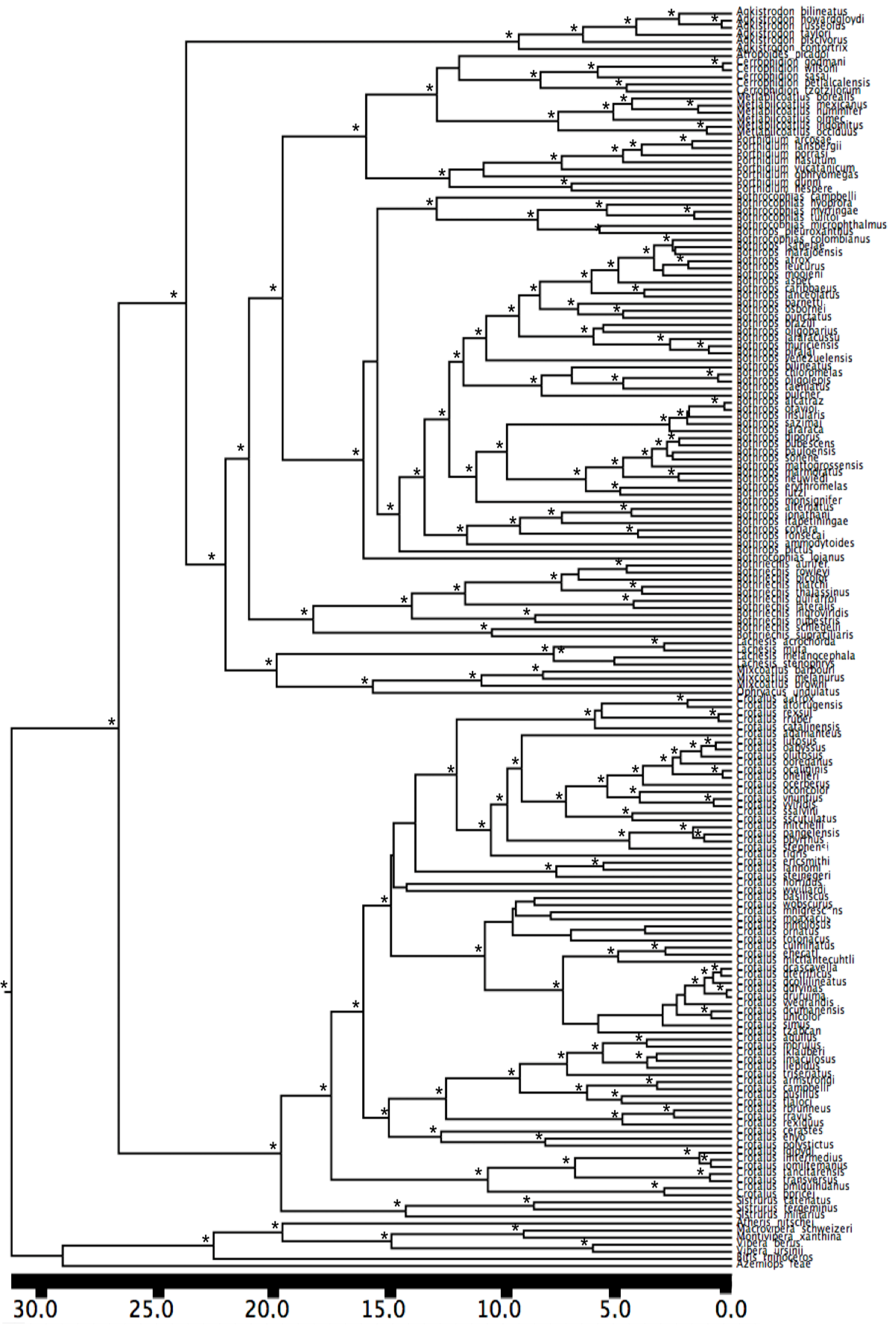

Biogeographic ancestral area reconstruction for North America under the best model (DIVALIKE AICc= 0.999). Ancestral areas with probability less of 0.25 were not depicted for clarity.

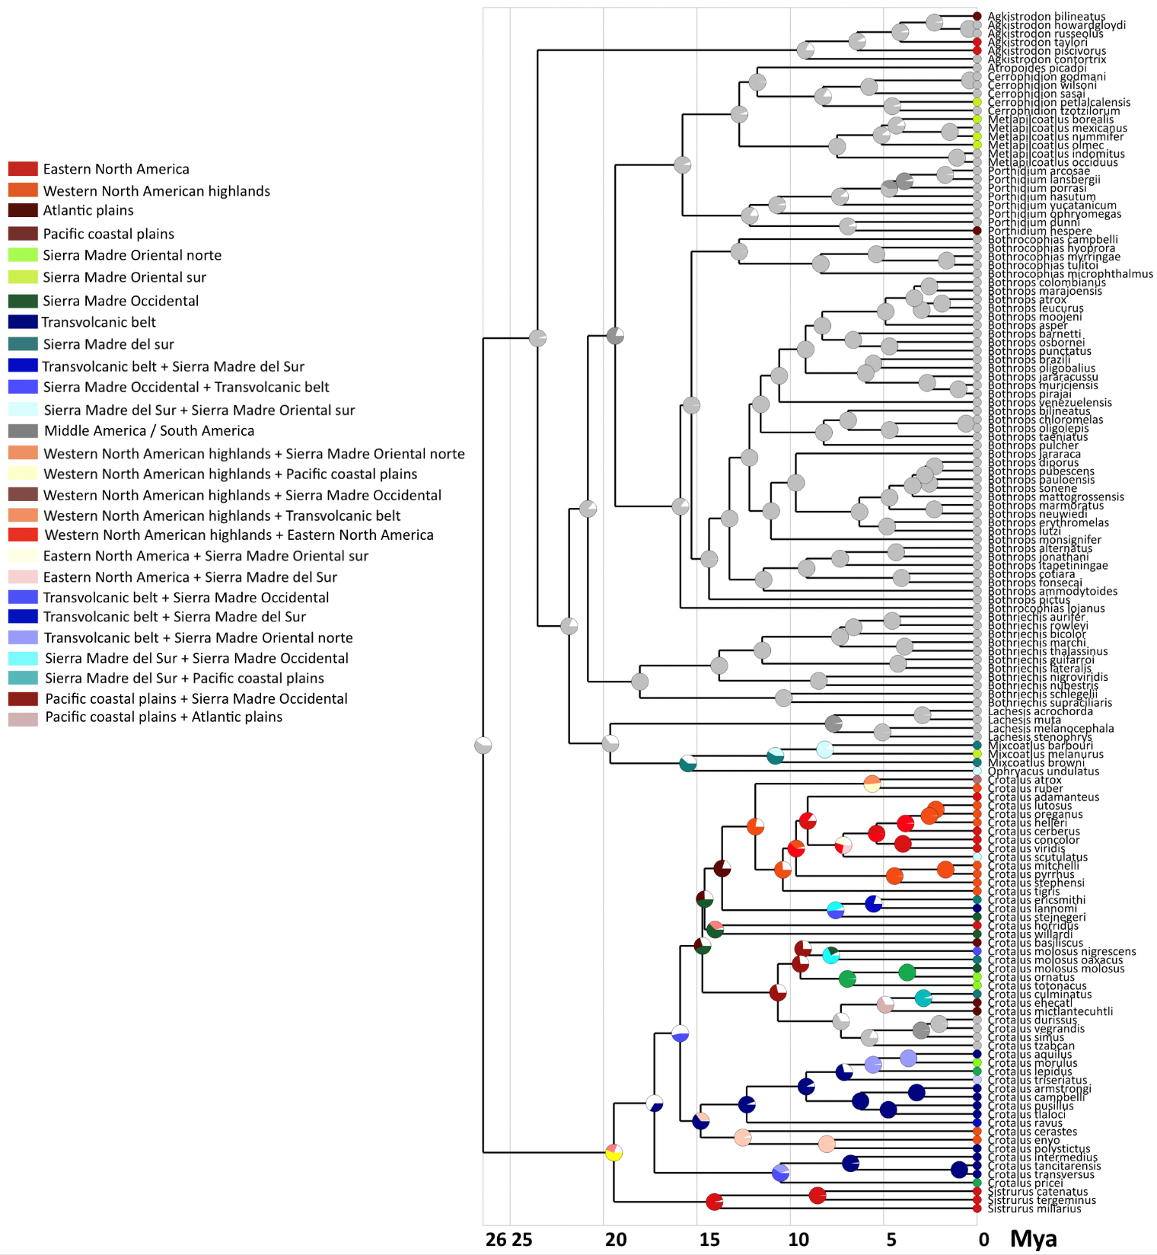

Biogeographic ancestral area reconstruction for Middle America under the best model (DIVALIKE AICc= 0.999). Ancestral areas with probability less of 0.25 were not depicted for clarity.

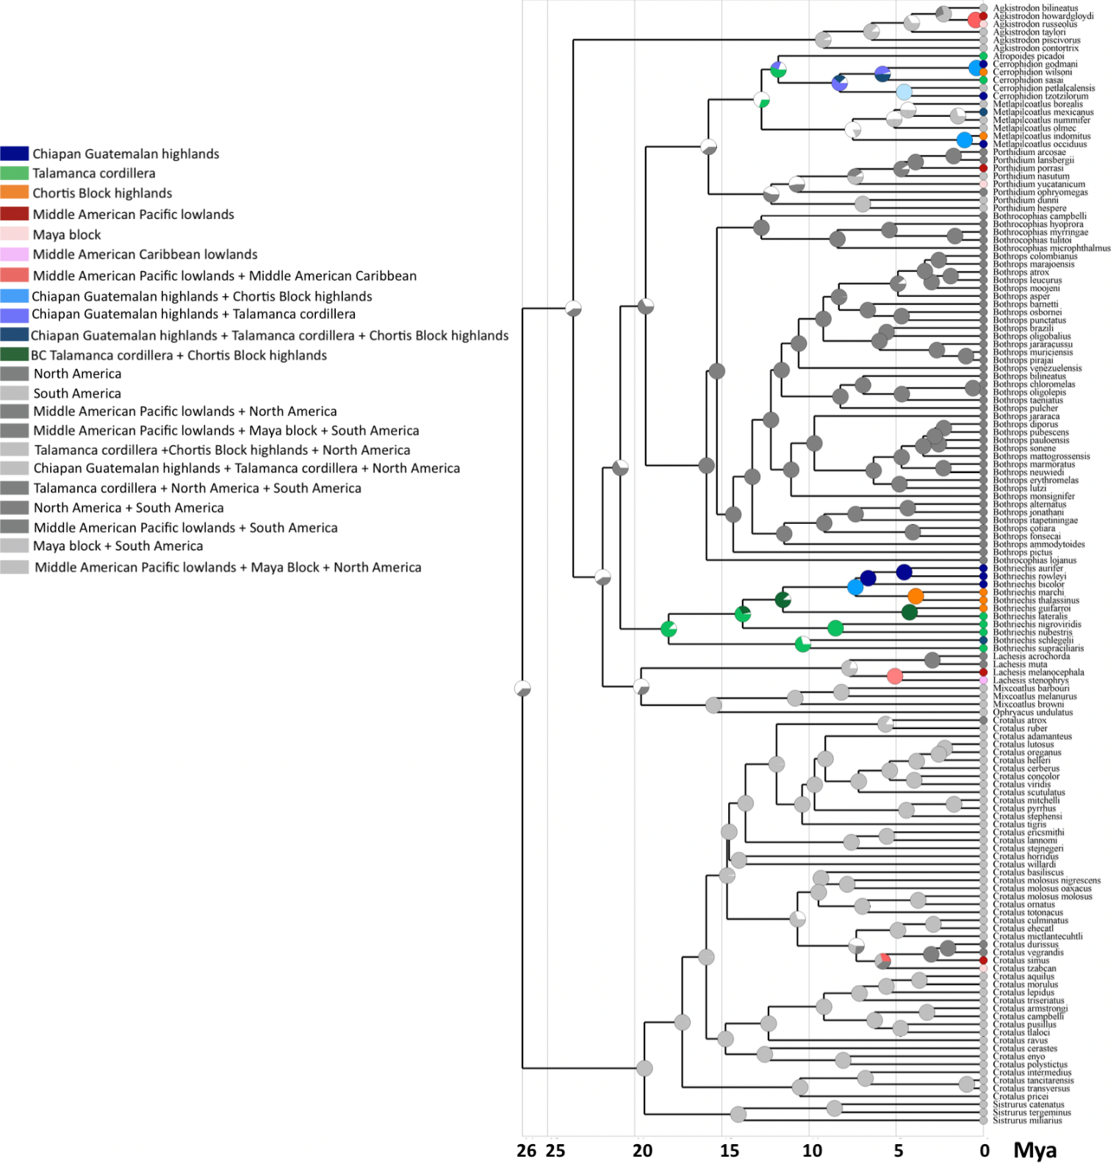

Biogeographic ancestral area reconstruction for South America under the best model (DEC AICc= 0.990). Ancestral areas with probability less of 0.25 were not depicted for clarity.

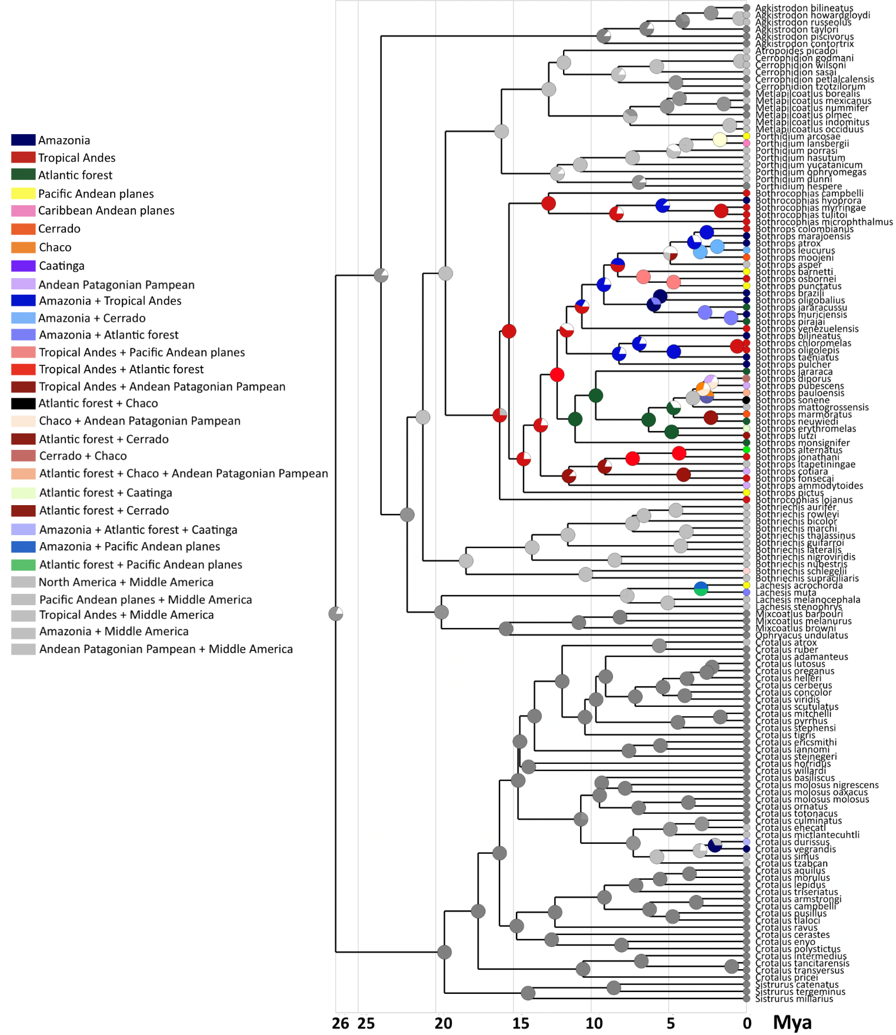

Detailed information about the inferred orographic patterns of speciation in American pitvipers: within mountains, between mountains, within lowlands, between lowlands and between lowlands and mountains. Information provided includes sister lineages groups involved in each event, posterior probabilities of the clade and divergence time in million years ago based on the mc tree. For each speciation event the primary biogeographic areas involved in the orographic pattern are those supported by the highest probability ancestral area reconstructed by the best model in BioGeoBEARS. The probability of orographic pattern is the probability of that supported by the highest probability obtained summing the probabilities of each ancestral speciation event of this mode.

|  |  |  |  |  |  |
| --- | --- | --- | --- | --- | --- |
| Species | Speciation event | Speciation mode | Age divergence | Node support | Probability of speciation mode |
| North America | | | | |  |
| *Porthidium dunni* / *Porthidium hespere* | Within Pacific coastal plains | Within lowlands | 6.9 | 1.000 | 0.926 |
| *Mixcoatlus barbouri* / *Mixcoatlus melanurus* | Between Sierra Madre Sur and Sierra Madre Oriental Sur | Between mountains | 8.1 | 1.000 | 0.868 |
| *Crotalus atrox* / *Crotalus ruber* | Sierra Madre Oriental norte+Altiplano central +Atlantic plains+Pacific Coastal Plains  and Western Central North America | Between mountains and lowlands | 5.6 | 1.000 | 0.491 |
| *Crotalus lutosus* / *Crotalus oreganus* | Within Eastern North American highlands | Within mountains | 2.2 | 0.996 | 0.998 |
| *Crotalus helleri* / *Crotalus lutosus* + *Crotalus oreganus* | Within Eastern North American highlands | Within mountains | 2.5 | 1.000 | 0.992 |
| *Crotalus concolor* / *Crotalus viridis* | Within Western North America | Within lowlands | 3.9 | 1.000 | 0.999 |
| *Crotalus mitchelli* / *Crotalus pyrrhus* | Within Eastern North American highlands | Within mountains | 1.6 | 1.000 | 0.999 |
| *Crotalus stephensi* / *Crotalus mitchelli* + *Crotalus pyrrhus* | Within Eastern North American highlands | Within mountains | 4.4 | 1.000 | 0.995 |
| *Crotalus ericsmithi* / *Crotalus lannomi* | Between Sierra Madre Sur and Transvolcanic belt | Between mountains | 5.5 | 0.993 | 0.865 |
| *Crotalus horridus* / *Crotalus willardi* | Between Eastern North America and Sierra Madre Occidental | Whitin mountains | 14.0 | 0.300 | 0.627 |
| *Crotalus molossus nigriscens* / *Crotalus molossus oaxacus* | Between Sierra Madre Occidental+Transvolcanic belt and Sierra Madre Sur | Between mountains | 7.8 | 0.333 | 0.704 |
| *Crotalus molossus molossus* / *Crotalus ornatus* | Between Sierra Madre Occidental + Altiplano central and Sierra Madre Oriental north | Between mountains | 3.7 | 0.680 | 0.998 |
| *Crotalus totonacus* / *Crotalus ornatus* + *Crotalus molossus molossus* | Between Sierra Madre Occidental and Sierra Madre Oriental norte | Between mountains | 6.9 | 0.453 | 0.987 |
| *Crotalus basiliscus* / *Crotalus molossus nigriscens* + *Crotalus molossus oaxacus* | Between Pacific coastal plains and Sierra Madre Occidental | Between lowlands and mountains | 9.3 | 0.140 | 0.743 |
| *Crotalus culminatus* / *Crotalus ehecatl* | Between Sierra Madre sur +Transvolcanic belt and Pacific Coastal plains | Between lowlands and mountains | 2.8 | 1.000 | 0.950 |
| *Crotalus mictlantecuhtli* / *Crotalus culminatus* + *Crotalus ehecatl* | Between Pacific coastal plains and Atlantic plains | Between lowlands | 4.9 | 0.684 | 1.000 |
| *Crotalus aquilus* / *Crotalus morulus* | Between Transvolcanic belt and Sierra Madre Oriental north | Between mountains | 3.6 | 1.000 | 0.998 |
| *Crotalus lepidus /* *Crotalus aquilus* + *Crotalus morulus* | Between Transvolcanic belt and Sierra Madre Oriental norte | Between mountains | 5.5 | 1.000 | 0.980 |
| *Crotalus armstrongi* / *Crotalus campbelli* | Within Transvolcanic belt | Within mountains | 3.2 | 1.000 | 0.994 |
| *Crotalus pusillus* / *Crotalus tlaloci* | Within Transvolcanic belt | Within mountains | 4.7 | 1.000 | 0.999 |
| *Crotalus enyo* / *Crotalus polystictus* | Between Western North America highlands and Transvolcanic belt | Between mountains | 8.0 | 1.000 | 0.991 |
| *Crotalus cerastes / Crotalus enyo* + *Crotalus polystictus* | Between Western North America highlands and Transvolcanic belt | Between mountains | 12.5 | 1.000 | 0.956 |
| *Crotalus tancitarensis* / *Crotalus transversus* | Within Transvolcanic belt | Within mountains | 0.9 | 1.000 | 0.992 |
| *Crotalus intermedius / Crotalus tancitarensis* + *Crotalus transversus* | Within Transvolcanic belt | Within mountains | 6.7 | 1.000 | 0.981 |
| *Sistrurus catenatus* / *Sistrurus tergeminus* | Between Eastern North America and North America | Within lowlands | 8.5 | 1.000 | 0.991 |
| *Sistrurus miliarius / Sistrurus catenatus* + *Sistrurus tergeminus* | Between Eastern North America and North America | Within lowlands | 14.0 | 1.000 | 0.961 |
| Middle America | | | | |  |
| *Agkistrodon howardgloydi* / *Agkistrodon russeolus* | Between Maya block and Middle Pacific American lowlands | Between lowlands | 0.4 | 1.000 | 1.000 |
| *Cerrophidion godmani* / *Cerrophidion wilsoni* | Between Chiapan-Guatemalan highlands and Chortis Block highlands | Between mountains | 0.3 | 1.000 | 1.000 |
| *Cerrophidion sasai* / *Cerrophidion godmani* + *Cerrophidion wilsoni* | Between Chiapan-Guatemalan highlands and Chiapan-Guatemalan highlands + Chortis Block highlands + Talamanca cordillera | Between mountains | 5.7 | 1.000 | 0.999 |
| *Metlapilcoatlus indomitus* / *Metlapilcoatlus occidus* | Between Chortis Block highlands and Chiapan-Guatemalan highlands | Between mountains | 1.0 | 1.000 | 1.000 |
| *Bothriechis aurifer* / *Bothriechis rowleyi* | Within Chiapan-Guatemalan highlands | Within mountains | 4.5 | 0.996 | 1.000 |
| *Bothriechis bicolor* / *Bothriechis aurifer* + *Bothriechis rowleyi* | Within Chiapan-Guatemalan highlands | Within mountains | 6.6 | 0.720 | 1.000 |
| *Bothriechis marchi* / *Bothriechis thalassinus* | Within Chortis Block highlands | Within mountains | 3.8 | 1.000 | 1.000 |
| *Bothriechis guifarroi* / *Bothriechis lateralis* | Between Chortis Block highlands and Talamanca Cordillera | Between mountains | 4.2 | 1.000 | 1.000 |
| *Bothriechis nigroviridis* / *Bothriechis nubestris* | Within Talamanca cordillera | Within mountains | 8.4 | 1.000 | 1.000 |
| *Lachesis melanocephala* / *Lachesis stenophrys* | Within Middle American lowlands | Within lowlands | 5.0 | 0.823 | 1.000 |
| South America | | | | |  |
| *Porthidium arcosae* / *Porthidium lansbergii* | Between Caribbean Andean plains and Pacific Andean plains | Between lowlands | 1.7 | 1.000 | 1.000 |
| *Porthidium porrasi* / *Porthidium arcosae* + *Porthidium lansbergii* | Between Middle American Pacific lowlands and Pacific Andean plains | Between lowlands | 3.8 | 1.000 | 1.000 |
| *Bothrocophias myrringae* / *Bothrocophias tulitoi* | Within Tropical Andes | Within mountains | 1.6 | 1.000 | 1.000 |
| *Bothrocophias hyopropa* / *Bothrocophias myrringae* + *Bothrocophias tulitoi* | Between Tropical Andes and Amazonia | Between lowlands and mountains | 5.3 | 1.000 | 0.879 |
| *Bothrops colombianus* / *Bothrops marajoensis* | Between Tropical Andes / Amazonia | Between lowlands and mountains | 2.5 | 1.000 | 1.000 |
| *Bothrops atrox* / *Bothrops leucrurus* | Between Amazonia and Atlantic forest | Between lowlands and mountains | 1.8 | 1.000 | 1.000 |
| *Bothrops osbornei* / *Bothrops punctatus* | Between Pacific Andean plains and Tropical Andes | Between lowlands and mountains | 4.6 | 1.000 | 1.000 |
| *Bothrops barnetti* / *Bothrops osbornei* + *Bothrops punctatus* | Within Tropical Andes | Within mountains | 6.6 | 1.000 | 1.000 |
| *Bothrops brazili* / *Bothrops oligobalius* | Within Amazonia | Within lowlands | 5.5 | 0.533 | 1.000 |
| *Bothrops muriciensis* / *Bothrops pirajai* | Between Amazonia and Atlantic forest | Between lowlands and mountains | 0.9 | 1.000 | 1.000 |
| *Bothrops jararacussu* / Bothrops *muriciensis +* *Bothrops pirajai* | Between Amazonia and Atlantic forest | Between lowlands and mountains | 2.6 | 1.000 | 1.000 |
| *Bothrops chloromelas* / *Bothrops oligolepis* | Within Tropical Andes | Within mountains | 0.6 | 1.000 | 1.000 |
| *Bothrops taeniatus* / *Bothrops chloromelas* + *Bothrops oligolepis* | Between Tropical Andes / Amazonia | Between lowlands and mountains | 4.6 | 1.000 | 1.000 |
| *Bothrops diporus* / *Bothrops pubescens* | Between Atlantic forest+Chaco+Andean Patagonian Pampean and Andean Patagonian Pampean | Ambigous | 2.2 | 0.996 | 0.435 |
| *Bothrops sonene* / *Bothrops pauloensis* | Between Amazonia and Cerrado+Chaco | Between lowlands | 2.5 | 0.826 | 0.737 |
| *Bothrops marmoratus* / *Bothrops neuwiedi* | Between Cerrado and Atlantic forest | Between lowlands and mountains | 2.3 | 1.000 | 1.000 |
| *Bothrops erythromelas* / *Bothrops lutzi* | Between Atlantic forest+Caatinga and Cerrado | Within lowlands | 4.8 | 1.000 | 1.000 |
| *Bothrops alternatus* / *Bothrops jonathani* | Between Atlantic forest+Andean Patagonian Pampean and Tropical Andes | Between lowlands and mountains | 4.3 | 1.000 | 1.000 |
| *Bothrops itapetiningae* / *Bothrops alternatus* + *Bothrops jonathani* | Between Tropical Andes and Atlantic Forest | Between mountains | 7.3 | 0.976 | 1.000 |
| *Bothrops cotiara* / *Bothrops fonsecai* | Between Andean Patagonian Pampean and Tropical Andes | Between lowlands and mountains | 4.0 | 1.000 | 1.000 |
| *Lachesis acrochorda* / *Lachesis muta* | Between Andean Pacific and Amazonia+Atlantic forest | Between lowlands | 2.9 | 1.000 | 1.000 |
| *Crotalus durissus* / *Crotalus vegrandis* | Between Atlantic Forest+Caatinga+Chaco Andean Pampean Patagonia and Amazonia | Between lowlands | 2.0 | 0.813 | 1.000 |
| Combined regions | | | | |  |
| *Crotalus simus* / *Crotalus durissus +* *Crotalus vegrandis* | Between Amazonia and Middle American Pacific lowlands | Between lowlands | 2.0 | 0.783 | 0.776 |
| *Cerrophidion petlalcalensis* / *Cerrophidion tzotzilorum* | Between Sierra Madre Oriental sur (North America) and Chiapan Guatemalan highlands (Middle America) | Between mountains | 4.5 | 1.000 | 1.000 |
| *Metlapilcoatlus borealis* / *Metlapilcoatlus mexicanus* + *Metlapilcoatlus nummifer* | Between Sierra Madre Oriental sur / Chiapan Gautemalan highlands + Talamanca cordillera | Between mountains | 4.3 | 0.916 | 0.889 |
| *Metlapilcoatlus mexicanus* / *Metlapilcoatlus nummifer* | Between Talamanca cordillera+Chortis Block highlands+Chiapan Guatemalan highlands (Middle America) and Sierra Madre Oriental sur (North America) | Between mountains | 1.4 | 1.000 | 0.974 |

Model fitting of species log-transformed elevation midpoint using Geiger. The best model Lambda had a lambda parameter =0.854.

|  |  |  |
| --- | --- | --- |
| Model | AICc | AICc weight |
| Brownian | 283.722 | <0.00001 |
| OU | 196.006 | 0.00064 |
| EB | 285.812 | <0.00001 |
| Lambda | 185.930 | 0.99148 |
| Kapa | 212.454 | <0.00001 |
| Delta | 248.932 | <0.00001 |
| Mean trend | 285.811 | <0.00001 |
| Rate trend | 264.456 | <0.00001 |
| White noise | 198.260 | 0.00208 |